Hahndorf Township Strategic Traffic Planning Study – Outcomes

Frequently Asked Questions

What is the Hahndorf Township Strategic Traffic Planning Study?
In July 2018, the Federal Minister for Infrastructure, Transport and Regional Development committed $1 million for a strategic traffic planning study, to address traffic safety, connectivity and amenity issues in Hahndorf. Access and efficiency for heavy freight vehicles travelling to surrounding areas was also considered.
The study area included the Hahndorf Township, the existing Verdun Interchange (towards the north-west of the Hahndorf Township) and the existing Mount-Barker Interchange (towards the south-east of the Hahndorf Township).
A key aim of the study was to investigate alternative route options for traffic which doesn’t have a purpose in the main street (Mount Barker Road). As the study progressed, the importance of Hahndorf’s unique heritage and character became increasingly evident. This has been considered, alongside traffic movements, in the options and ideas.
The Department has now completed the initial Hahndorf Township Strategic Traffic Planning Study. The options and ideas identified by the study to improve traffic safety, connectivity, and liveability in and around Hahndorf are now out for public consultation until 7 June 2021.
Improving safety, access and connectivity will support Hahndorf to remain a thriving Adelaide Hills community and one of South Australia’s most loved tourism destinations.

2. What is the Hahndorf Township Improvements and Access Upgrade Project?
The Australian and South Australian governments have announced a funding investment of $250 million ($200 million in Australian Government funding and $50 million in South Australian Government funding) towards the project for detailed planning, design and construction. The scope of this project will be guided by the Hahndorf Township Strategic Traffic Planning Study outcomes and the community feedback received during the current consultation process.

3. Why is the Hahndorf Township Improvements and Access Upgrade Project needed?
Without new infrastructure and upgrades in and around Hahndorf, the Hahndorf Township Strategic Traffic Planning Study found it is likely that:
- Traffic and freight will continue to increase in the Hahndorf main street affecting the amenity of the township.
- Traffic collisions are likely to increase in Hahndorf, the surrounding townships and at the existing interchange sections.
- The performance of existing intersections will continue to decline with increased delays, queues and further disruptions to the community and businesses.
- Growth opportunities for the local economy, which is tourism dominated, will be limited due to the road environment.

Addressing these problems will ensure that Hahndorf can continue to safely accommodate visitors and retain its role as one of South Australia’s most significant tourism hubs.

4. What is the current situation in Hahndorf?
The Hahndorf Township is a significant tourist destination located in the Adelaide Hills, drawing around one million visitors each year. Hahndorf is also located on a key transport route for both general traffic and freight vehicles.
Currently, the existing road network around Hahndorf provides no alternative route for certain journeys accessing the South Eastern Freeway, or those with destinations to the north or south of Hahndorf, to do so without having to travel through the main street (Mount Barker Road). This causes additional traffic along the main street, which currently carries around 11,000 vehicles per day including approximately 480 commercial vehicles. The main street has limited capacity to cope with the variety of traffic passing through, and with the traffic volume growing at about 1.9 per cent per year the safety, function and amenity of Hahndorf are facing challenges.
The main street has limited space to accommodate the many modes of traffic (e.g. heavy vehicles, buses, traffic, pedestrians etc.) that occupies the current street space (e.g. roadway, parking and footpath activities). It is also the highest pedestrianised trafficked street in South Australia.
Key facts:
- About 1 million visitors each year visit Hahndorf.
- 11,000 vehicles per day travel through the main street.
- Approximately 300 road users on weekday peak hour do not have a purpose in Hahndorf.
- There are approximately 480 commercial vehicles on the Hahndorf main street each day.
- 90% of commercial vehicles are heavy vehicles.
- 45 crashes have occurred in the past five years.
- Only three pedestrian crossing locations along 1.2 kilometres of main street.

- Up to 9,800 people cross the main street daily on Saturday and Sunday.

5. What are the key traffic problems in Hahndorf?
The study identified several problems in Hahndorf and the surrounding area including:
- The nature of the current connectivity to and from the South Eastern Freeway is causing additional traffic and freight in the township, primarily due to:
- There being no convenient alternative route between the east (Mount Barker) and the north (Balhannah/Woodside) without travelling through the main street of Hahndorf.
- There being no convenient alternative route between the south (Echunga) and the west (Adelaide) or east (Murray Bridge) without travelling through the main street of Hahndorf.
- The current traffic on the Hahndorf main street (Mount Barker Road) is limiting the economy, function, and amenity of the township. There are approximately 11,000 vehicles per day on the main street and a very high number of pedestrians.
- Poor wayfinding and driver behaviour is causing unnecessary congestion.
- Limited public parking is available.
- The limited capacity of Mount Barker Interchange is causing delay and safety risks.
- Limited active transport (pedestrian and bike paths) infrastructure is available outside of the township.

What were the key steps in the planning study process?
The Department undertook consultation and investigations as part of the planning study to inform, develop and assess multiple options and ideas to address the current and future traffic problems facing the Hahndorf area. The key steps and activities of the planning study are described overleaf.
Key Steps | What’s involved
1. Problem Identification | - Consultation with the community and stakeholders  - Identification of the problems and opportunities  - Data collection and surveying
2. Review and investigations | - Review and analysis of data  - Geotechnical site investigations  - Environmental, social, and economic assessments the current situation  - Traffic counts to determine seasonal variations and origin-destination surveys
3. Long list | - Identification and assessment of a long list of options and ideas  - Consultation with project stakeholders including Councils and the Federal Government
4. Shortlisted options | - Development of short-listed options  - Analysis of the short-listed options  - Consultation with project stakeholders including Councils and the Federal Government
5. Business Case | - Development of a preliminary Business Case to provide justification for the proposed options and ideas

What criteria was used to develop and assess the options?
The Department assessed a variety of options and ideas against several criteria listed below. Options and ideas that did not perform well against the assessment criteria did not progress for further consideration and development.
Assessment criteria | Description
Tourist and visitors | Functional performance of the transport network for tourists and visitors to Hahndorf
Resident and workers | Functional performance of the transport network for residents and workers in Hahndorf
Through passengers and freight | Functional performance of the transport network for passengers and freight passing through Hahndorf
Safety | Safety performance of the transport network for all classes of road users
Environment and heritage | Impact of options on natural, built and social environments
Constructability | Deliverability of options and the need to minimise construction impacts on Hahndorf including extent and duration of works
Cost | Whole of life cost of the options
Benefit to cost ratio | Benefit-cost analysis of the options based on the Australian Transport Assessment and Planning guidelines

Were options for a new interchange at Pine Avenue considered?
Yes. Interchange options at Pine Avenue were also investigated, however these options were not progressed for the following reasons:
- A new interchange at Pine Avenue does not address the key issue of removing traffic from the main street as effectively as the short-listed options for the following reasons:
  - Vehicles travelling from the north of Hahndorf (e.g. Woodside) heading east on the freeway (and vice versa) would still use the main street.
  - Vehicles travelling from the south of Hahndorf (e.g. Echunga) to the north of Hahndorf (e.g. Woodside) and vice versa would still use the main street.
  - Vehicles travelling from the south to Bridgewater, and vice-versa, would still use the main street.
- A new interchange would focus a significant amount of traffic onto Pine Avenue and cause increased congestion at the junction with Mount Barker Road causing major delays and safety risks
- Environmental and social impacts are greater than for the three short listed options with regards to land acquisition, vegetation removal and amenity.

How was community and stakeholder feedback considered?
Initial community consultation played a significant role informing the development of the current options and ideas. The feedback received early in the planning process helped to identify key issues and problems that were important to the community. Key considerations included:
- The future needs and desires of the community
- Minimising the project impacts on residents and business.
- Environmental considerations including heritage and vegetation clearance requirements.
- Constructability considerations to ensure the options and ideas are viable.
The Department will also continue to work closely with Mount Barker Council to ensure any ideas taken forward for the main street are integrated with Council’s Revitalisation Plans.
- What are the short-listed options?
The outcomes of the study identified three proposed interchange options (two at River Road and one at Verdun), as well as a set of ideas to improve traffic management and amenity in the main street. As part of the project, the Department also proposes to:
- Upgrade the Mount Barker Interchange with traffic signals at the southern intersection and ramp capacity improvements.
- Install a dedicated and separate shared walking and cycling path connecting Verdun and Hahndorf, thus acknowledging Hahndorf’s heritage by providing the missing link to the Pioneer Women’s Trail.
The shortlisted options detailed below improve the connectivity and efficiency of the road network in and around Hahndorf, with a focus on improved access to/from the South Eastern Freeway.
River Road-Option 1
Includes a full interchange at River Road and a new link road connecting Echunga Road and River Road. The key benefits of this option are that it provides direct access for motorists travelling in all directions, significantly improving emergency service access and creating alternate routes for vehicles (and heavy vehicles) that unnecessarily pass through the Hahndorf main street. This option also provides travel time savings for the trips that bypass the main street. The benefits and limitations of this options are summarised below:
Benefits | Provides the most direct access to the freeway in all directions for emergency services
 | Provides freeway access to the east (Murray Bridge and Mount Barker) without using the main street
 | Provides freeway access to the west (Adelaide) without using the main street
 | Provides freeway access from the south (Echunga / Kuipto Forrest) without using main street
 | Provides access between the north (Balhannah and Woodside) and south (Echunga / Kuipto Forrest) the without using the main street
 | Reduces heavy vehicles and traffic from Mount Barker Road, including the main street
Limitations | Will marginally increase traffic volumes on River Road
 | Mainline road traffic may need to give way at the newly introduced roundabouts

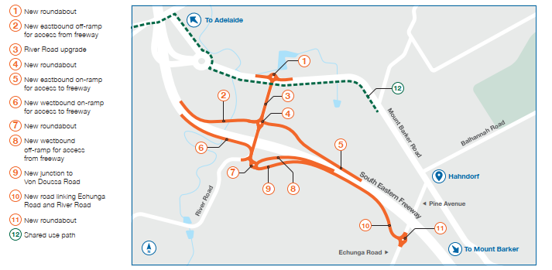
River Road Option 1

River Road-Option 2
Includes a half interchange at River Road and a link road connecting Echunga Road and River Road. The key benefits of this option are that it provides direct access for motorists travelling to and from the south and east. This option will improve emergency service access and will create an alternate route for vehicles (and heavy vehicles) that unnecessarily pass through the Hahndorf main street. This option also provides travel time savings for the trips that bypass the main street.
The benefits and limitations of this options are summarised below:
Benefits | Provides eastbound access to the freeway for emergency services from north and south of Hahndorf
 | Provides freeway access to the east (Murray Bridge and Mount Barker) without using the main street
 | Provides freeway access to the west (Adelaide) without using the main street
 | Provides freeway access from the south (Echunga / Kuipto Forrest) without using main street
 | Provides access between the north (Balhannah and Woodside) and south (Echunga / Kuipto Forrest) the without using the main street
 | Reduces heavy vehicles and traffic from Mount Barker Road, including the main street
Limitations | Traffic accessing the freeway to/from the west will have a longer travel time than Option 1 due to using the current Verdun interchange
 | Will marginally increase traffic volumes on River Road
 | Main road traffic may need to give way at the newly introduced roundabouts

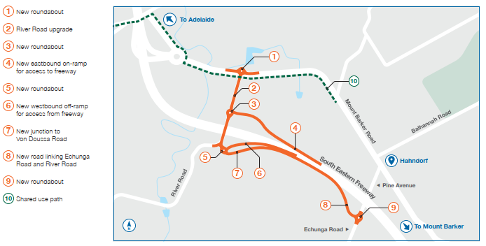
River Road Option 2

Verdun Interchange-Option 3
Includes upgrading to a full access interchange at Verdun with a link road connecting Echunga Road and River Road. The key benefits of this option are improved access for motorists travelling to and from the east. This option will improve emergency service access, however, this option does not remove all unnecessary trips through Hahndorf.
The benefits and limitations of this option are summarised below:
Benefits | Provides eastbound access to the freeway for emergency services from the north and south of Hahndorf
 | Provides freeway access to the west (Adelaide) from the south (Echunga / Kuipto Forrest) without using main street
 | Provides access between the north (Balhannah and Woodside) and south (Echunga / Kuipto Forrest) the without using the main street
 | Reduces heavy vehicles and traffic from Mount Barker Road, including the main street
Limitations | Will marginally increase traffic volumes on River Road
 | Main road traffic may need to give way at the newly introduced roundabouts
 | Does not provide freeway access to the east (Murray Bridge and Mount Barker) to/from the south (Echunga / Kuipto Forrest) without using main street
Compared to Options 1 and 2:
- It does not remove all unnecessary trips i.e. least effective at reducing traffic volumes through Hahndorf.
- Greater distance and longer travel times between the freeway and the south (Echunga) and the east (Murray Bridge and Mount Barker)
- Less direct access to the freeway for emergency services to/from the South

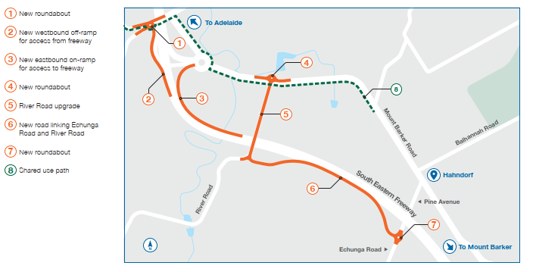
Verdun Interchange-Option 3

Main street (Mount Barker Road) ideas
Several ideas have been identified to improve the main street of Hahndorf to address current and future amenity, safety, parking and efficiency issues. Any improvements on the main street are intended to be integrated with the Mount Barker District Council’s Revitalisation Plans as the scope is refined for the Hahndorf Township Improvements and Access Upgrade Project.
Key benefits could include:
- Enhancements to improve pedestrian and visitor safety including better pedestrian facilities, upgraded crossings, continuous raised footpaths across side roads and raising the road to the same height as the footpath between Pine Avenue and English Street to give greater priority and presence to pedestrian traffic.
- Protected right-turn lanes for vehicles turning onto Balhannah Road and Pine Avenue.
- Gateway treatments (such as road marking, buildouts, signs and landscaping) at either end of the main street to signal a change in the traffic environment.
- Increased off-street public parking.
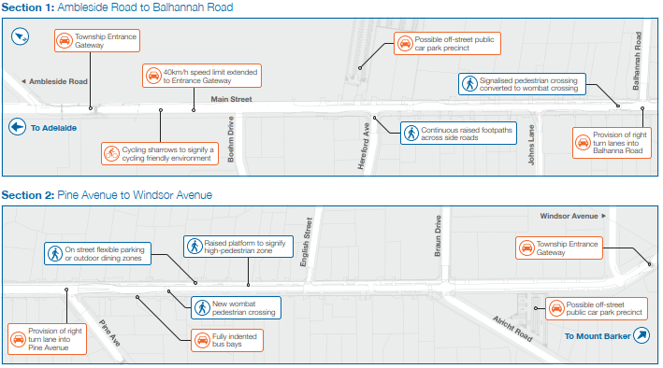
Main street (Mount Barker Road) Ideas

12. Are traffic signals at the intersection of the Main Street and Balhannah Road being considered?
Not at this stage, because outcomes of early investigations determined that the introduction of traffic signals at the main street and Balhannah Road would have a negative impact of traffic efficiency in the area. The set of ideas shortlisted for main street include separate right turn lanes to Balhannah Road and Pine Avenue to assist traffic to move along Mount Barker Road efficiently and to remove queueing from this intersection. Additionally, converting the pedestrian activated crossing to a wombat crossing will ensure consistency for pedestrian crossing facilities along main street. This will provide pedestrians the right of way when required.

Why is the proposed link road between River Road and Echunga Road important?
The link road is important because it will provide direct and alternative access for traffic traveling to/from the south (i.e. Echunga / Kuipto Forrest) to/from the north (i.e. Onkaparinga Valley Road) without having to travel through the Hahndorf main street. The link road will provide an important connection to the freeway for traffic to/from the south which needs to travel east (i.e. to Murray Bridge) or west (i.e. to Adelaide) without having to travel through the Hahndorf main street.

Why can’t the existing road network be used for this link instead?
The existing road network is not suitable to provide a link road between River Road and Echunga Road as these connections are indirect, inefficient and not intuitive for drivers. Upgrading the existing road network for this purpose would involve substantial and costly road works i.e. widening, cuttings, straightening and road condition upgrades.

How big is the proposed link road (e.g. it won’t be a four-lane highway next to the Freeway, will it)?
The link road proposed for each option is expected to be single-lane road in each direction. Interchanges and roadways would be designed in line with the style of existing roads in the area. We note that these designs are very early concepts and ideas. The detail of what the roads will look like and the alignment of the roads will be determined during detailed design and will be informed by feedback received during this consultation period.

What is the normal process for any property acquisition?
We are not commencing any acquisition processes for this project at this stage as the nature and impacts of a preferred solution are not yet known. We are currently inviting the public to provide feedback on the three interchange options, and ideas for the Hahndorf main street.
The outcomes of the planning study, as well as community feedback received during this consultation period, will help in identifying a preferred package of works for the Hahndorf Township Improvements and Access Upgrade Project, and a decision can be made as to which option and main street ideas will provide the best possible outcome for the community overall.
If acquisition is required for the project, the process would be managed by the dedicated property team within the Department for Infrastructure and Transport and is bound by the Highways Act 1926 and the Land Acquisition Act 1969. These Acts protect the rights of individuals affected by acquisition and articulate the process.

What are the normal measures considered for noise abatement?
The Department’s Road Traffic Noise Guidelines provide guidance to departmental staff and consultants in addressing road traffic noise as a key part of infrastructure project development. The Guidelines set out the process to be followed and criteria to be applied when assessing the road traffic noise impacts of infrastructure projects involving new roads and/or major upgrading of existing roads.
During the detailed design of the project the Department would undertake noise modelling to understand what the impacts of the new roads might be on surrounding properties. Based on the modelling outcomes, noise reduction measures would be implemented along the new alignment at points where noise levels exceed the thresholds of the Road Traffic Noise Guidelines. Some noise reduction measures can include, but are not limited to, noise-reducing asphalt and noise barriers.
Please be assured every effort is made by the Department to minimise impacts to local residents as much as practically possible.

What are the next steps?
The Department invites you to provide feedback on the three interchange options, and ideas for the Hahndorf main street. Consultation runs from 29 April to 7 June 2021.
The outcomes of the planning study, as well as community feedback received during this consultation period, will help inform how the Department progresses the design and delivery of the Hahndorf Township Improvements and Access Upgrade Project. A decision can then be made on which option and main street ideas will provide the best possible outcome for the community overall. Detailed planning for the Hahndorf Township Improvements and Access Upgrade Project will commence later this year, with construction likely to begin late 2023.
The Department will continue to engage with the community at each stage of the project. We encourage you to visit the project webpage and register for updates so we can keep you informed as the project progresses.

Have your say
Community and stakeholder consultation is critical to the success of the project. To find out more about the project, to provide your feedback or to register for project updates please:
- Visit the project webpage: dit.sa.gov.sa/hahndorf
- Email us at dit.communityrelations@sa.gov.au
- Call us on telephone 1300 794 880.

