DIT Procurement Services
Repair and Upgrading of Marine Structures
Prequalification Application Form

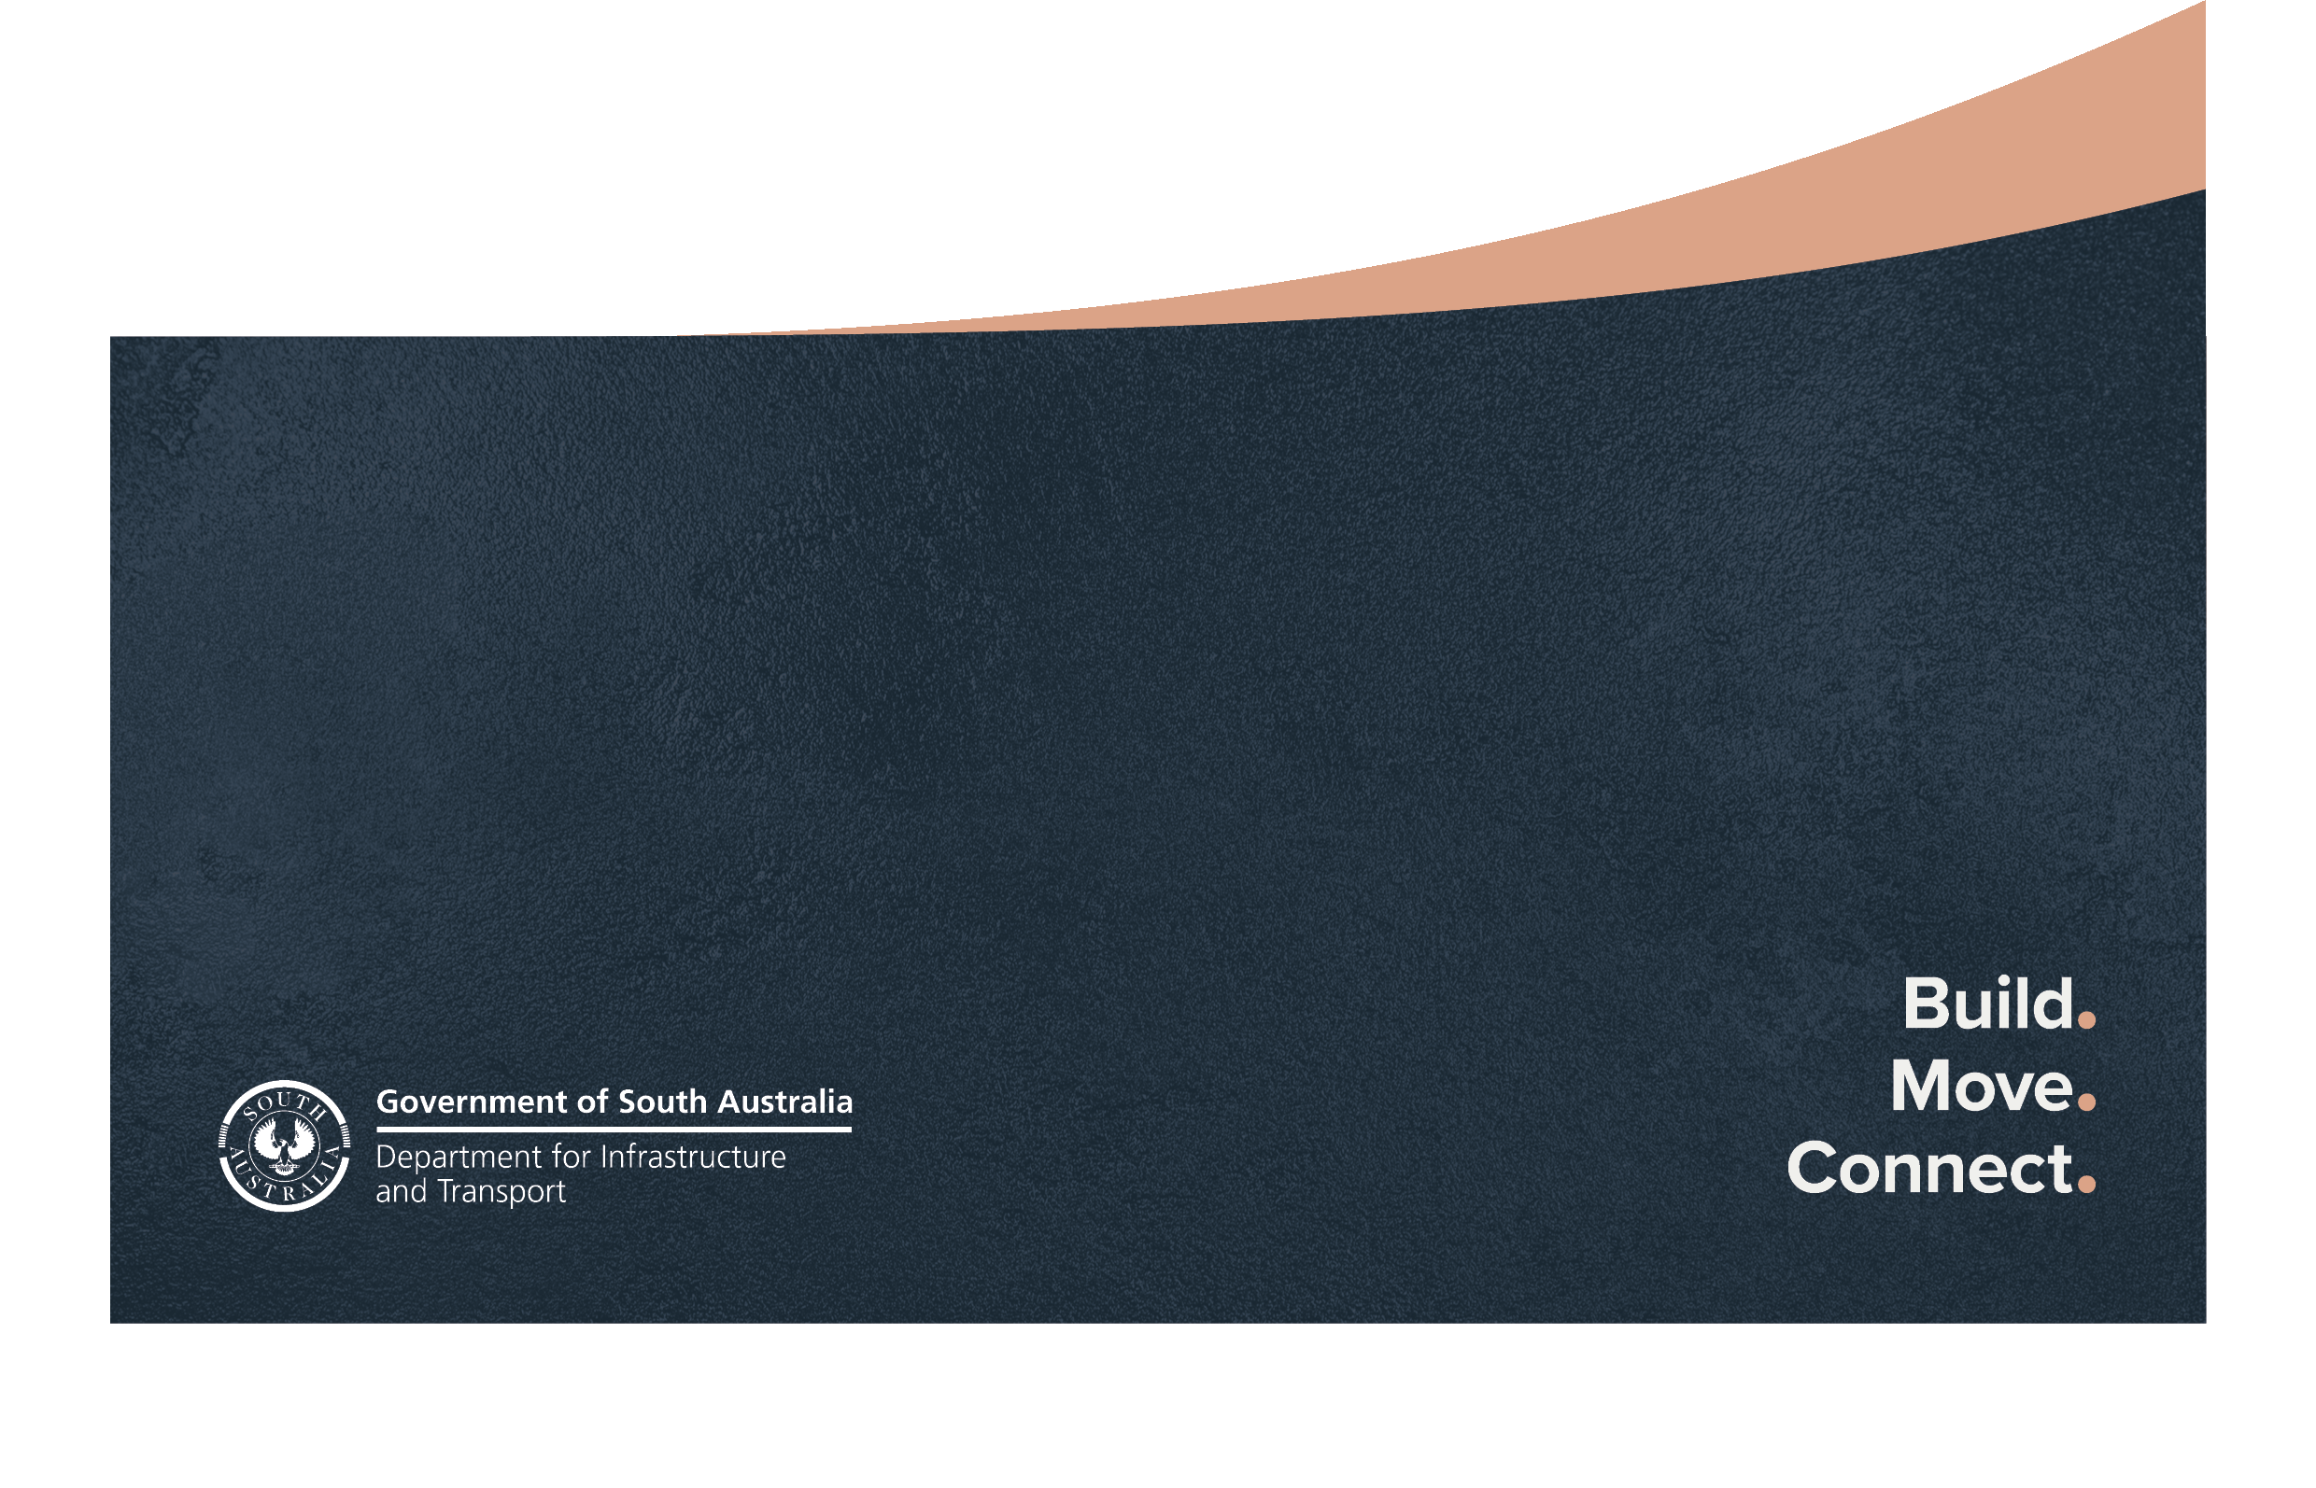

Document references
KNet file part:
KNet number: 21398481

Document purpose and instructions
The purpose of this document is to:
- provide Applicants with the response structure required for a compliant submission;
- detail requirements for each Schedule; and
- align all Applicants’ submissions to ensure a fair evaluation.
Instructions
General
Companies (Applicants) wishing to apply for prequalification for the Repair and Upgrading of Marine Structures with the Department for Infrastructure and Transport (DIT) must fill out this Application Form and attach the information requested.
- Complete the Application Form and save as a .docx or .pdf file (without these instruction pages).
- save the attachments as .pdf files. Where the files are small, they should be combined so that an absolute maximum of 10 files in total are submitted. Strictly follow the numbering system in this form when preparing the attachments.

Further guidance on applying for membership can be found in the Application Guidelines (the Guidelines).
The submission of an Application is deemed agreement by the Applicant to the Terms and Conditions.
Submitting the Application
Applications should:
- include all documentation outlined in this Application Form, together with any other supporting technical.
- include file names which clearly indicate the applicable section numbers of this application that are addressed in the file.
- be marked:
DIT Prequalification Application
Attention: Team Leader, Prequalification and Tender Management
- be emailed to DIT.Prequal@sa.gov.au or be complied on a USB memory device and posted to GPO Box 1533, ADELAIDE SA 5001 (Do not submit a hard copy)
- the applicant must nominate an authorised person, as a single point of contact, that is capable of acting on behalf of the business to provide all information required on the application, on behalf of the business seeking to be prequalified. The Department will not liaise with anyone who is not authorised to act for the Applicant.
Enquiries may be directed to DIT.Prequal@sa.gov.au or phone (08) 7133 1263.

Publication of details
Once prequalified, the contact details provided in this Application Form will be published on the following internet site: https://dit.sa.gov.au/contractor_documents/prequalification.
Contractors must be registered on the SA Tenders and Contracts internet site (https://www.tenders.sa.gov.au ) to receive invitations and submit tenders.

Document version control
Date | Version No. | Amendments | Approved by

This document is the property of the Department for Infrastructure and Transport (the Department) and contains information that is confidential to the Department. It must not be copied or reproduced in any way without the written consent of the Department. This is a controlled document and it will be updated and reissued as approved changes are made.

DIT Prequalification Application - Repair and Upgrading of Marine Structures
Company Name:
Company Numbers: | ABN  ACN
Applying for the following Category & /Level: | M1 |  |  | Yes/No
 | M2 |  |  | Yes/No
Address of Registered Office

Postal Address

Email
South Australian (SA) Contractors Building Licence must be endorsed with as a minimum:  - “CIVIL CONSTRUCTION ASSOCIATED WITH MARINE STRUCTURES” which covers civil construction associated with the Marine environment with restrictions  OR either of the following:  - “ANY BUILDING WORK” which covers all building and civil without restriction  - “CIVIL CONSTRUCTION” which covers all civil work without restriction | BLD No. | Expiry Date: | Endorsed Category/Subcategory:

Applicant’s Contact Person:
Position in Company:
Phone No:
Email:
Details supporting this application for DIT Prequalification Application for Repair and Upgrading of Marine Structures are attached as set out in the “INFORMATION TO BE SUBMITTED BY APPLICANT”.
In submitting this application I agree to comply with the DIT Conditions of Prequalification:
(refer: https://www.dit.sa.gov.au/contractor_documents/prequalification)

Signed by Applicant’s Contact Person: …………………………………….. Date: …..…………….

Please provide the information listed in the relevant column “INFORMATION TO BE SUBMITTED BY APPLICANT”

 |  |  | These columns for DIT use only
SUBJECT |  | INFORMATION TO BE SUBMITTED BY APPLICANT | MINIMUM REQUIREMENT  For M1 | Meets Requirement? | MINIMUM REQUIREMENT  for M2 | Meets Requirement?
1. | . COMPANY STRUCTURE | Outline of company structure and ownership | For information. |  | For information.
 |  | Organisational Chart showing key personnel, including Company Directors, managers, professional staff, site supervisors and field personnel | For information. |  | For information.
2. | INSURANCE | Evidence of Insurance Policies and certificates of currency | $10,000,000 Public Liability insurance. |  | $20,000,000 Public Liability insurance.
3. | BUILDERS LICENCE | Copy of Builders Licence | Current Licence |  | Current Licence
4. | COMPANY PERSONNEL | Job and Personal specifications / CV’s for staff nominated to work on marine projects, clearly setting out relevant:  - experience, particularly in relation to jetties, marine works or similar structures  - skills / abilities  - qualifications | Note: the following requirements only apply to staff nominated to work on DIT marine projects:
 |  |  | Senior managers: at least 4 years’ experience in works contracts that demonstrates the ability to manage contracts for minor repairs to marine structures. |  | Senior managers: at least 7 years’ experience in either heavy structural timber works, marine works, jetty / wharf repairs or in contracts of a similar nature and complexity.
 |  |  | Supervisors: have more than 4 years supervisory experience in contracts of a similar complexity to minor repairs to marine structures and the number of experienced supervisors is appropriate for size of contracts undertaken by company. |  | Supervisors: have more than 7 years’ experience in either: heavy structural timber works, marine works, jetty / wharf repairs or in contracts of a similar nature and

 |  |  | These columns for DIT use only
SUBJECT |  | INFORMATION TO BE SUBMITTED BY APPLICANT | MINIMUM REQUIREMENT  For M1 | Meets Requirement?  (Yes / No) | MINIMUM REQUIREMENT  for M2 | Meets Requirement?  (Yes / No)
4. COMPANY PERSONNEL |  |  |  |  | complexity and the number of experienced supervisors is appropriate for size of contracts undertaken by company.
 |  |  | Permanent staff: appropriate experience for the position occupied |  | Permanent staff: appropriate experience for the position occupied and the company has a demonstrated history of being able to retain employees with relevant experience and knowledge
5. | SUBCONTRACTING | For M2 applications only: if the company uses subcontractors, outline of how often and for what type of work sub-contractors are used. | No requirements |  | If using subcontractors, a history of stable, long term relations with them.
6. | PARTNERING | For M2 applications only: description of the company’s understanding and/or approach to partnering | No requirements |  | Demonstrated commitment to the principles of partnering.
7. | PLANT | Description of plant owned and / or leased by the company which may be used for the repair or upgrading of marine structures. | Plant and equipment is appropriate for the work to be undertaken. |  | Plant and equipment is appropriate for the work to be undertaken.
8. | WORK HISTORY | Details of completed relevant contracts in the last 5 years, including:  - contract name & client (including contact details)  - detail description of work  - contract type (eg lump sum) and value | Successful completion of contracts that demonstrate the ability to undertake minor repairs to marine structures.  Referees satisfied with company performance. |  | Company history demonstrating experience in successfully undertaking the repair or upgrading of marine structures or in contracts of a similar nature and complexity.

 |  | These columns for DIT use only
SUBJECT | INFORMATION TO BE SUBMITTED BY APPLICANT | MINIMUM REQUIREMENT  For M1 | Meets Requirement?  (Yes / No) | MINIMUM REQUIREMENT  for M2 | Meets Requirement?  (Yes / No)
8. WORK HISTORY | - any subcontractors or suppliers  - date  - any other referees | Note: for newly formed companies, project work undertaken by personnel when employed by other companies will be taken into consideration |  | These contracts may include:  - Timber jetty repair.  - Heavy structural timberwork  - Construction work in a marine environment.  - Specialist work such as diving or pile driving.  - Management of subcontractors.  - Work using Specifications from DIT, Flinders Ports or other marine authorities.  Referee reports provide evidence of above.
9. QUALITY MANAGEMENT | For M1 applications:  Outline of understanding and approach to Quality Management  For M2 applications only:  Copy of certification of quality management system;  Or  Details of quality management system, which includes a company quality Policy endorsed by the CEO and addresses the relevant elements of AS/ISO 9001. | Demonstrated understanding and commitment to quality management principles. |  | Third party certification of quality system to a recognised standard  (eg CCF IMS or AS/ISO 9001);  Or  Evidence of understanding and commitment to quality management principles and evidence of ISO 9001 elements being applied in practice

 |  | These columns for DIT use only
SUBJECT | INFORMATION TO BE SUBMITTED BY APPLICANT | MINIMUM REQUIREMENT  For M1 | Meets Requirement?  (Yes / No) | MINIMUM REQUIREMENT  for M2 | Meets Requirement?  (Yes / No)
10. ENVIRONMENTAL MANAGEMENT | 10.1 Outline of company’s awareness of Codes of Practice and legislation relevant to marine work. | Company demonstrates awareness and understanding of relevant Codes of Practice and legislation. |  | Company demonstrates awareness and understanding of relevant Codes of Practice and legislation.
 | 10.2 The company’s Environmental Management Policy endorsed by the CEO | The policy demonstrates:  - an understanding of the nature, scale and environmental impacts of the organisation’s activities, products and services.  - the organisation’s commitment to environmental improvement, prevention of pollution, compliance with relevant environmental legislation and regulations; and is signed off by senior management. |  | The policy demonstrates:  - an understanding of the nature, scale and environmental impacts of the organisation’s activities, products and services.  - the organisation’s commitment to environmental improvement, prevention of pollution, compliance with relevant environmental legislation and regulations; and is signed off by senior management.

 |  |  | These columns for DIT use only
SUBJECT | INFORMATION TO BE SUBMITTED BY APPLICANT |  | MINIMUM REQUIREMENT  For M1 | Meets Requirement?  (Yes / No) | MINIMUM REQUIREMENT  for M2 | Meets Requirement?  (Yes / No)
10. ENVIRONMENTAL MANAGEMENT | 10.3 | The defined responsibilities/accountabilities for management and other staff responsible for activities effecting the environment. | At least one person must be identified. |  | At least one person must be identified.
 | 10.4 | For M2 applications only: Copy of certification of quality management system;  Or  Details of environmental management system which addresses the relevant elements of AS 14001. | Not Required |  | Certified EMS system to a recognised standard (eg CCF IMS or AS/ISO 14001);  Or  Components of an EMS are in place and evidence of its use is provided;  e.g. operational procedures; checking and corrective action.
11. OCCUPATIONAL  HEALTH & SAFETY (OH&S) | For M1 applications:  11.1 Details of OH&S Management System  For M2 applications only:  11.1 Copy of certification of OH&S management system;  Or  Details of OH&S management system, which includes a company safety policy endorsed by the CEO and addresses the relevant elements of AS/ISO 45001. |  | OH&S Management System in place which meet the requirements of:  - the OH&S Act  - the regulations under the Act  - relevant Codes of Practice and Australian Standards |  | Certified OH&S system to recognised a standard  (e.g. CCF IMS or AS/ISO 45001);  Or  A comprehensive OH&S management system which addresses all the elements of AS 4801/ISO 45001 (or equivalent) has been implemented and is maintained.

 |  |  | These columns for DIT use only
SUBJECT | INFORMATION TO BE SUBMITTED BY APPLICANT |  | MINIMUM REQUIREMENT  For M1 | Meets Requirement?  (Yes / No) | MINIMUM REQUIREMENT  for M2 | Meets Requirement?  (Yes / No)
11. OCCUPATIONAL HEALTH & SAFETY (OH&S) | 11.2 | Return to Work SA (Workcover) Registration Number,  Certificate of Currency for Workers  Compensation and a copy of the annual  Workcover renewal notification | Satisfactory certification |  | Satisfactory certification
 | 11.3 | If an Infringement Notice under the OH&S Act has been issued in the last 2 years, details of the Notice and evidence that Corrective Action has been implemented. | A satisfactory response to any an Infringement Notice under the OH&S Act and evidence that Corrective Action has been implemented |  | A satisfactory response to any an Infringement Notice under the OH&S Act and evidence that Corrective Action has been implemented

