Road & Marine Assets

ASSET TYPE AND CONDITION RATING EXAMPLES
– Roads Addendum
RAMA-AM-PRC-005

Document #: 12290952 Version 2.1
RAMA

Table of Contents
1. INTRODUCTION 5
1.1. Purpose of this Document 5
2. ASSET STATUS 5
2.1. Operating Asset 5
2.2. Renewing assets 5
2.3. Decommioning or deleting assets 5
3. ROAD ASSET TYPE EXAMPLES 6
3.1. Sign posts 6
3.2. Signs 7
3.3. Safety Barrier 9
3.4. Terminals 14
3.5. Motorcycle Protection 21
3.6. Drainage 23
3.7. Inlet / Outlet / Junction 28
3.8. Fence / Gates 32
3.9. Stack Sites 34
3.10. Retaining Wall 35
3.11. Rest Area 37
3.12. Bins 38
3.13. Shelter 39
3.14. Toilet Block 40
3.15. Water Tank 40
3.16. Median 41
3.17. Pathways 44
3.18. Bollards 45
3.19. Windsocks 45
3.20. Arrestor Bed 45
3.21. Weigh Stations 46
3.22. Park ‘N’ Ride 46
3.23. Roadstrips 47
3.24. Grids 47
3.25. Floodway’s 48
4. ASSET CONDITION EXAMPLES 50
4.1. Sign posts 50
4.2. Signs 53
4.3. Safety Barrier 58
4.4. Terminals 62
4.5. Motorcycle Protection 64
4.6. Drainage 66
4.7. Inlet / Outlet / Junction 68
4.8. Fence / Gates 70
4.9. Stack Sites 71
4.10. Retaining Wall 74
4.11. Rest Area 75
4.12. Bins 77
4.13. Table 79
4.14. Shelter 80
4.15. Toilet Block 82
4.16. Water Tank 83
4.17. Median 85
4.18. Pathways 88
4.19. Bollards 89
4.20. Windsocks 91
4.21. Weigh Stations 93
4.22. Grids 95
4.23. Floodways 98

DOCUMENT CONTROL

DOCUMENT HISTORY
Document Name | Version | Release Date
RAMA-AM-PRC-005 - Roads Addendum | Rev 1 | 1 August 2018
RAMA-AM-PRC-005 - Roads Addendum | Rev 2 | July 2019
RAMA-AM-PRC-005 - Roads Addendum | Rev 2.1 | Dec 2019

- INTRODUCTION
  - Purpose of this Document
The purpose of this document is to clarify the variety of road asset types and provide a guidance for selecting the asset condition rating as described within Road and Marine Asset Data Collection Manual (RAMA-AM-PRC-005).

- ASSET STATUS
  - Operating Asset
Operating status shall be used for all assets that are currently in operation.

  - Renewing assets
When an asset is renewed the asset condition rating changes to “new” and the installation date is to be updated. For features such as signs the manufacture date is also required.

  - Decommioning or deleting assets
Where a road asset has been removed or decommissioned, the asset status should change from “Operating” to “Decommissioned”. The decommissioning date shall be entered into the field comment.
When an asset is removed completely, the asset status changes from “Operating” to “Deleted”. The date of removal shall be entered into the field comment.

- ROAD ASSET TYPE EXAMPLES
  - Sign posts
Types
Aluminium Frangible | Steel I Beam Slip Base Posts
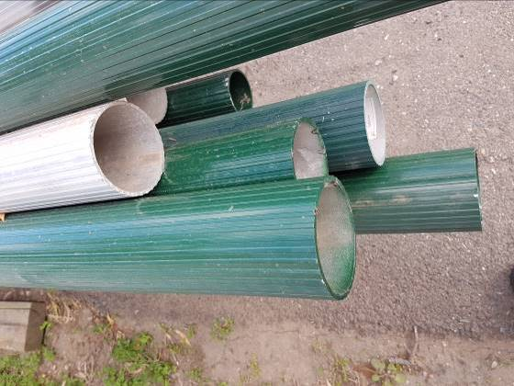 | 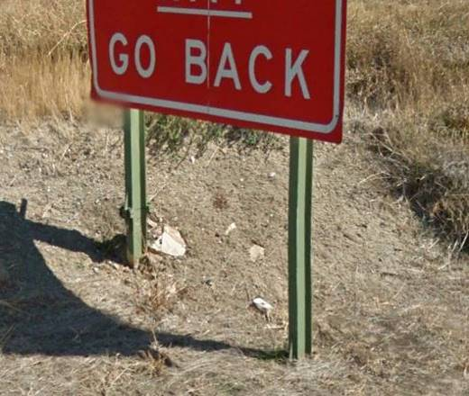

Steel Flex | Poly-flex
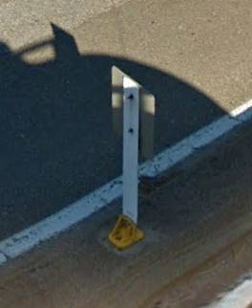 | 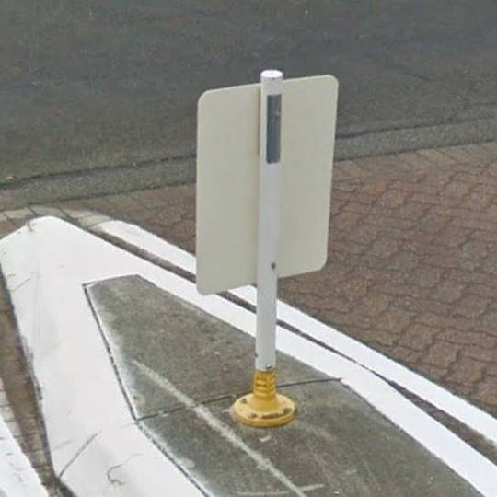

Frangible
All 80x40 posts are frangible.
Circular posts may not be considered frangible depending on the speed environment. Refer to table below for assistance (Master Specification R49).

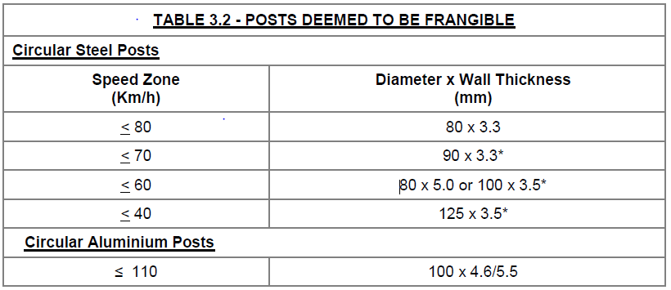

  - Signs
Types
Refer to DPTI ‘s Standard Road Sign Index Link for sign type information:

http://www.dteiapps.com.au/signindx/Search.aspx

Regulatory RX - R Series
Warning RX – W Series
Guide GX – G3 series, G6 Series, G7 (Standard), G9 (Standard), G10 Series, GE6 Series,
Hazard DX – D Series

Note: Against the sign type the size code (i.e. A, B, C, D) shall be added for all signs.

A TES number shall be included for the following signs:

Tourist – G8 Series (non Standard), G11 Series, GE11 Series (TOUR)
Service – G7 Series (non Standard) GE7 Series (SERV)
Information –G4 Series, GE4 Series (REAS), G9 (non standard), Information (INFO),
Road Safety (RSS)
Direction – G1 Series (AD/ASN), G2 Series (ID), GE1 Series (AD/ASN), GE2 Series (ID)
Maintenance Marker (TES 13824)
Other – Warning (WARN), Regulatory (REG), Misc (MISC),
Road Side Significant Sites (TES 12564), Bikeway (BKWY), Tunnel (TUNL)

Note: Sign code for TES signs use information given in the G series or brackets above.

Refer to DPTI Sign Map Server for to obtain the TES number and sign information:

http://itims.dpti.sa.gov.au/Asset/Signs/

MAINTENANCE MARKERS (TES 13824) | ROAD SIDE SIGNIFICANT SITES (TES 12564)
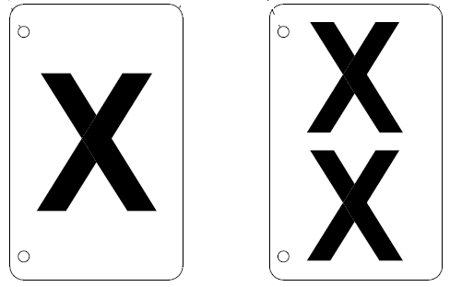 | 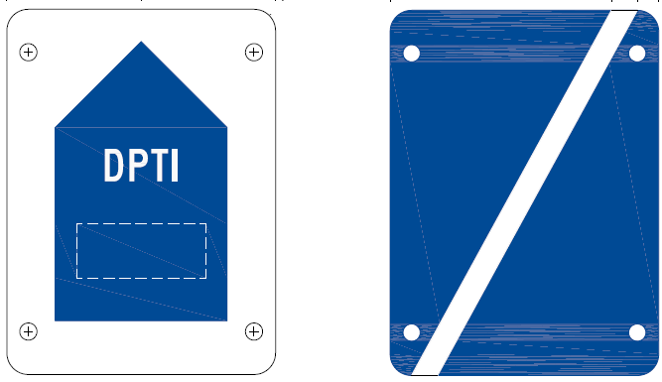

Dynamic Type
Static | CMS – Changeable Message Sign
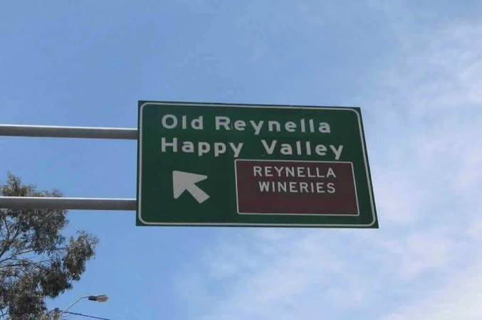 | 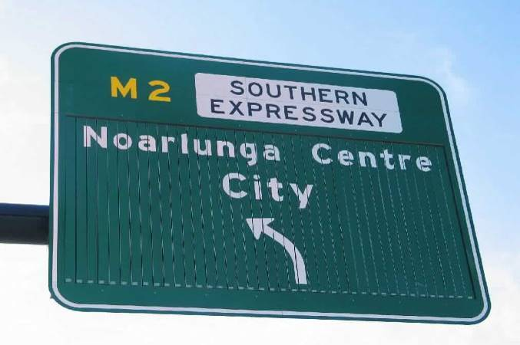

VMS – Variable Message Sign | Static & Lights
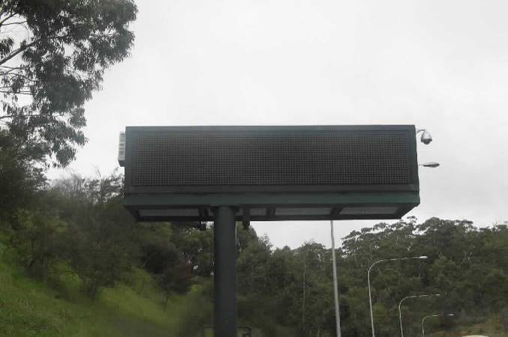 | 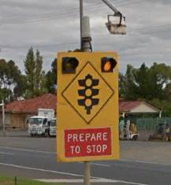

  - Safety Barrier
Barrier Types
Backing Rail
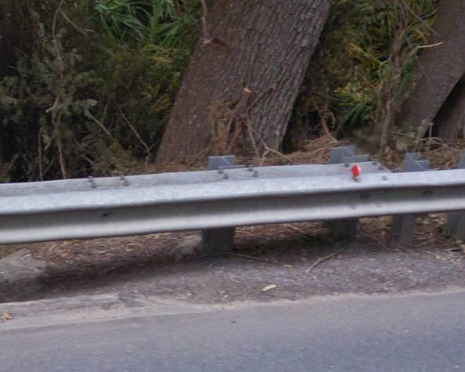 | 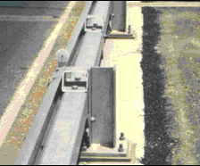

Bridge Rail
TBC

Concrete Barrier
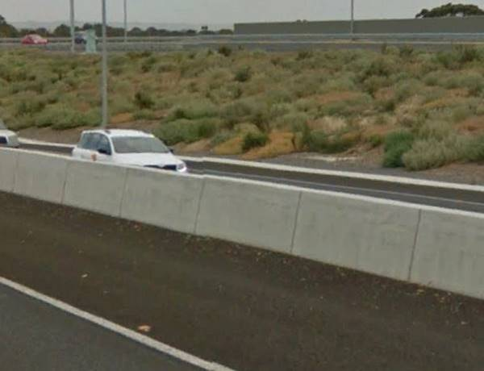 | 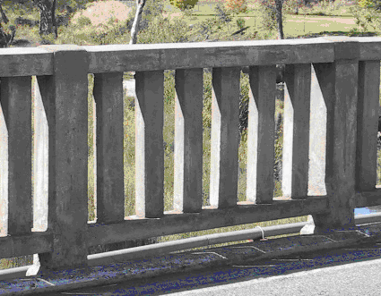

Thrie Beam
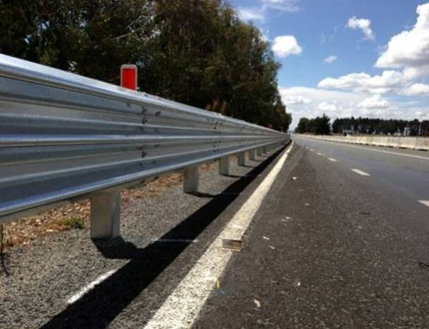 | 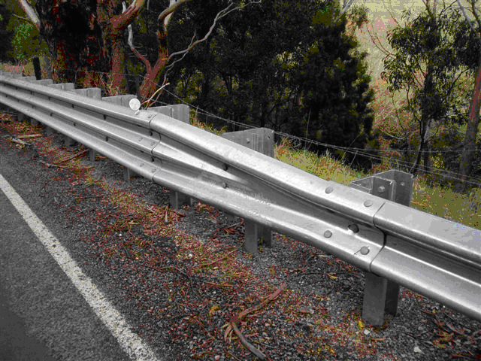

Wire Rope Briffin
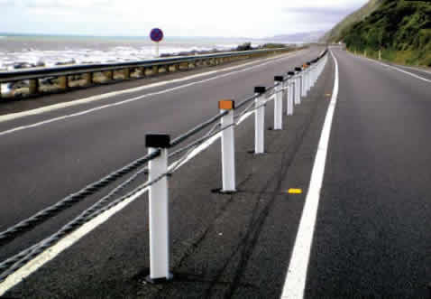 | 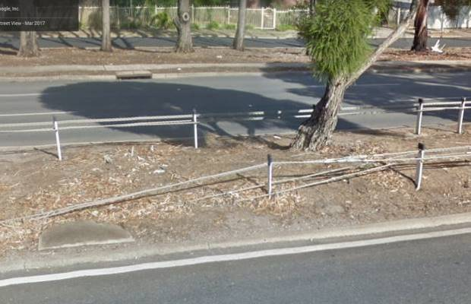

Wire Rope Sentryline
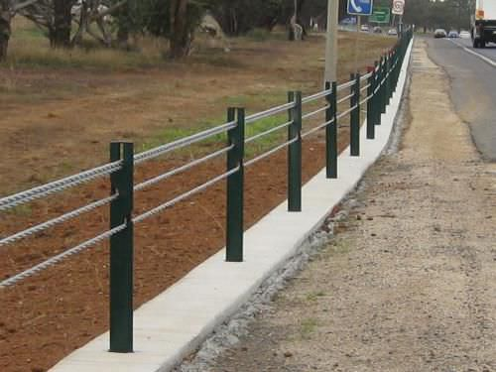 | 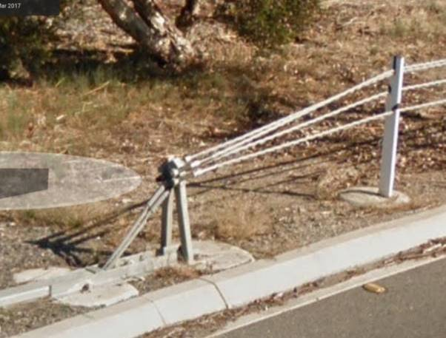

Wire Rope Flexfence
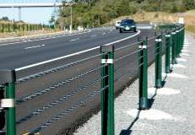 | 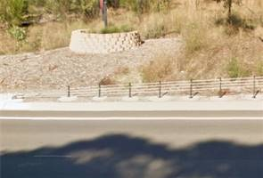

Ezy-Guard Smart | W Beam
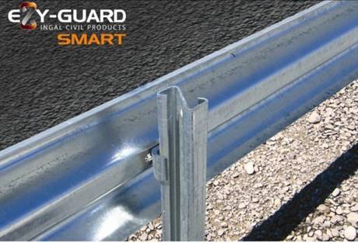 | 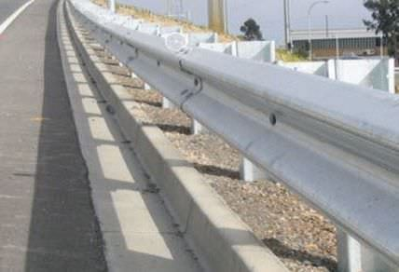
“Z” shaped posts, no spacer

Armorguard | BarrierGuard Gate
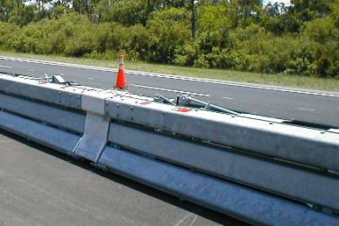 | 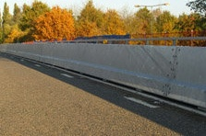

Masonry Wall
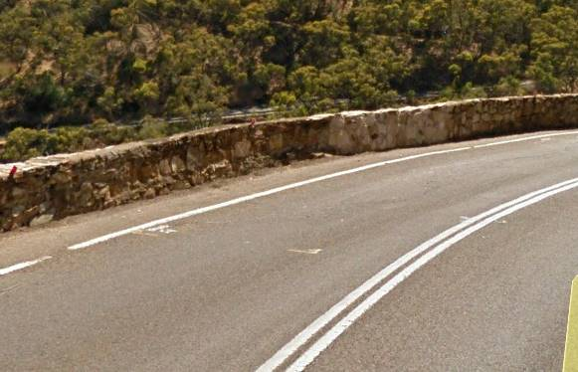 | 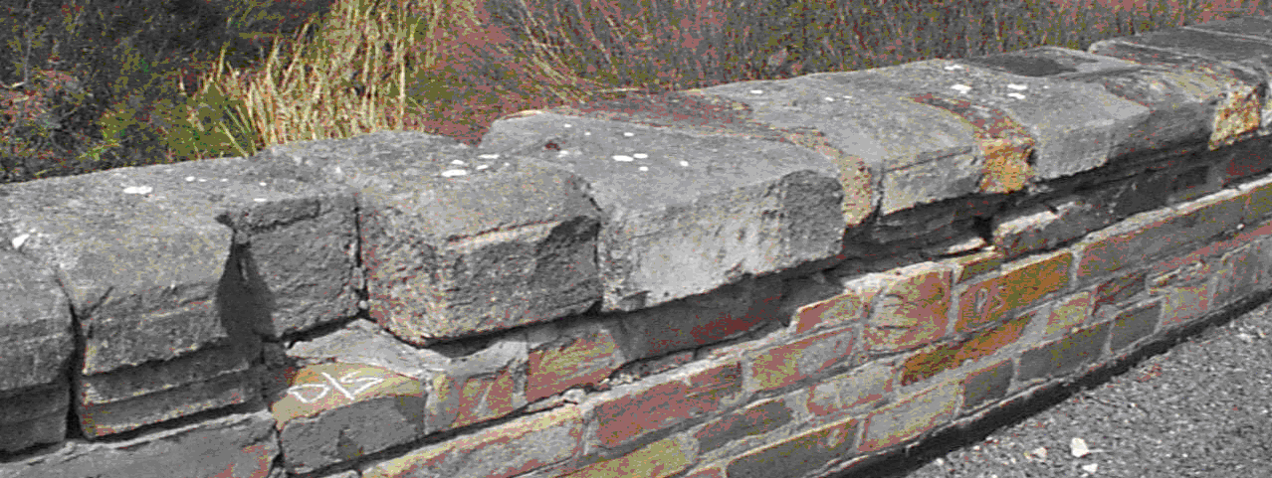

Aluminium RHS
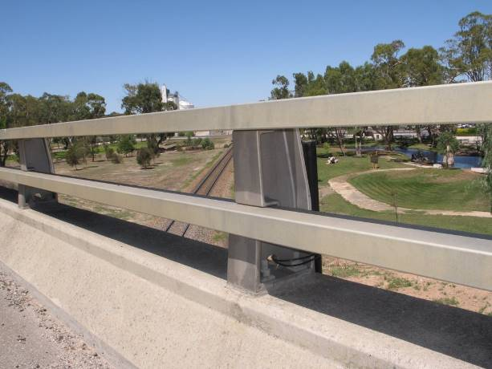

Steel RHS
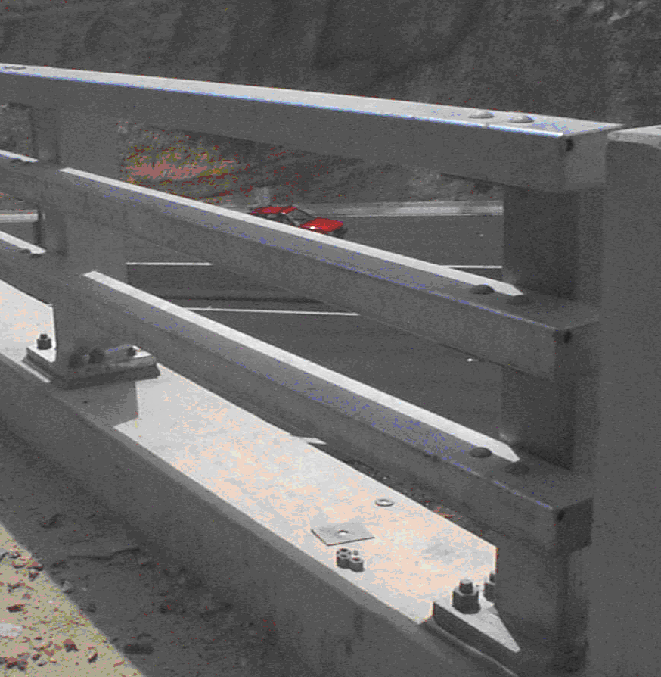 | 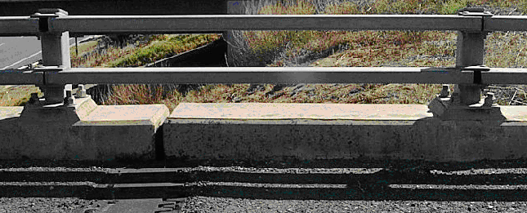

Steel Panel
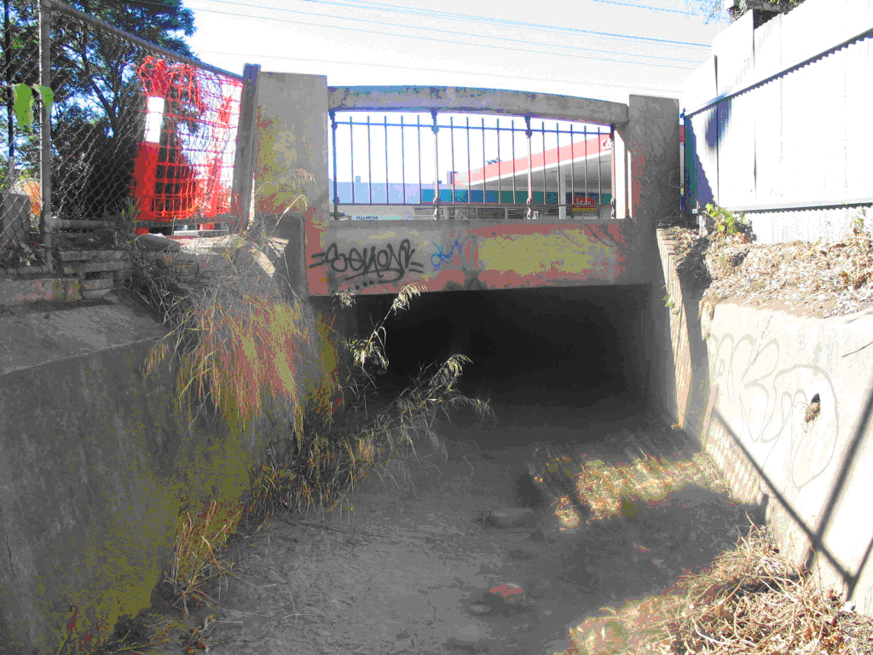

Steel Pipe
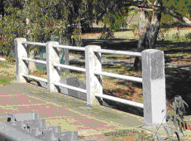 | 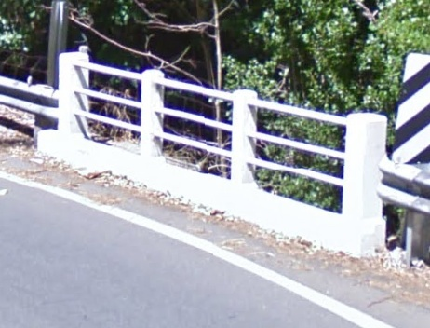

Sentry W-Beam
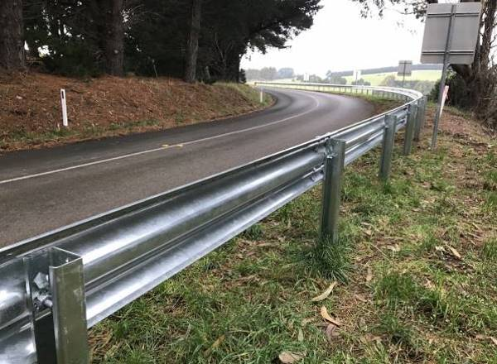 | 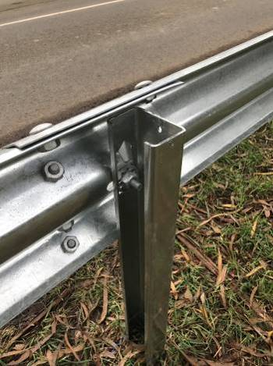
“C” shaped posts, no spacer. Smaller that traditional W beam posts.

Ezy-Guard High Containment
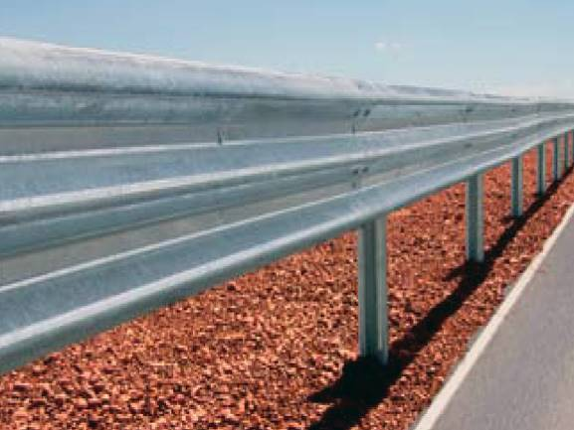 | 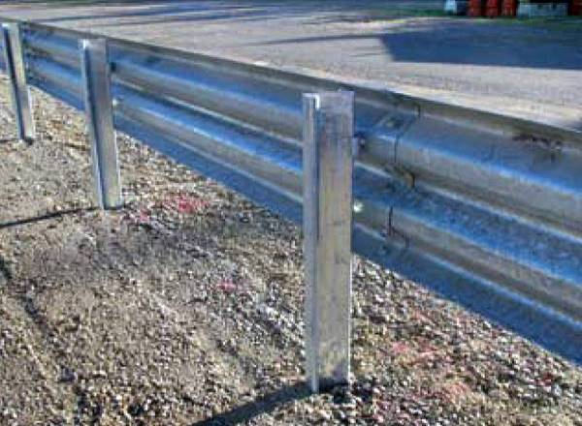
“Z” shaped posts & no spacer

  - Terminals
Type
MELT – Modified Eccentric Loader Terminal
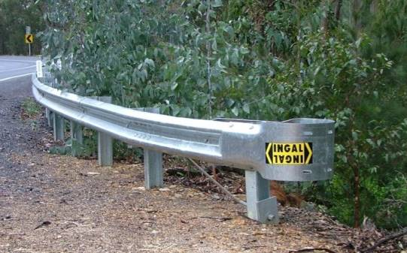 | 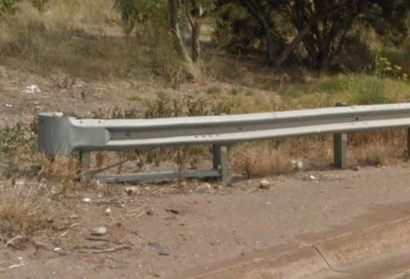
Melt (Older Assembly) | Melt (Current Assembly)
- Melts Terminal Length are 12m long.
- Trailing Melt terminals (End) of 4m in length maybe used where there is no possible impact from opposite direction.
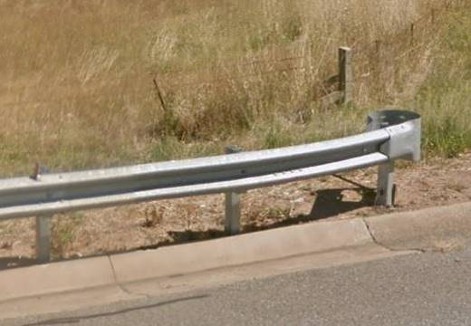
Trailing Melt terminal

BCT – Breakaway Cable Terminals
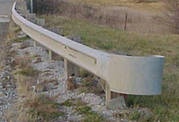
Typically made with wooden posts with plate at the front and the first 2 post having holes.
- BCT Start Terminal Length is 8m long, however there are some that are 4m long.
  - For 8m lengths first 2 posts are wooden, group of posts closer together or not bolted to the post (like Melts), followed by 2 posts of standard distance apart.
  - For 4m lengths first 2 posts are wooden then 2 posts of standard distance apart.
- Trailing BCT terminals (End) are generally 4m long.

SKT – Sequential Kinking Terminal
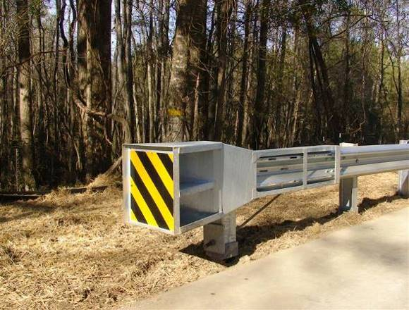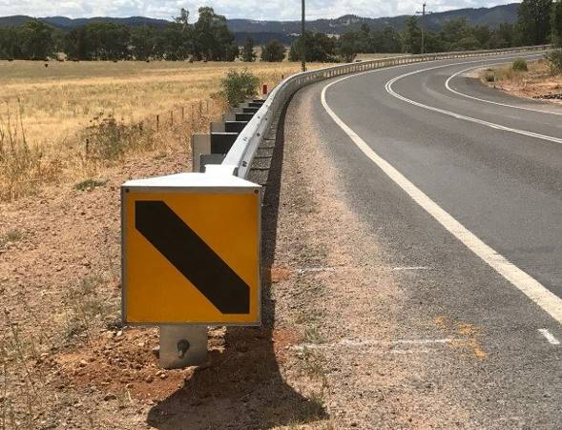
SKT (Supplied by Safer Direction) are a square head. Installation is generally straight, but can flared by a maximum of 600m from rest of the barrier.
- Terminal Lengths are 8m or 16m
- End of the terminal is at the location which the black spacer blocks finish

FLEAT – Flared Energy Absorbing Terminal
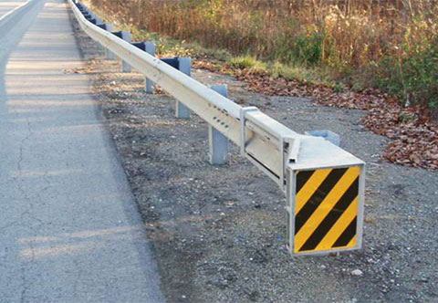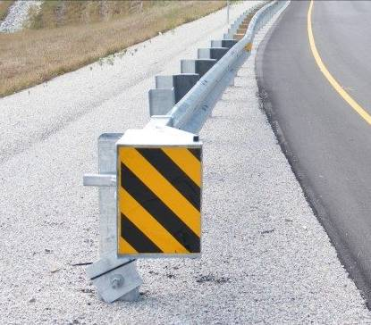
FLEAT (Supplied by Safer Direction) have a rectangular head. Generally flared installation.
- Terminal Lengths are 8m or 12m
- End of the terminal is at the location which the black spacer blocks finish

ET-2000 Plus – Extruder Terminal
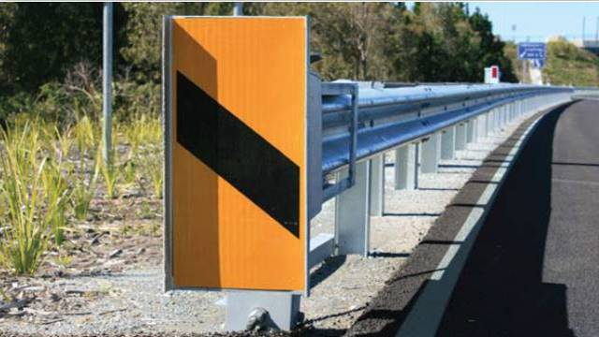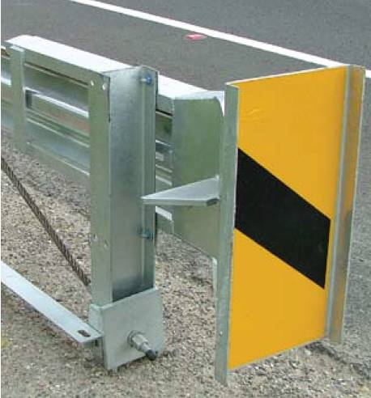
ET-2000 Plus (Supplied by Ingal) has Rectangular head. Key difference between an ET-2000 and FLEAT is the strut installed in between the first and second post.
- Terminal Lengths are 8m or 16m
  - 8m lengths are only to be used in speed environments of less than 70km/h.
  - 16m length can be used at any speed.
- End of the terminal is at the location which the black spacer blocks finish

TREND 350
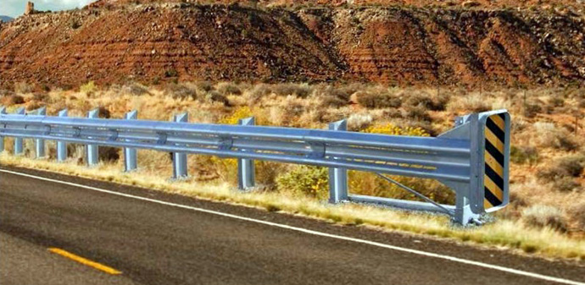
TREND 350 (Supplied by Ingal) is a Rectangular noise. Key difference between a TREND 350 and ET 2000 is continual cut openings along the length of the W section of the terminal. There is no cage to guide the head along the W beam.
- Terminal Lengths are only 12m long.
  - Can only be used in speeds less than 100km/h

X-Tension
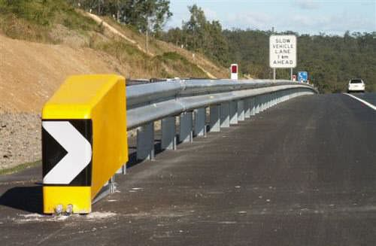
X-Tension (Supplied by ACP) is easily identified with the large yellow head.
- Terminal Lengths are only 12m long.

Fishtail Terminal
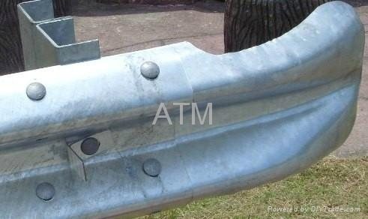
Fishtail terminals are 0.75m length. Should only be use where there isn’t any possibility of spearing if impacted by vehicles.

Omni Stop End
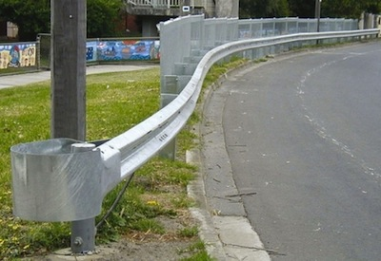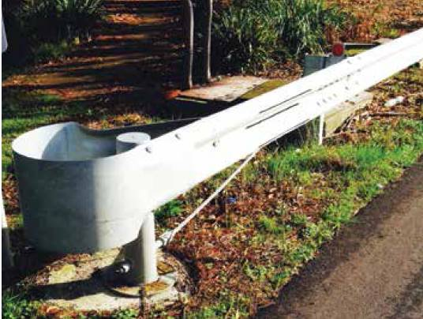
Omni Stop End (Supplied by Safer roads) may get confused by a Melt with the end barrel; however the key difference is the circular end post vs the traditional C section posts.
- Terminal Lengths are only 2.5m long.
  - Can only be used in speeds less than 70km/h

Driveway
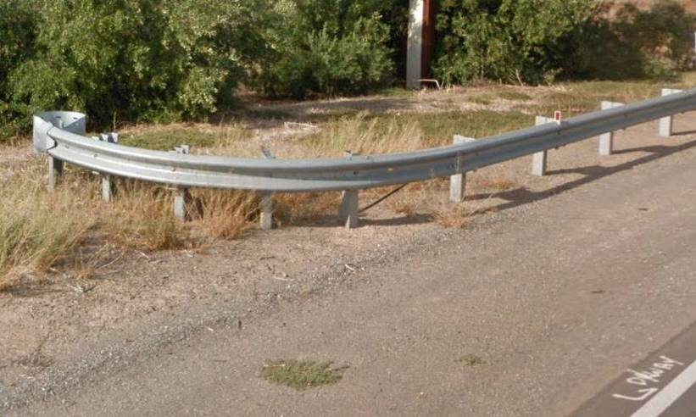
Driveway terminals are constructed the same way as Melts or BCT, however the terminal turns 90 degrees compared with the slight flaring of the terminal. Used for opening into driveways or roads.

QuadGuard | Smart Cushion
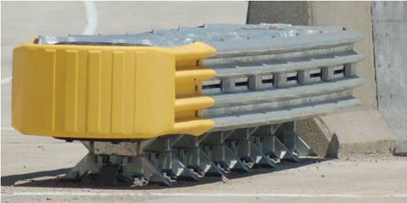 | 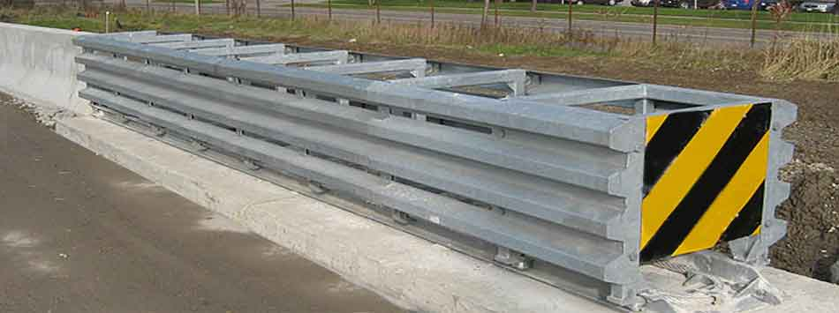
Single sliding mechanism in the Centre | Square shaped no barrels along

Universal TAU-II | TRACC
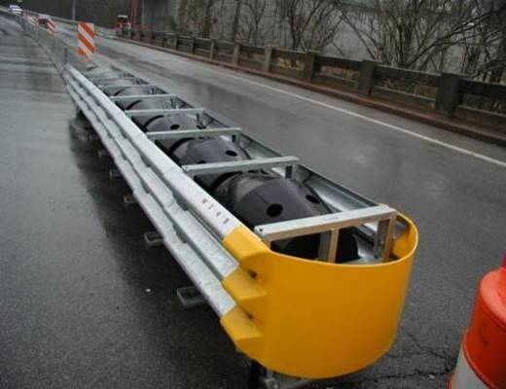 | 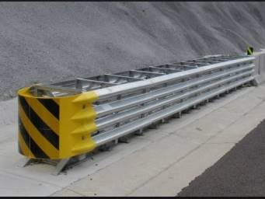
Thrie Beam along the side | Dual sliding Mechanism on the sides.

EAPTB Stobie Buffer | Treefend
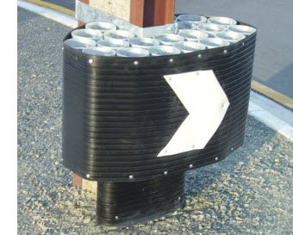 | 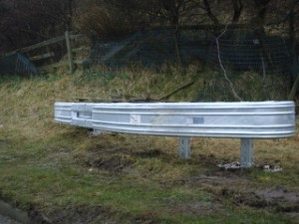

RAPTOR
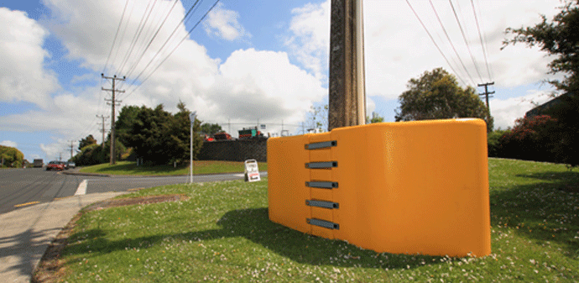

  - Motorcycle Protection
Types
Stack Cushion
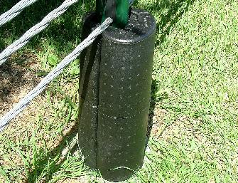

MPR
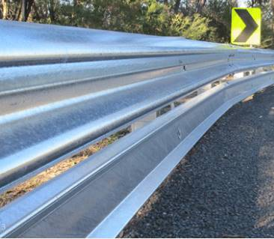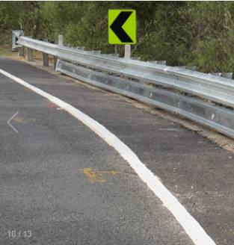
MPR can be identified with the ridge at the top and bottom.

HIASA SPM-ES2
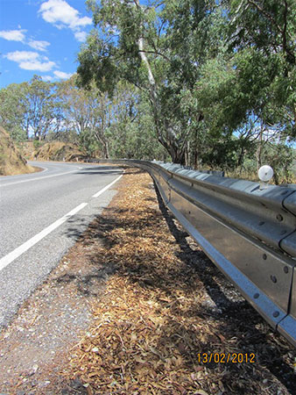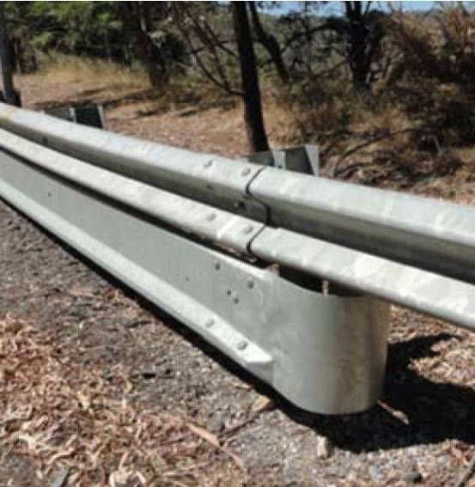
HIASA SPM-ES2 can be identified with the ridge only at the bottom.

  - Drainage
Types
Pipe Culvert
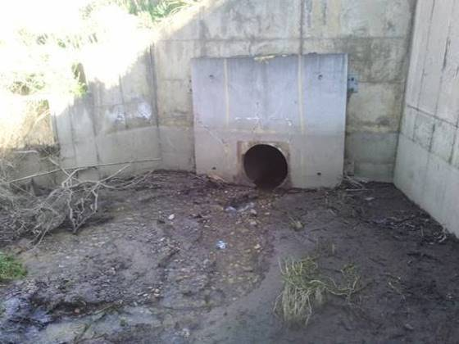 | 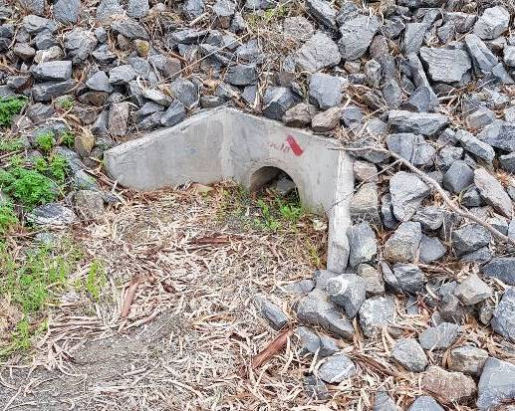

Box Culvert
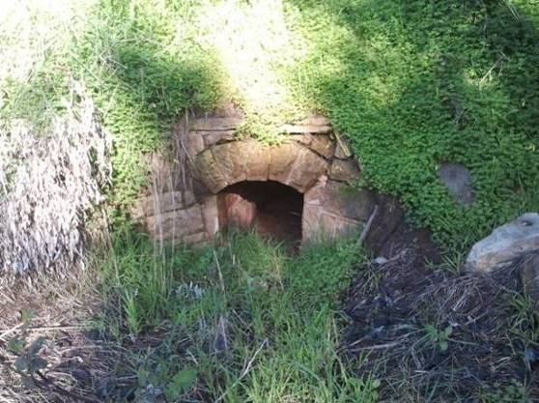 | 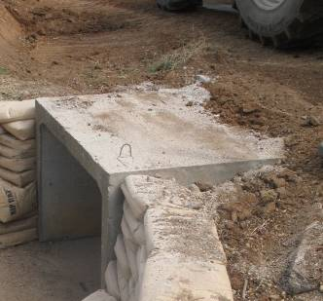
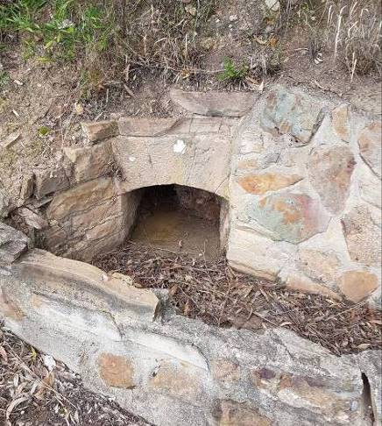 | 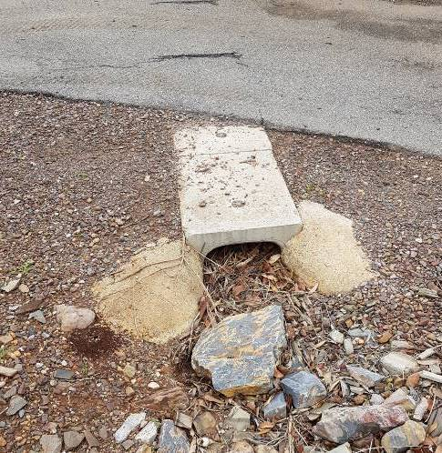

Subsoil Drain
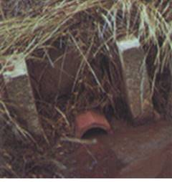 | 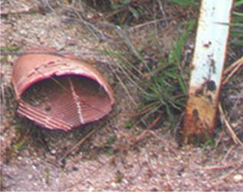

Grate
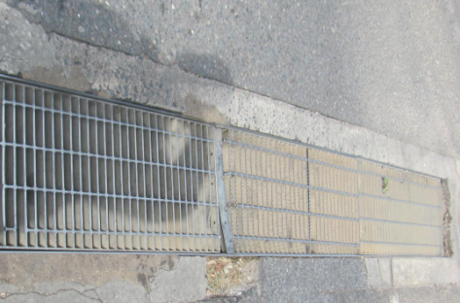 | 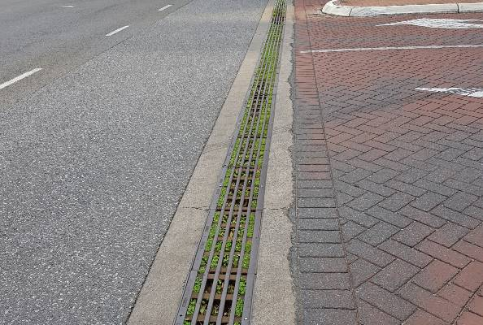

Lined Drain
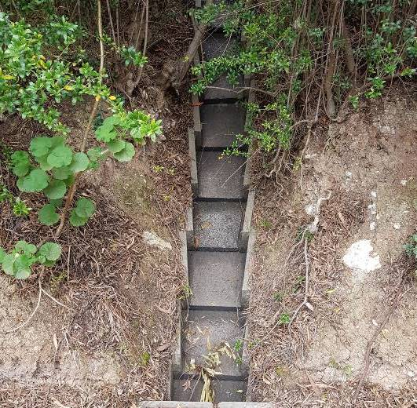 | 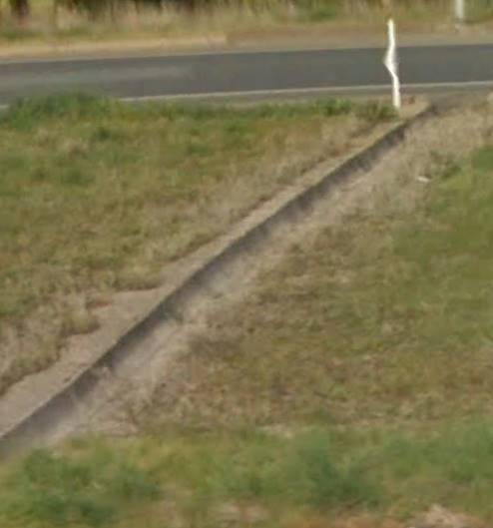

Swale
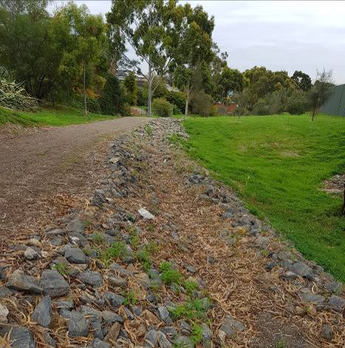 | 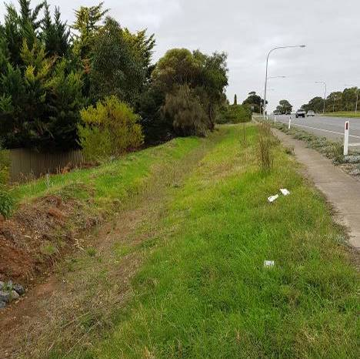

Bioretension Swale
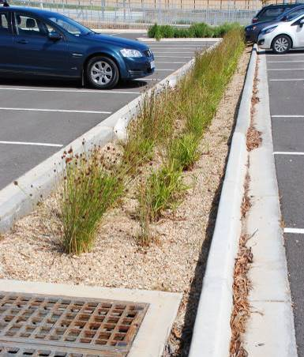 | 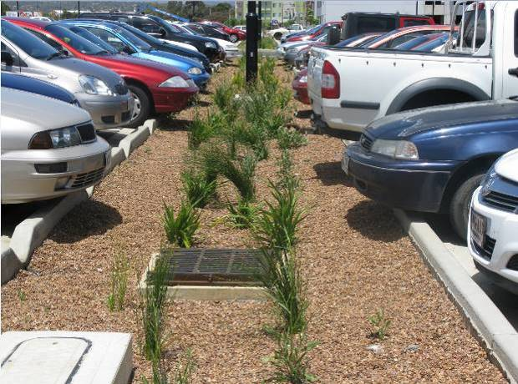

Arch
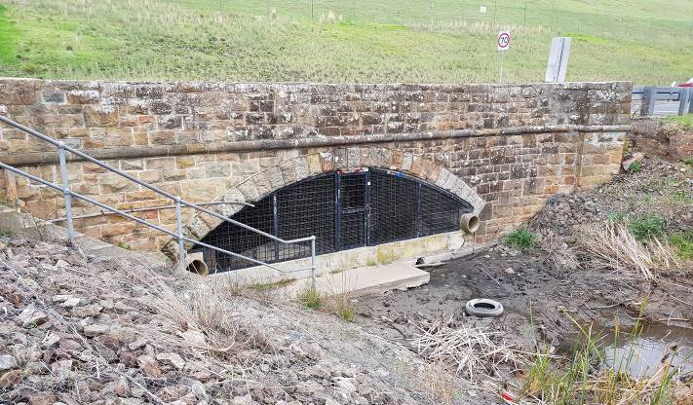

Wetland
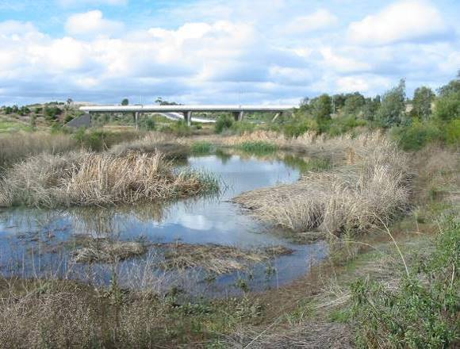 | 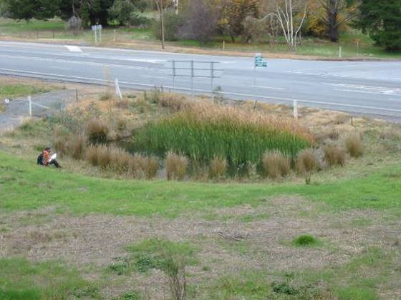

Sedimentation Basin
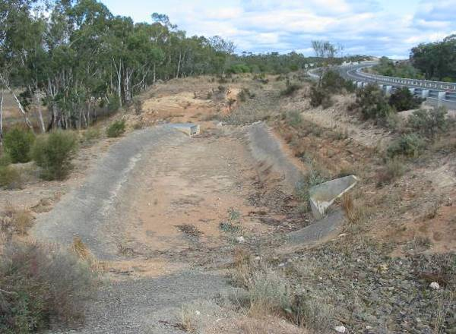 | 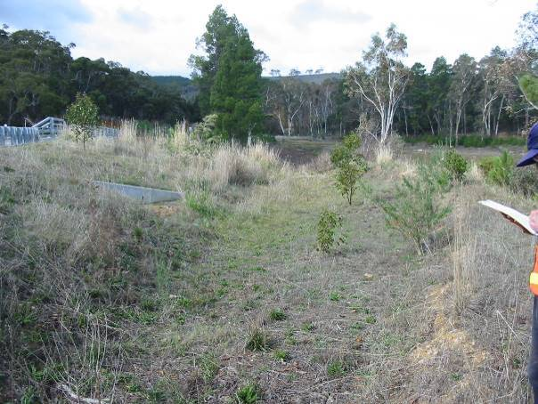

Detention Basin
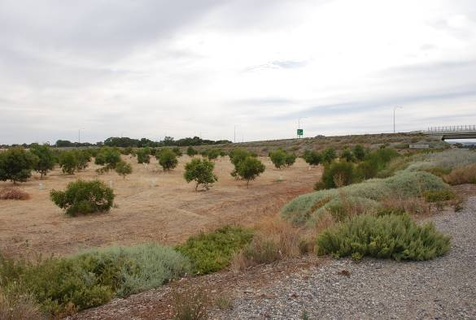

  - Inlet / Outlet / Junction
Types
Headwall
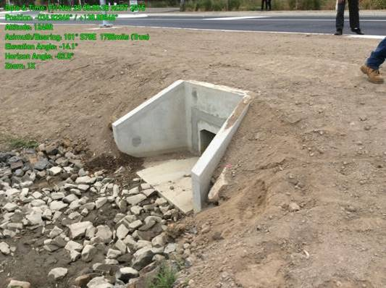 | 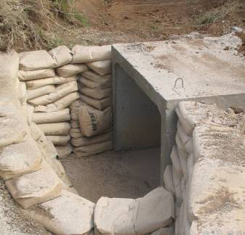

SEP
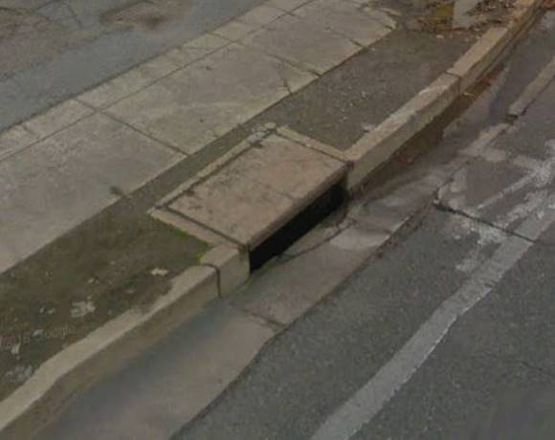 | 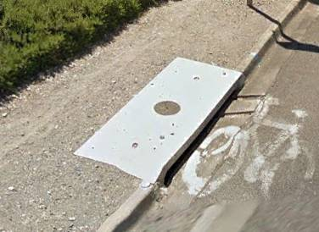

Grate
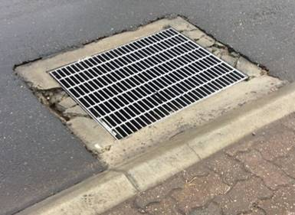 | 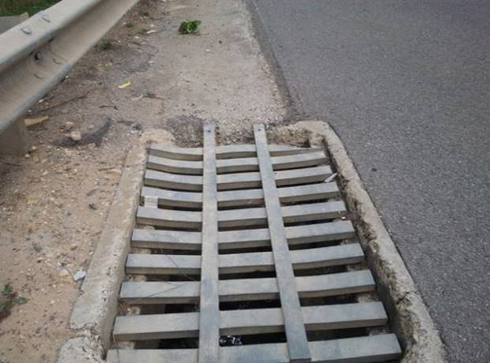

SEP / Grate Combo
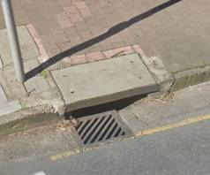 | 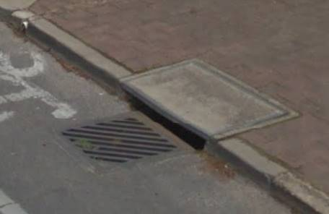

Field Gully
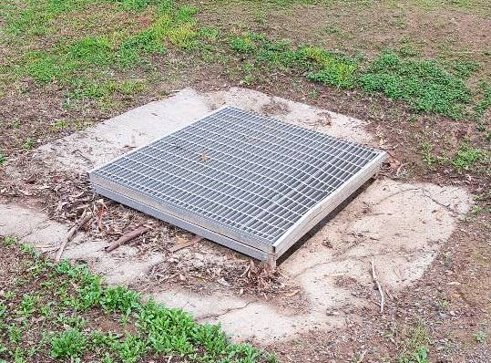 | 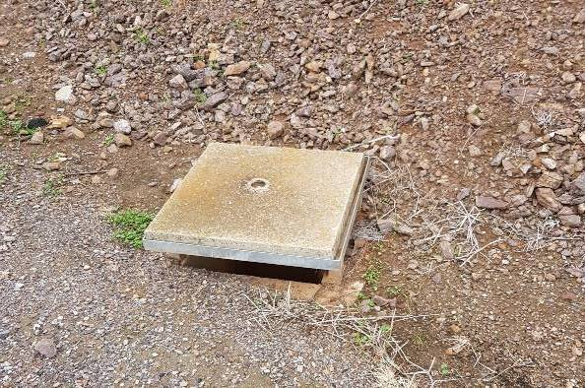

Junction Box
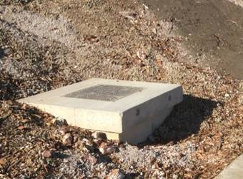 | 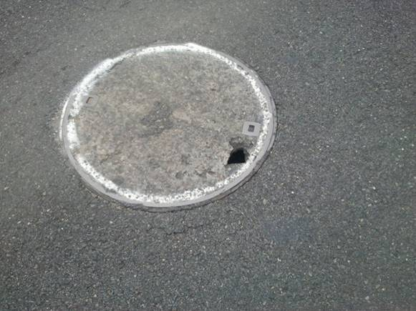

HUMEceptor
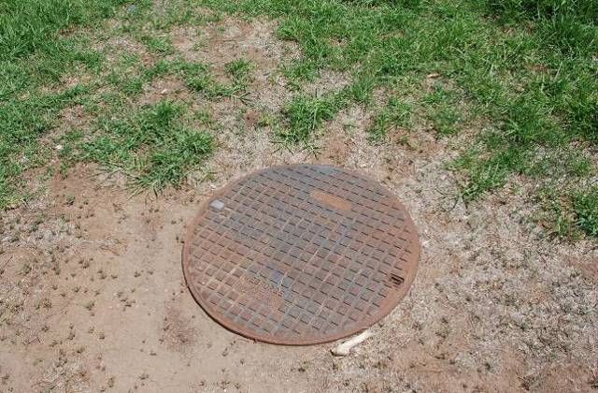

Stormceptor
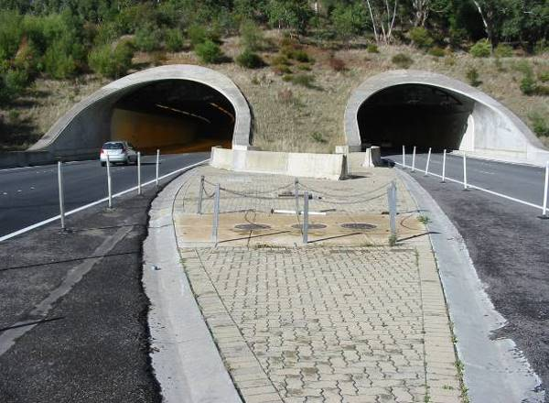 | 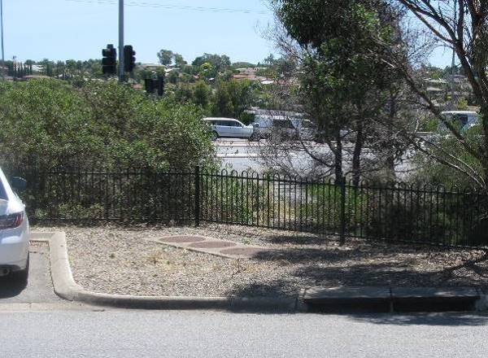

Downstream Defender
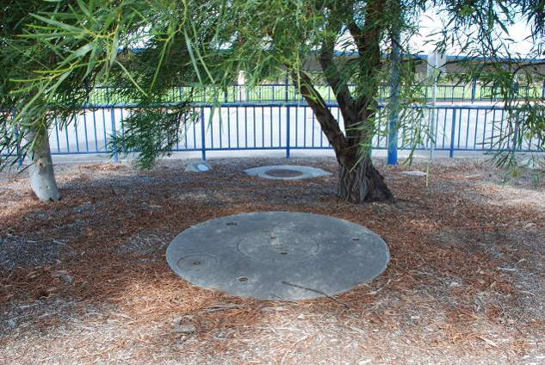

EcoSol RSF 4000
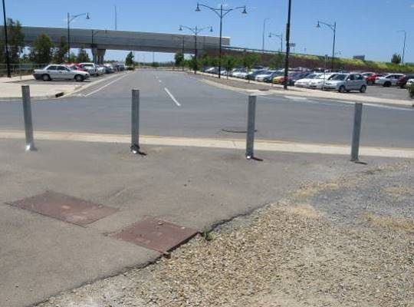 | 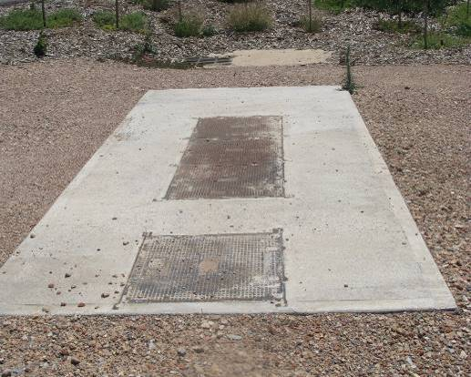

Gross Pollution Trap
TBC

Trash Nets
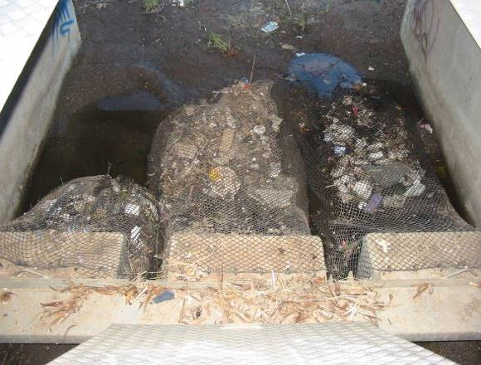 | 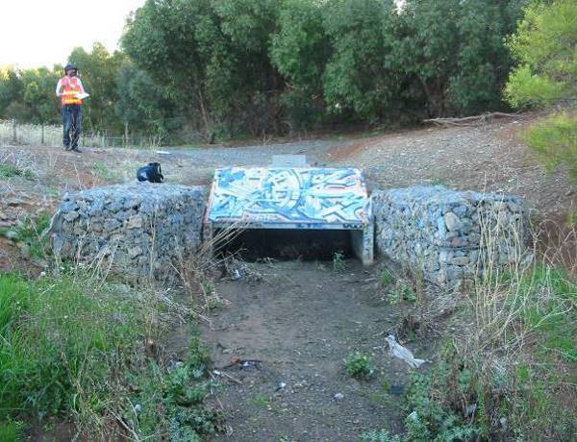

  - Fence / Gates
Types
Farm or Stock
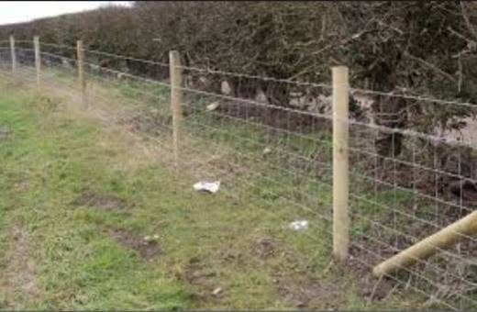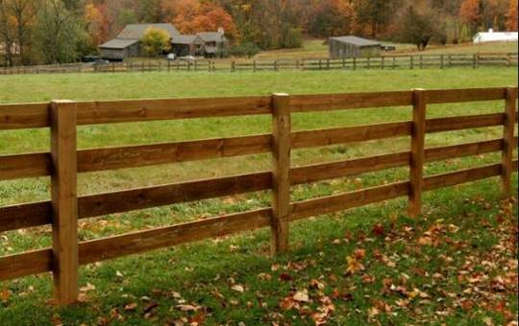

Chainmesh | Pedestrian
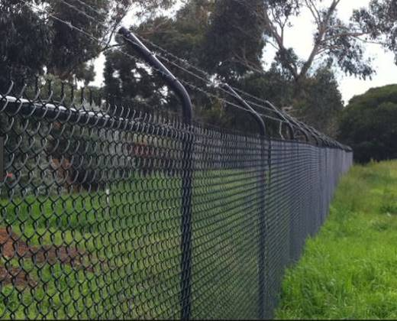 | 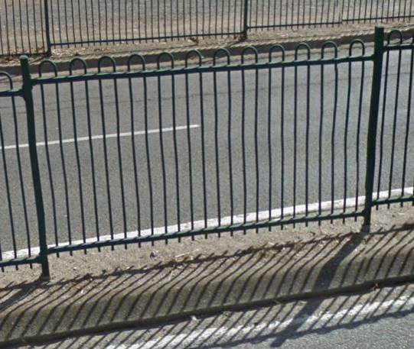

Vermin Proof | Concrete Panel
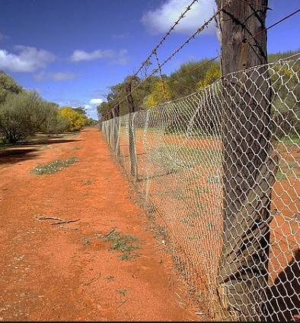 | 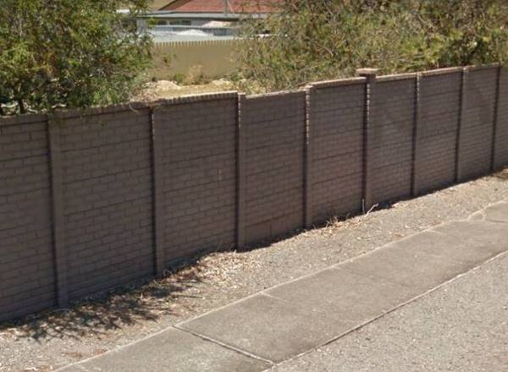

Timber Panel | Security fence
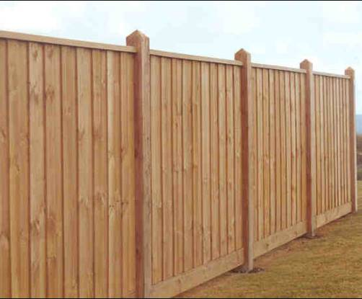 | 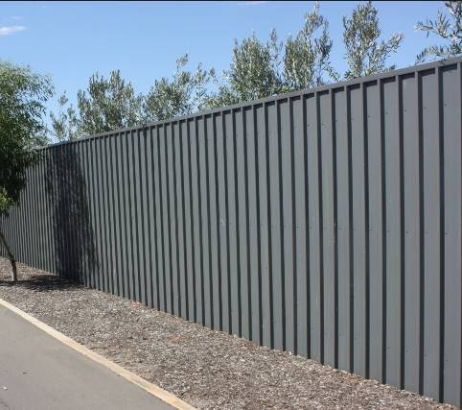

1200 Pedestrian Rail and 600 Pedestrian Rail | Stock Gate
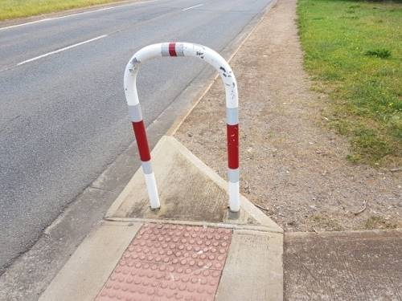 | 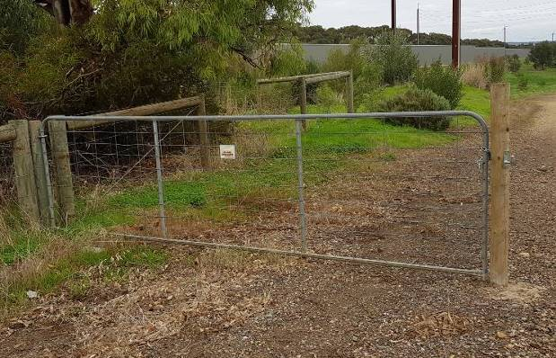

Pedestrian Gate | Security Gate
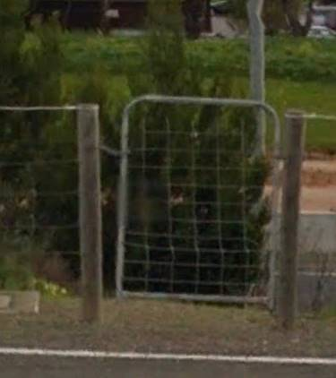 | TBC

Motorised Security Gate | Other eg
TBC | 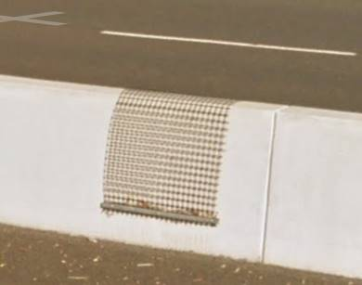
 | Other include Koala Crossing in comments add “Koala Crossing”

  - Stack Sites
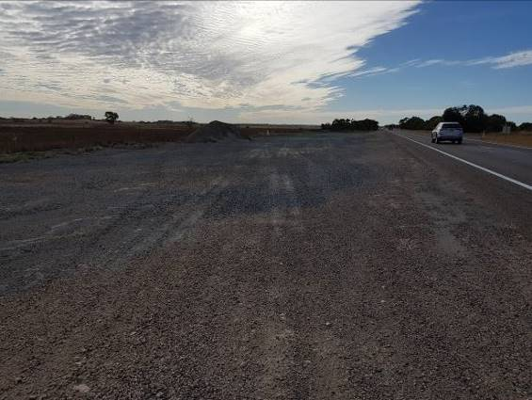

  - Retaining Wall
Types
Concrete Block | Concrete Crib
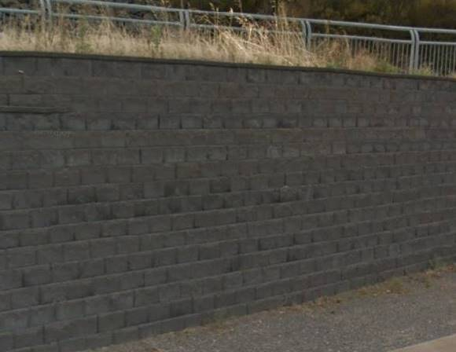 | 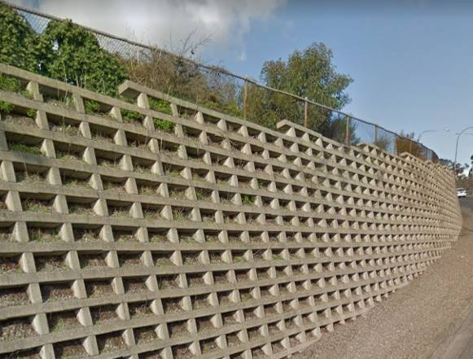

Timber Crib | Gabion
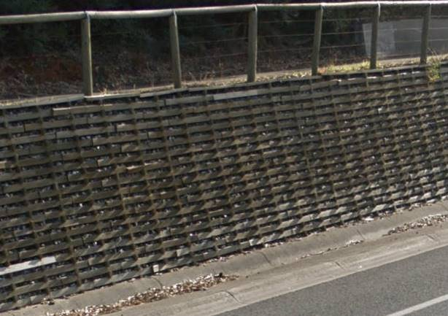 | 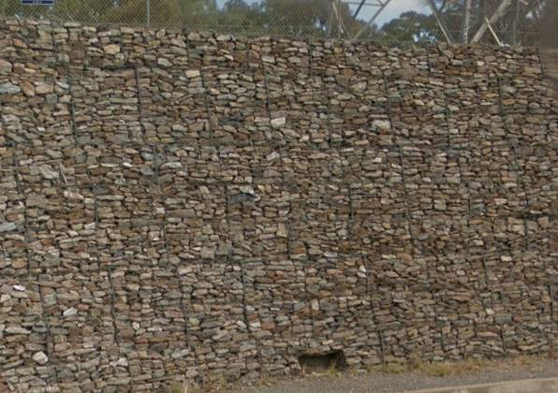

Shotcrete | Stone Walling
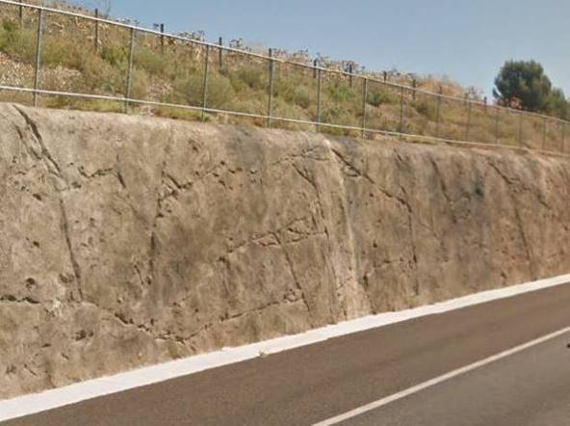 | 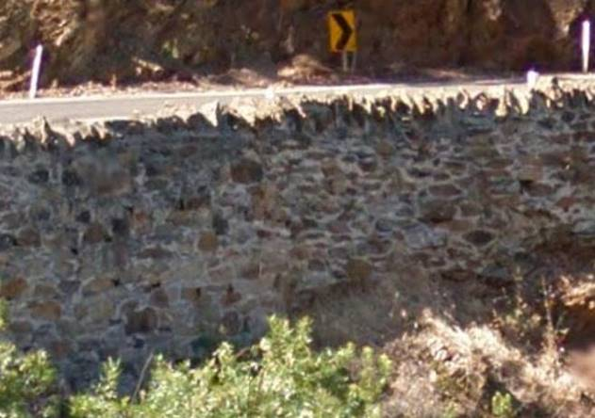

Reinforced Concrete | Reinforced Earth – Concrete Faced
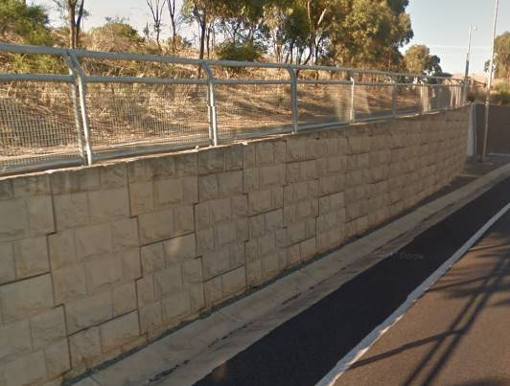 | 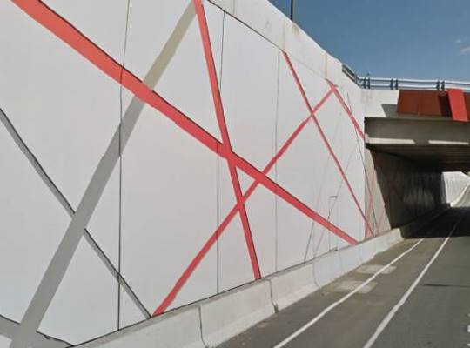

Reinforced Earth - Concrete Panel | Reinforced Earth – Gabion Faced

Reinforced Earth - Keystone | Stone Pitched
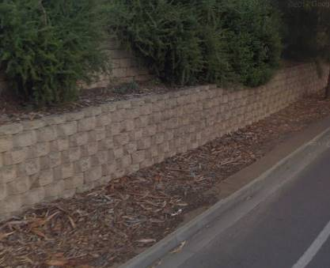 | 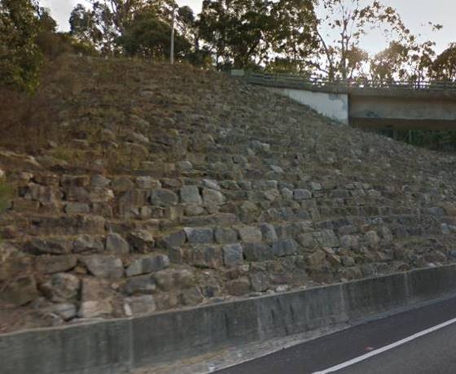

Steel Post & Concrete Panel
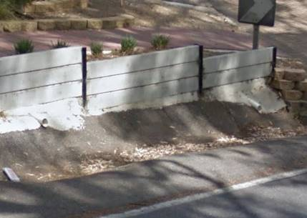

  - Rest Area
Refer to Operational Instruction 20.3 to determine if a rest area is Major, Minor or Truck Parking Truck Parking informal.

Truck Parking – Unless the rest area is signed with No Trucks Parking Symbol (S23) truck parking is recorded as “Y”

  - Bins
Plastic | Concrete
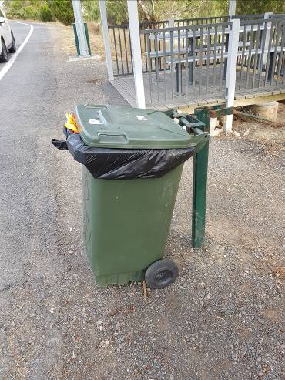 | 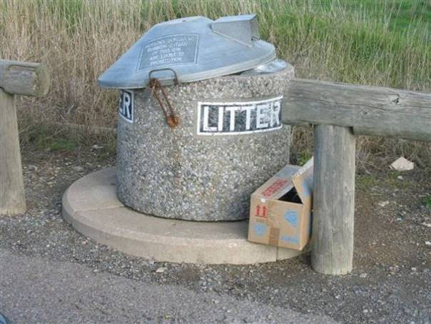

Metal | Other
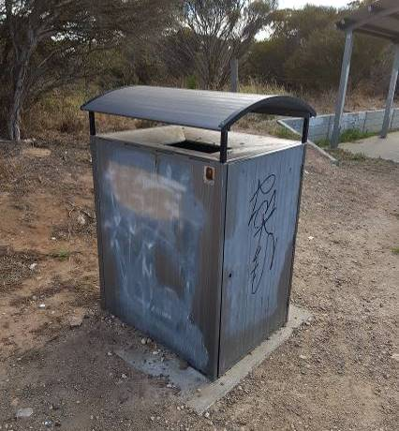 | TBC

Table
Metal | Wood
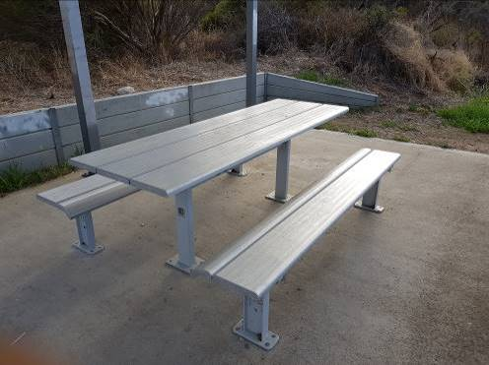 | 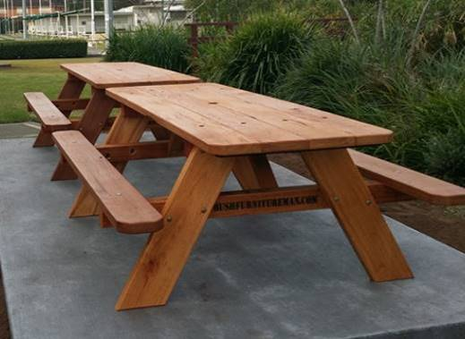

Recycled Plastic | Other
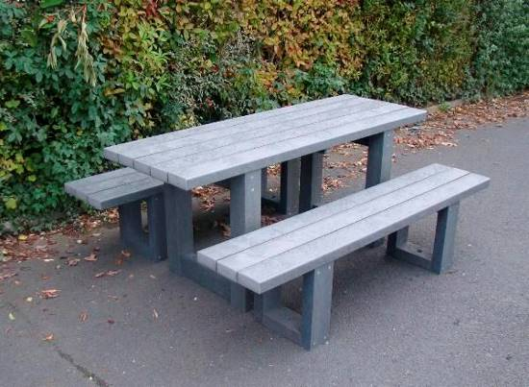 | 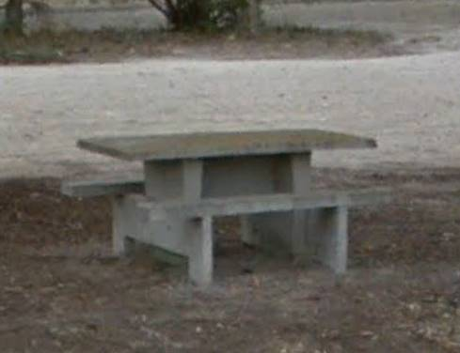

  - Shelter
Cantilever | Truss
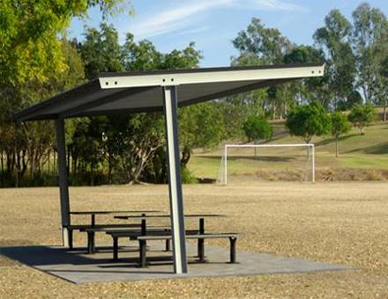 | 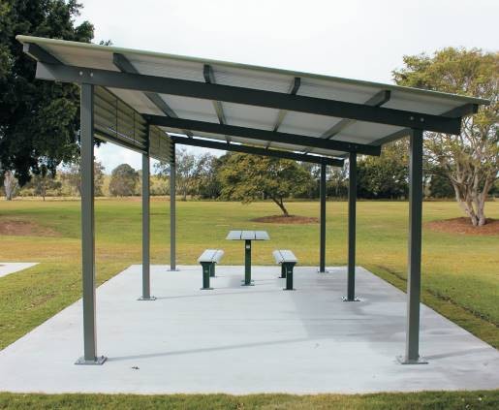

Sails | Other
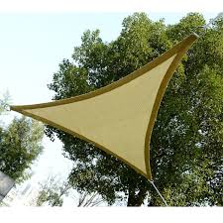 | TBC

  - Toilet Block
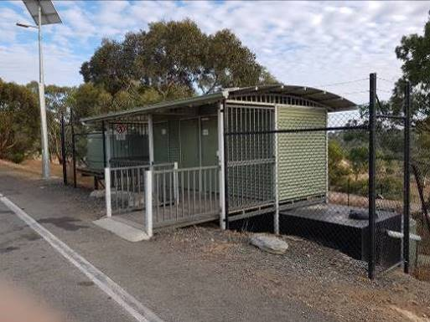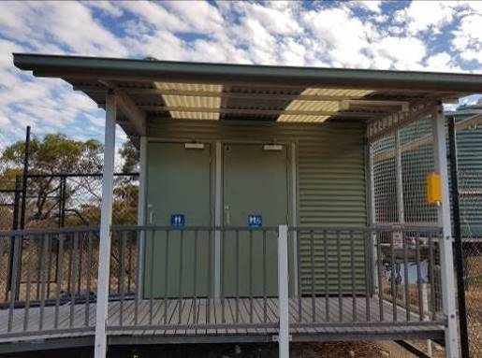

  - Water Tank
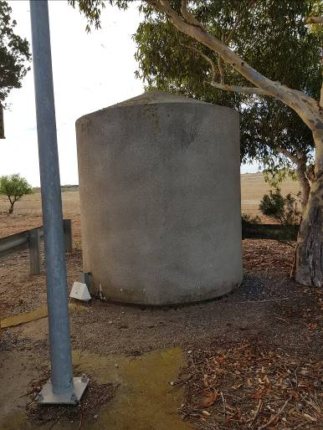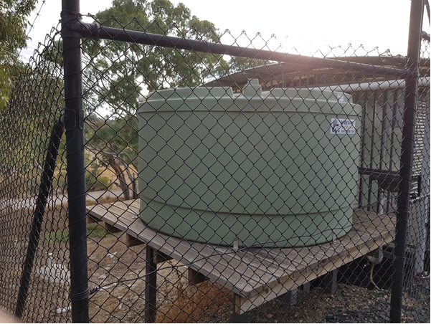

  - Median
Types
Kerbed Median | Barrier
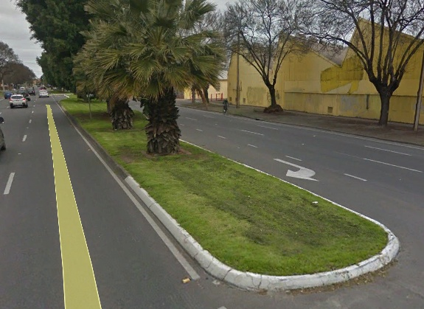 | 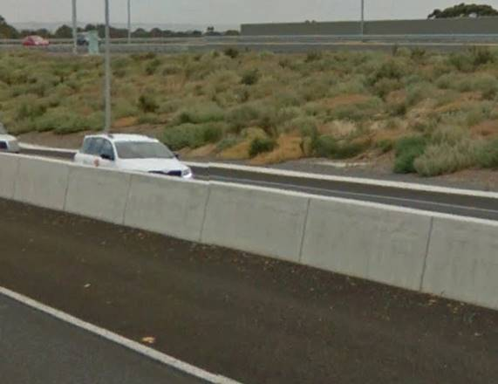
 | Median concrete barrier should also be recorded under Safety Barriers “Concrete”.

No Edge
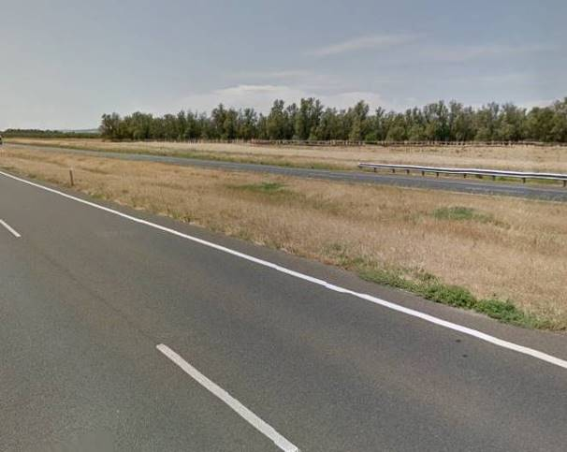

Median Infill

Infill type is for the majority of the median, unless Deciduous Trees.
Paved | Concrete
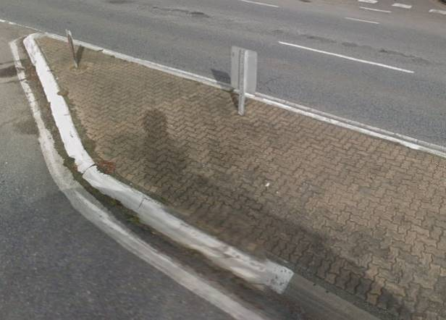 | 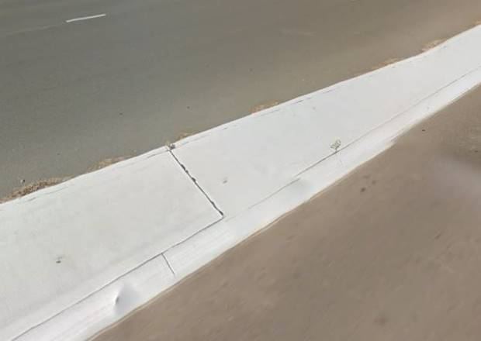

Asphalt | Synthetic Turf
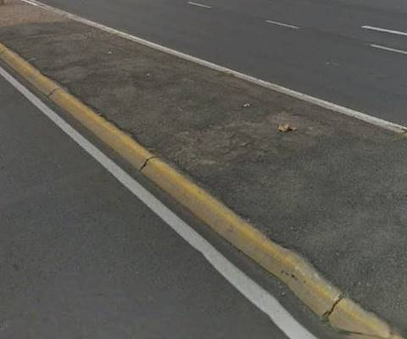 | 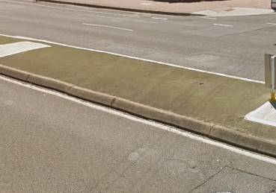

Rubble | Grassed
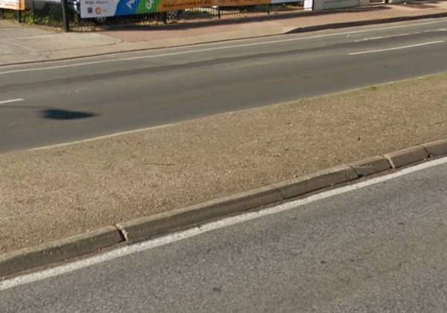 | 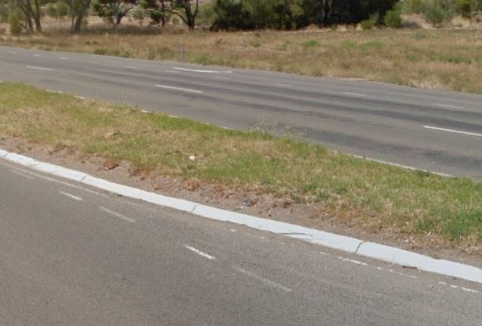

Deciduous Trees | Mulched
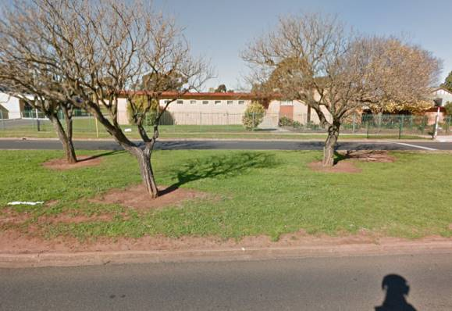 | 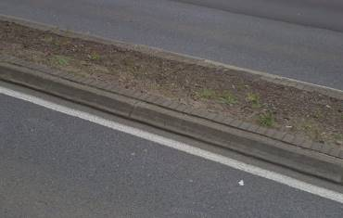

Rock Filled | Other Landscaping
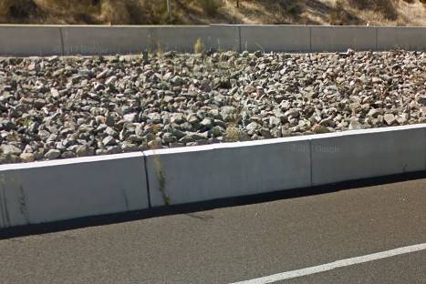 | TBC
 | If a median has multiple types (e.g. Grassed and trees) record as “Other Landscaping” and note what there is in the comments

  - Pathways
Pedestrian | Shared Use
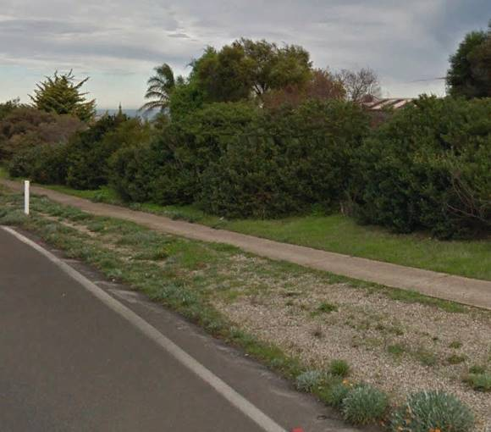 | 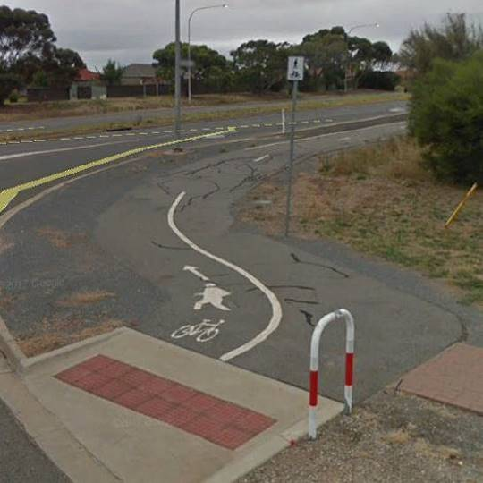
No signage footpaths | Signed with R8-2

Bicycle | Other
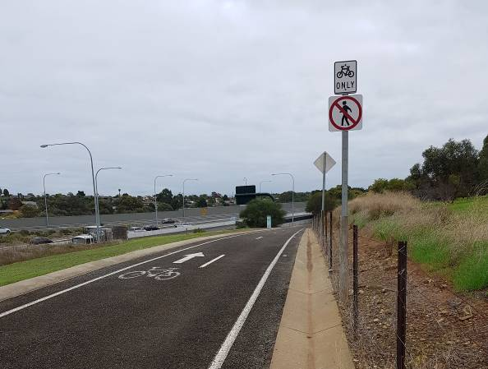 | TBC
Signed with R8-1 and/or R6-10-3

  - Bollards
Timber | Steel Removable
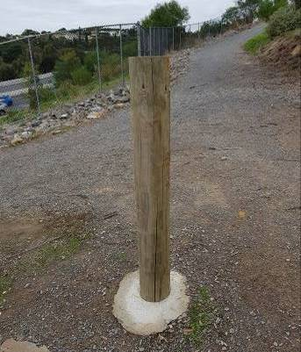 | 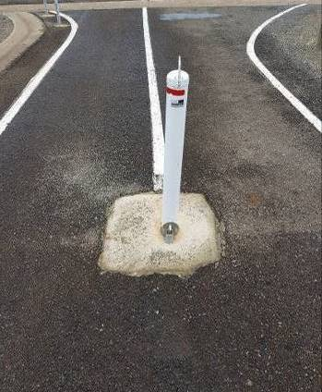

  - Windsocks


  - Arrestor Bed
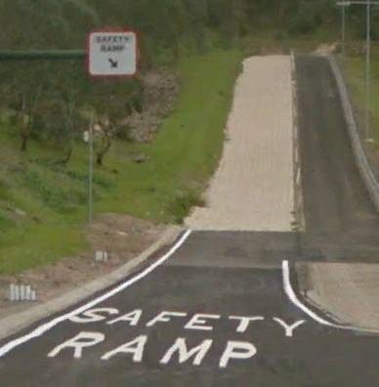

  - Weigh Stations
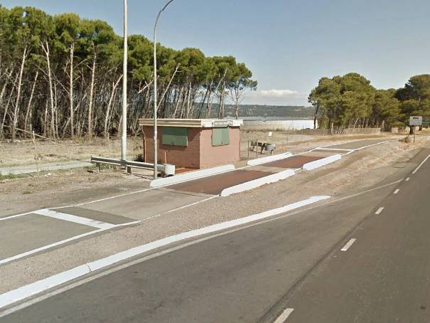

  - Park ‘N’ Ride
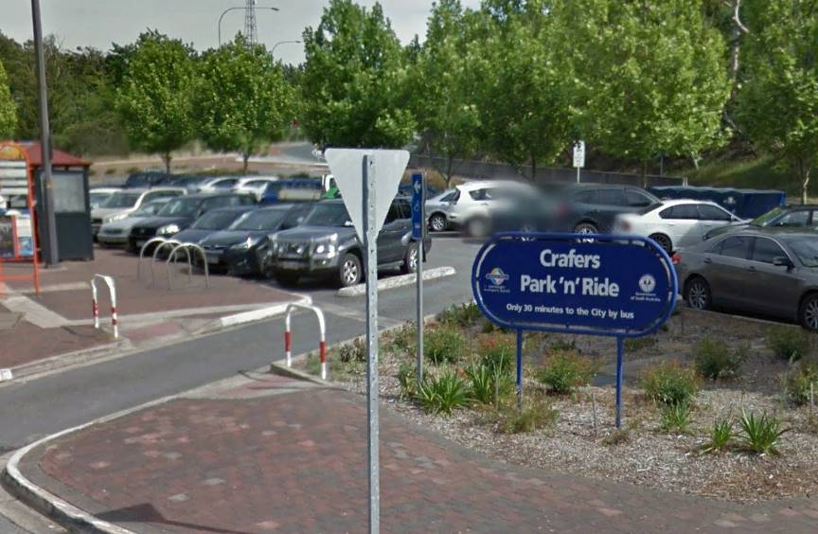

  - Roadstrips
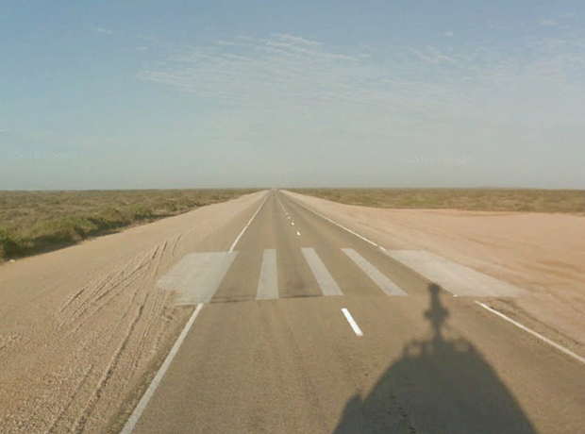 | 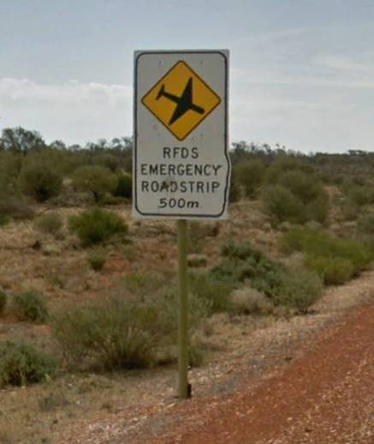

  - Grids
Types
DPTI Design and construct | Aprilla
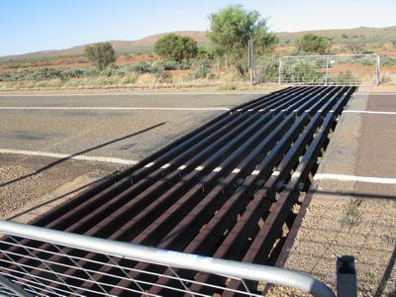 | 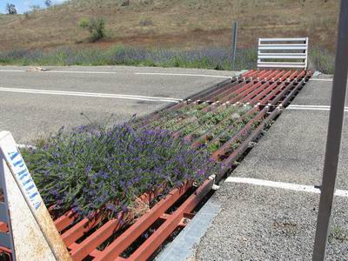

Gridrite
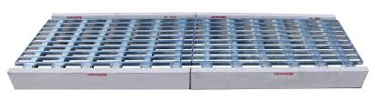

  - Floodway’s
Unsealed | Stabilised
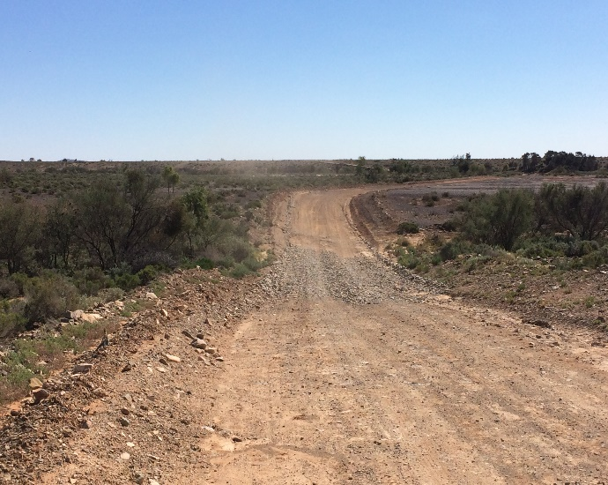 | 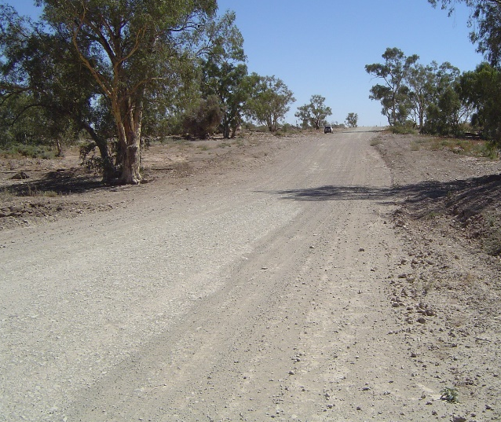

Sealed | Concrete
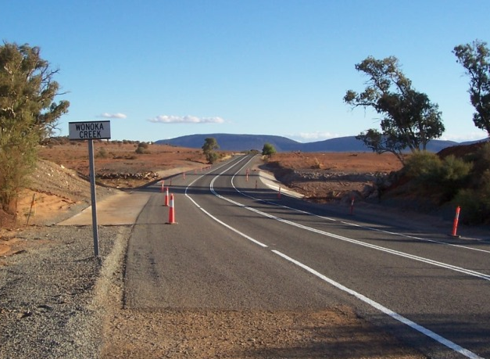 | 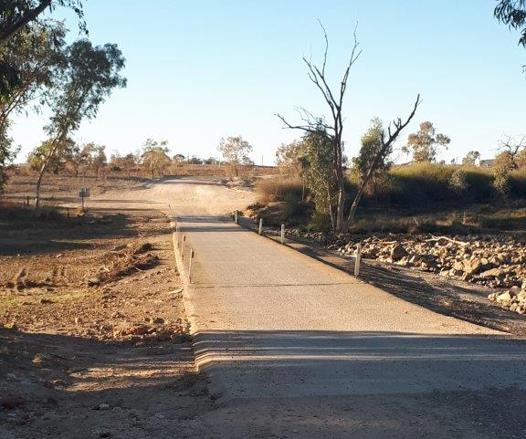

- ASSET CONDITION EXAMPLES`
Asset Condition rating within the Road and Marine Assets Data Collection Manual is provided in the Table below. Images within this section are used as a guide to assist in defining the various condition ratings.

1 | New | As new
2 | Good | No corrosion or other deterioration
3 | Average | Some deterioration but structural integrity satisfactory.  (eg. some corrosion of steel but strength not affected)
4 | Poor | Considerable deterioration so that structural integrity compromised.  (eg. steel corroded to extent that strength may be affected, cracked concrete posts)
5 | Unserviceable | Deteriorated to extent that structural integrity is severely affected.  (eg. severely corroded rail, spalled concrete posts, deteriorated timber components)

  - Sign posts
New
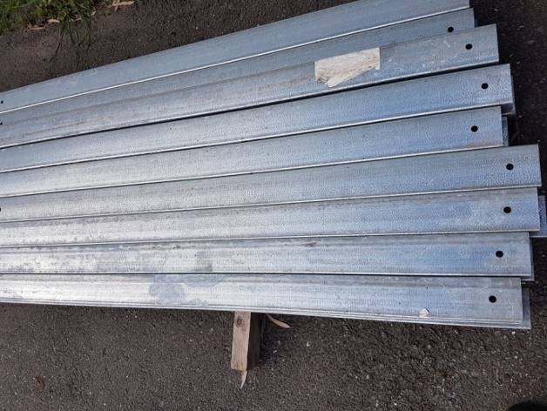

Good
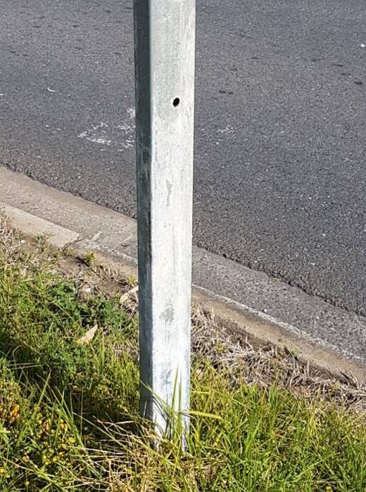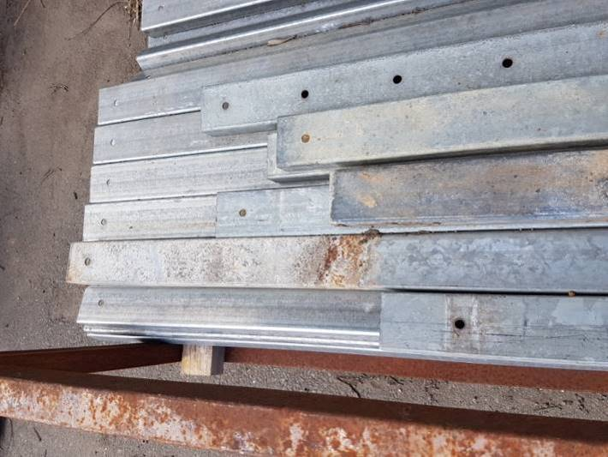

Average
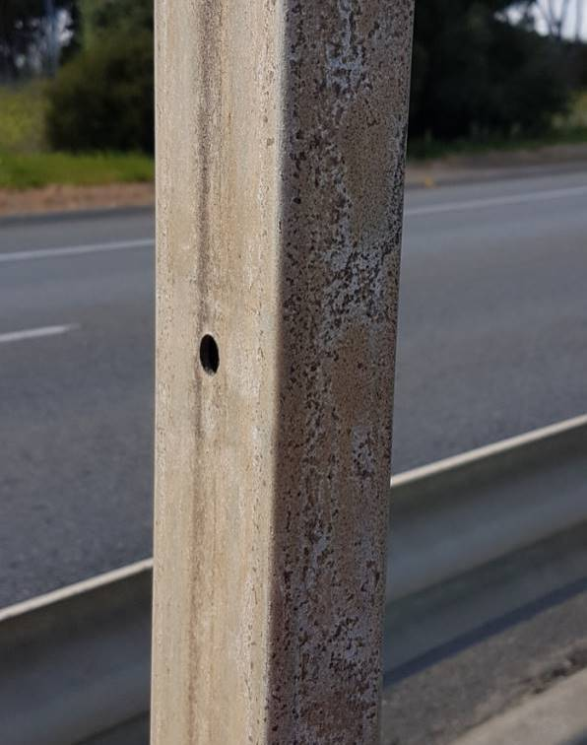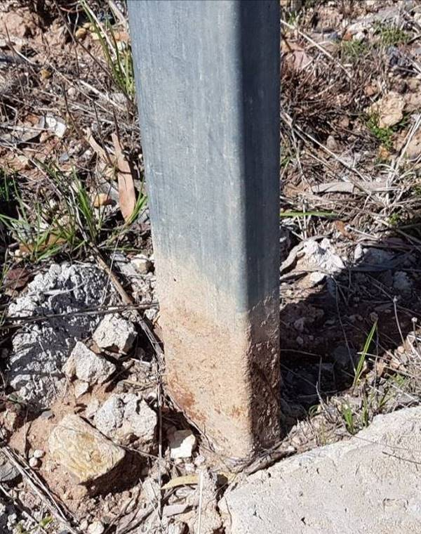

Poor
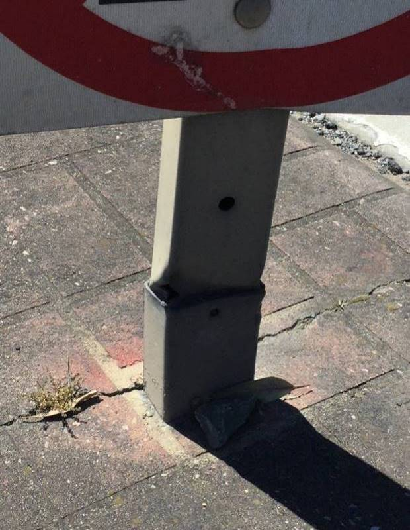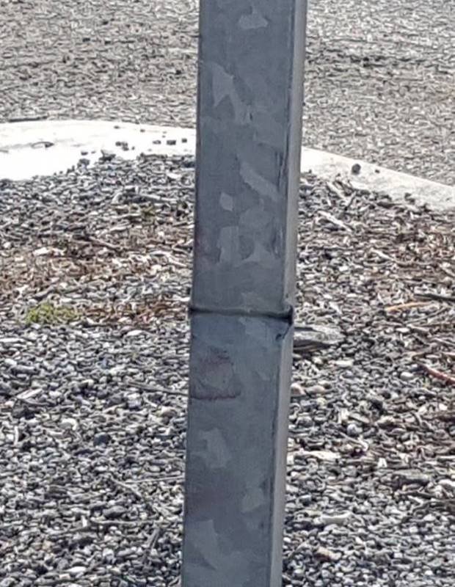

Unserviceable
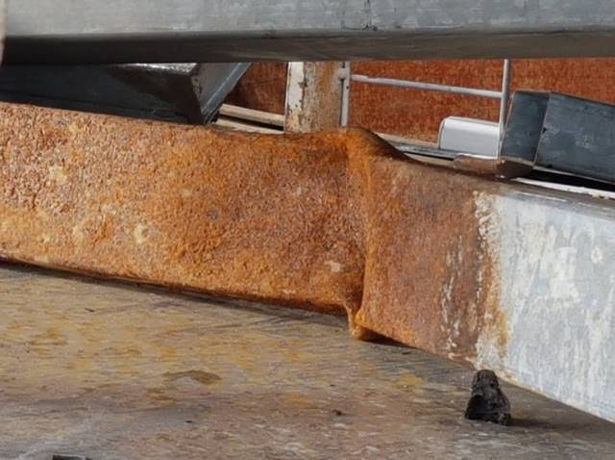

  - Signs
New (No signs of damaged or fading)
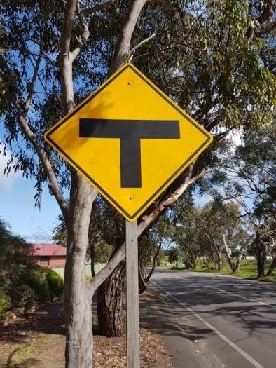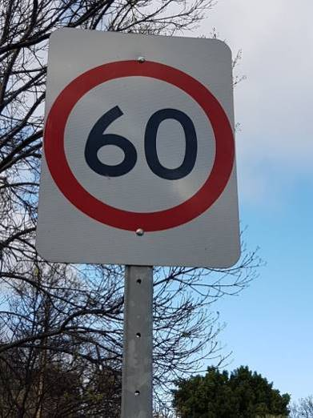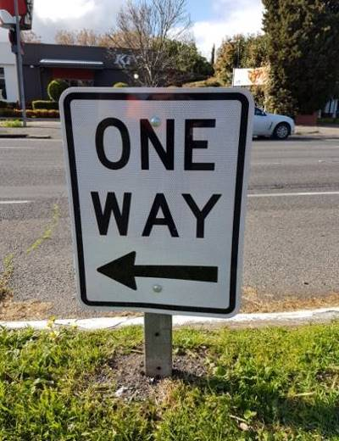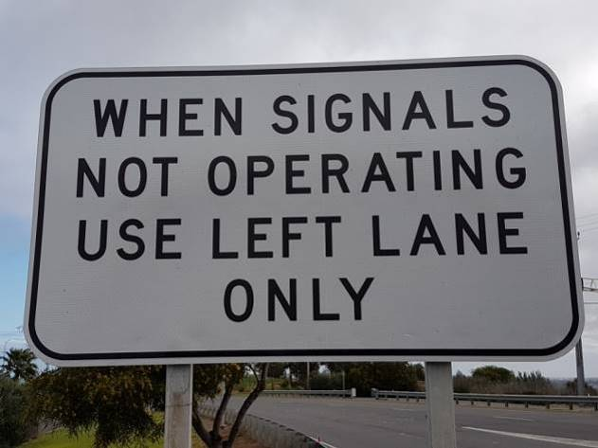
Night (Reflectivity 100-90%)
TBC

Good (Full sign visible, minor damages or fading)
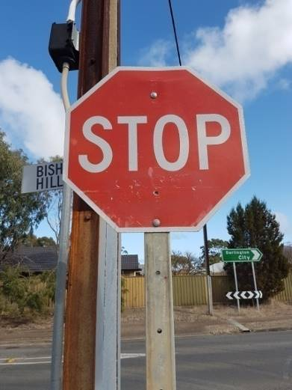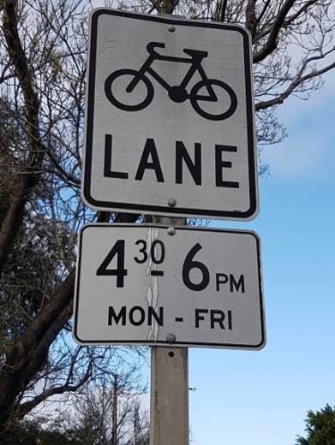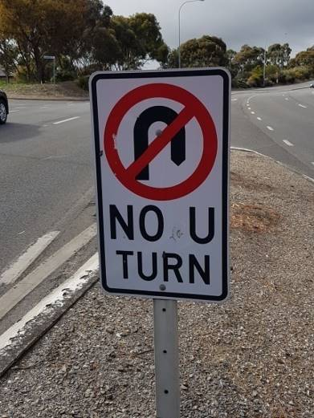
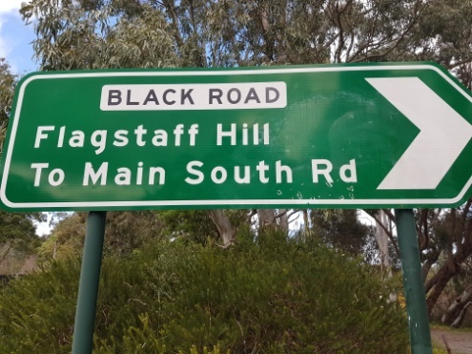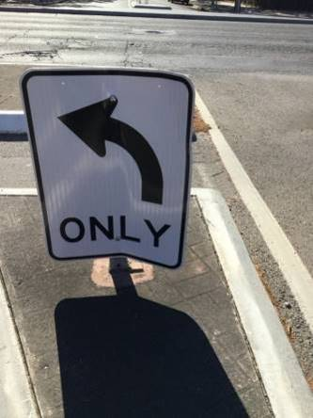
Night (Reflectivity 90-75%)
TBC

Average (Majority of the sign is still visible, 30-50% damaged or fading)
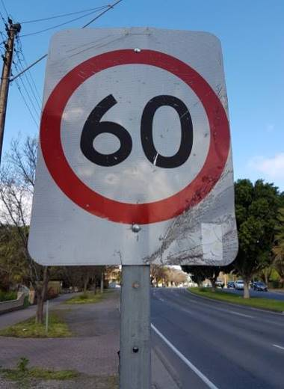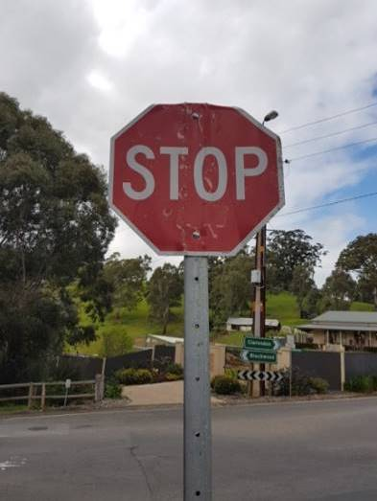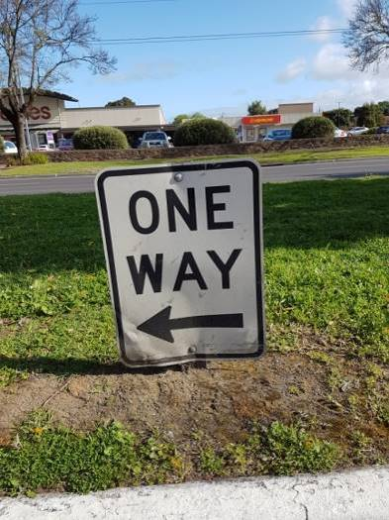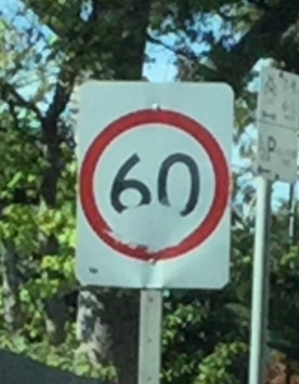
Night (Reflectivity 75-65%)
TBC

Poor (Sign’s message has been impacted by damages / fading)
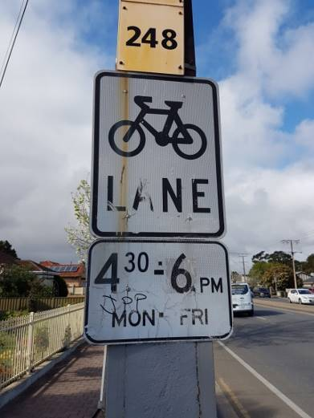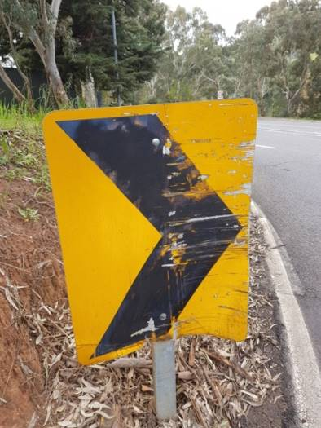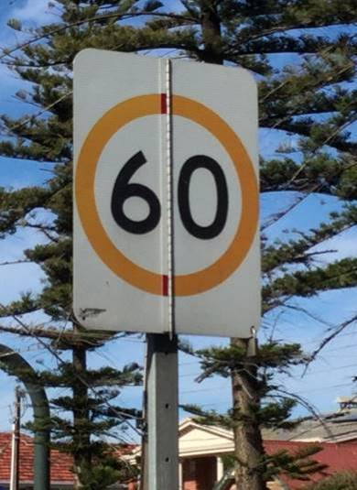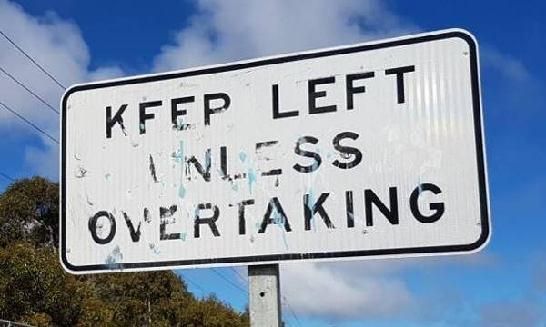
Night (Reflectivity 65-50%)
TBC

Unserviceable (Sign cannot be seen clearly, majority of reflective material peeling / cracked)
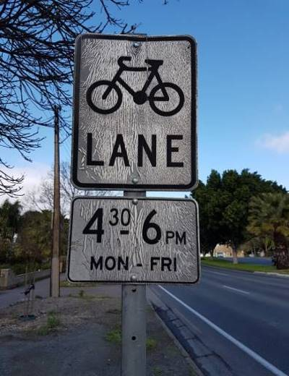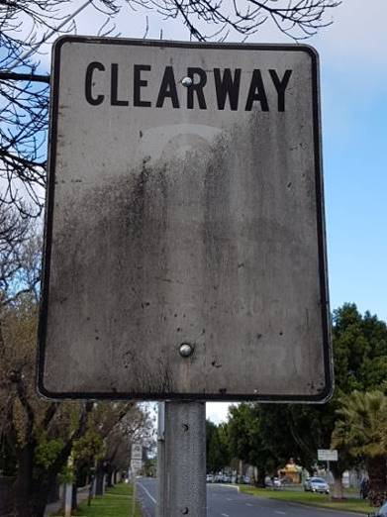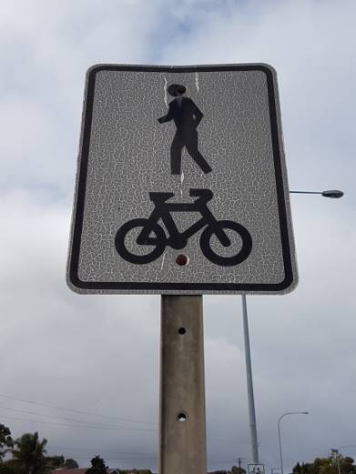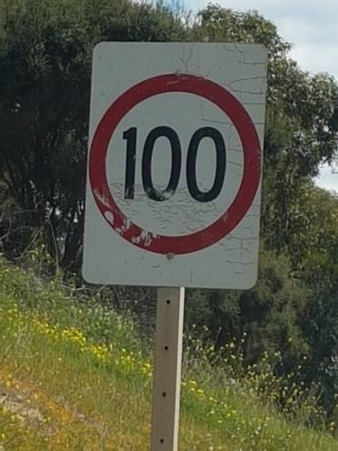
Night (Reflectivity 50-0%)
TBC

  - Safety Barrier
New (Installed in the last 10 years)
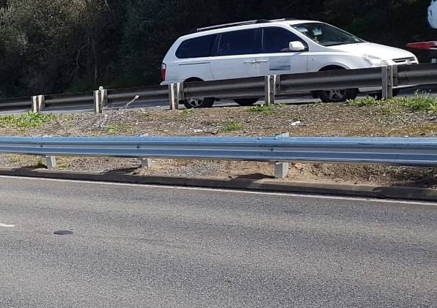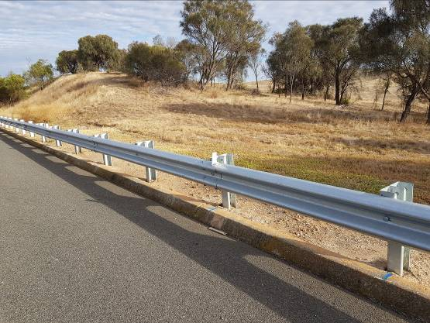

Good (Installed in the last 10-20 years)
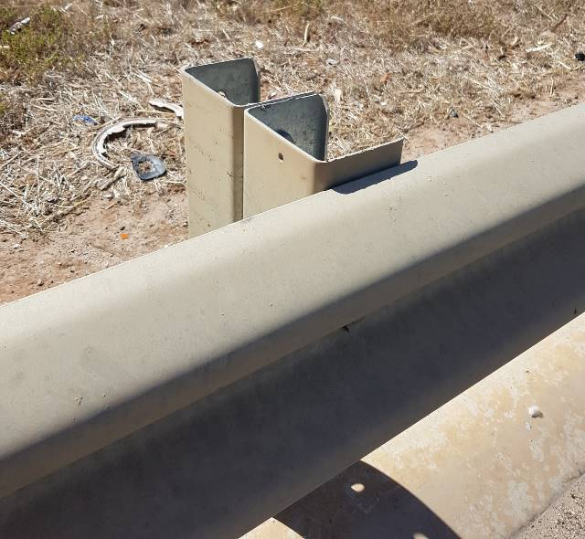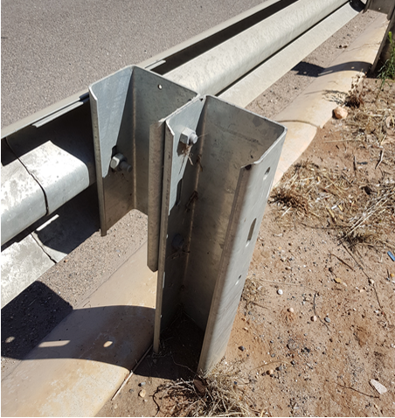

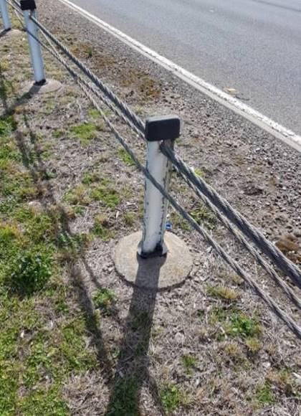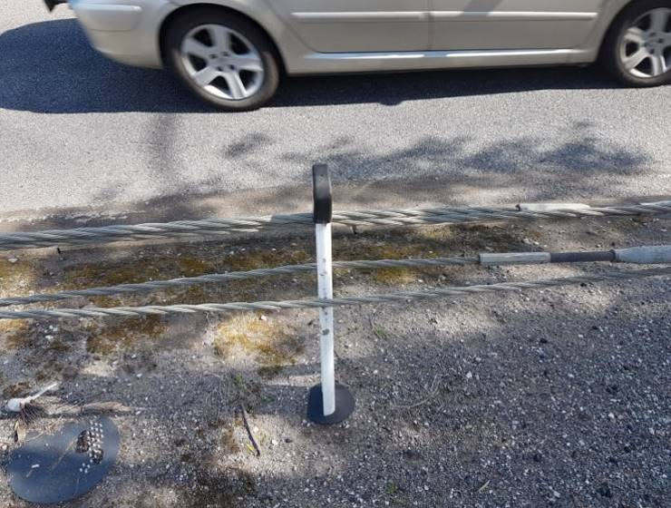

Average (Installed in the last 20-30 years)
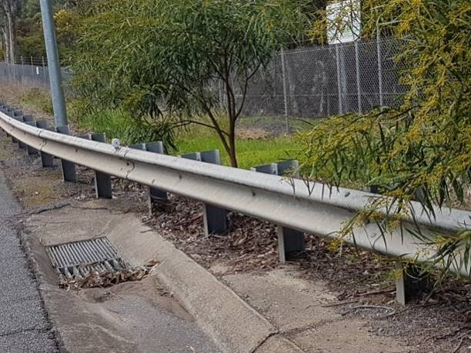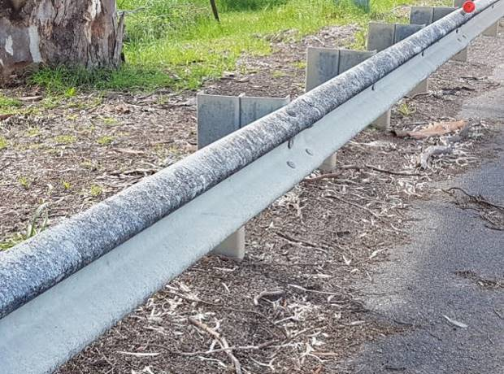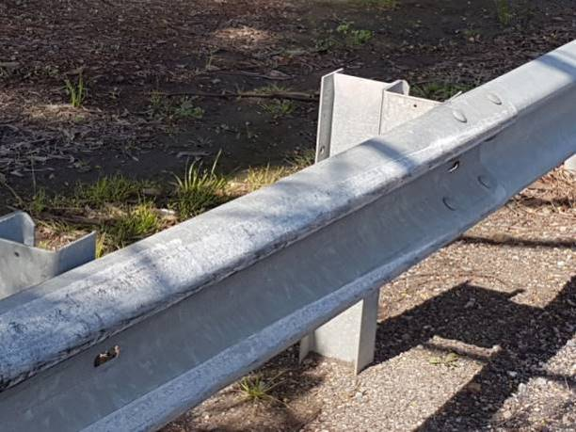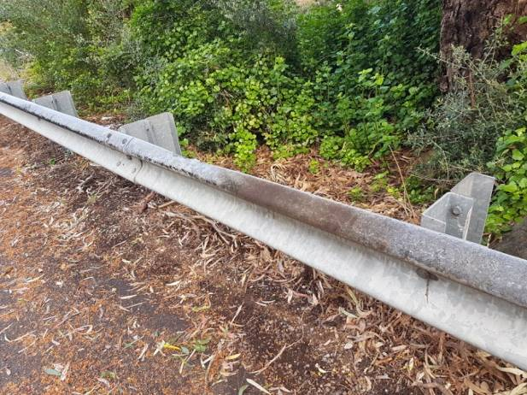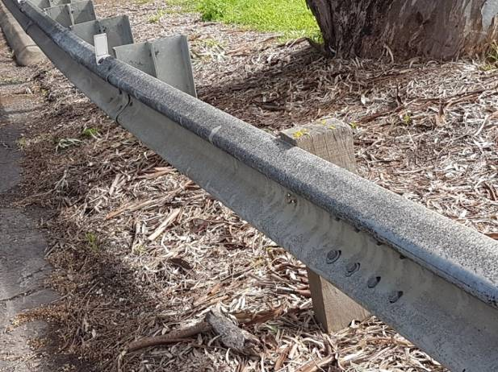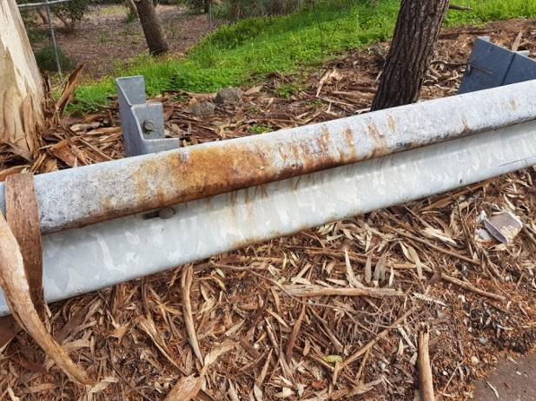

Poor (Installed in the last 30-40 years)
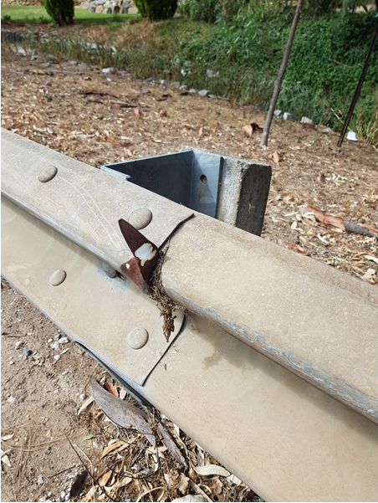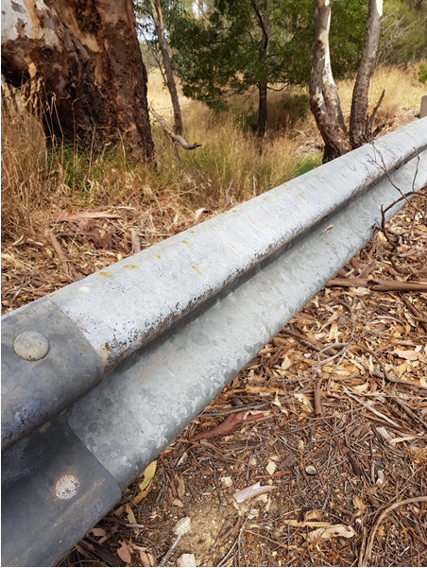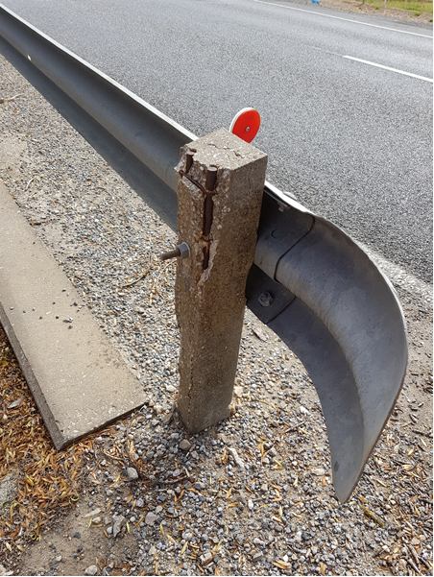

Unserviceable (Installed in 40+ years)
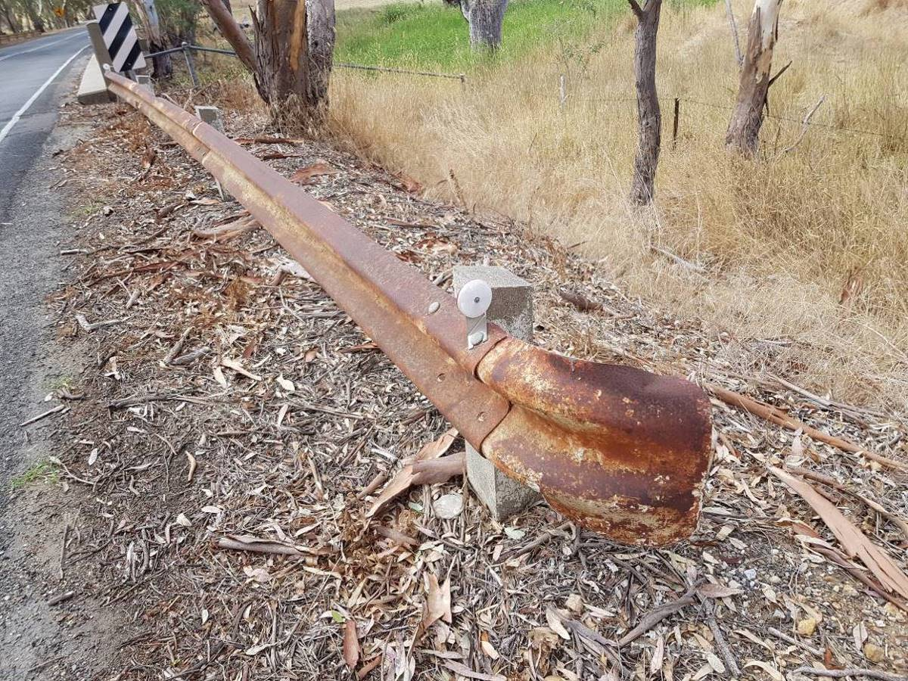

  - Terminals
Steel condition components refer to barriers for examples.

New (Installed in the last 10 years)
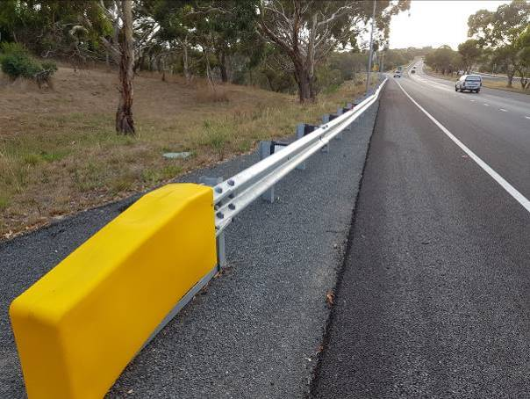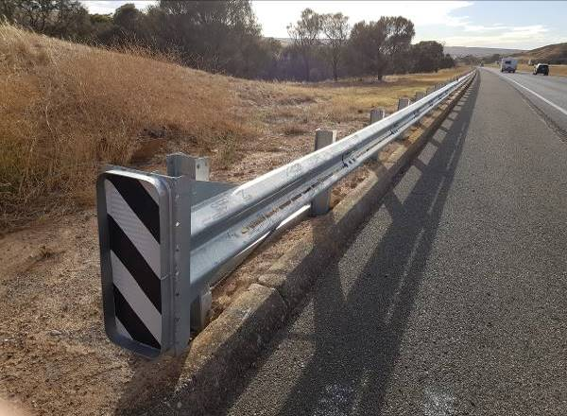

Good (Installed in the last 10-20 years)
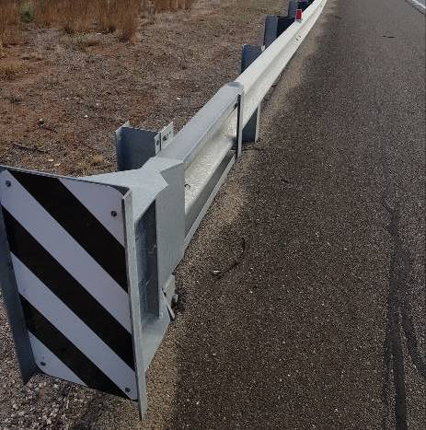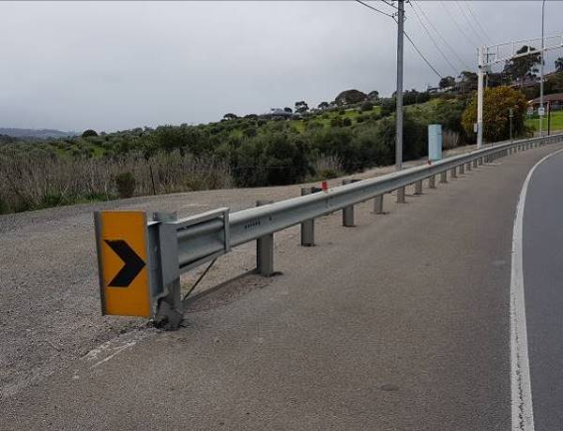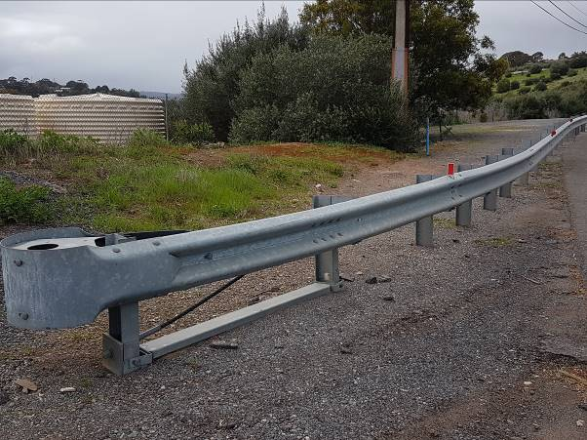

Average (Installed in the last 20-30 years)
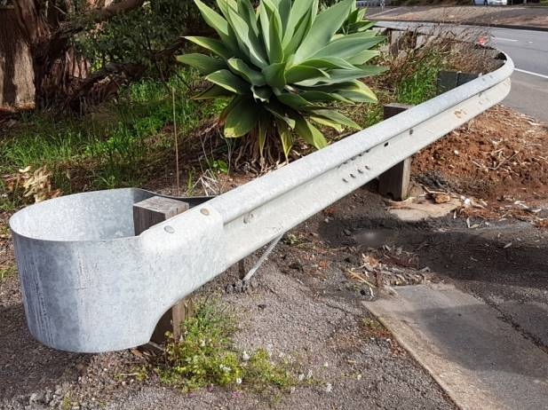

Poor (Installed in the last 30-40 years)
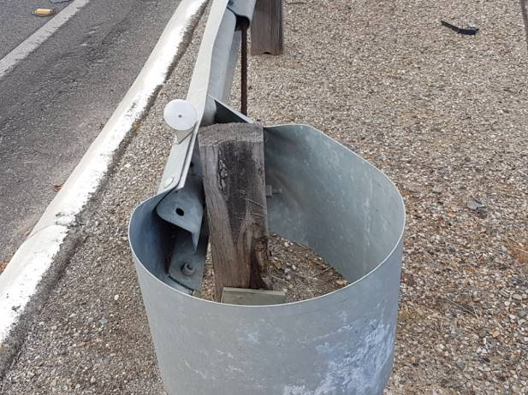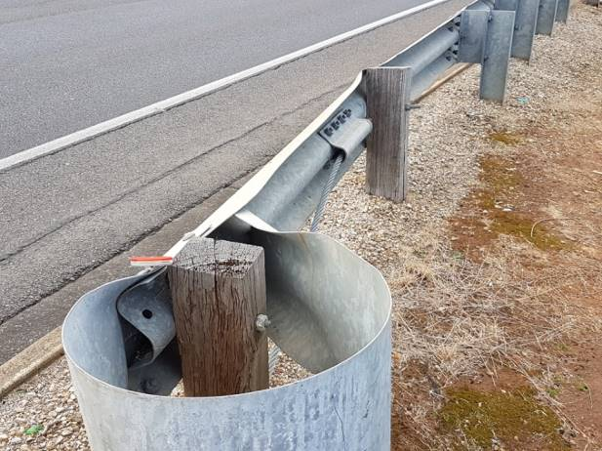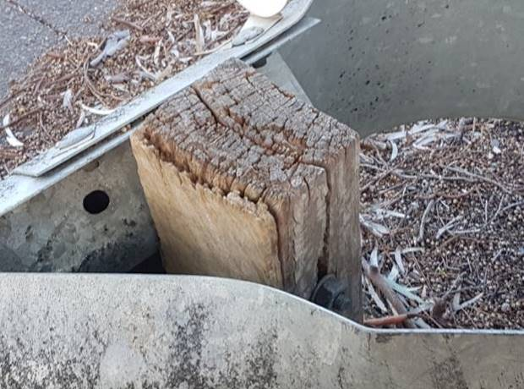

Unserviceable (Installed in 40+ years)
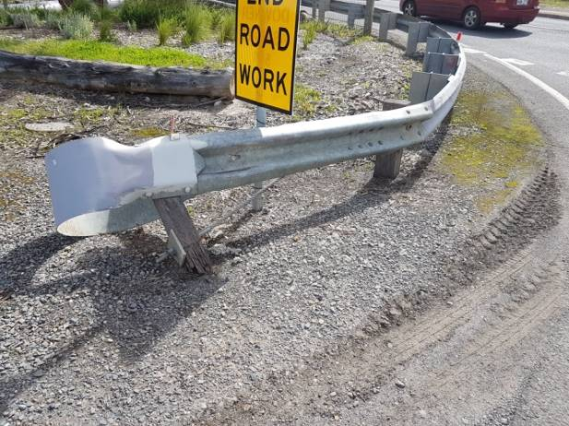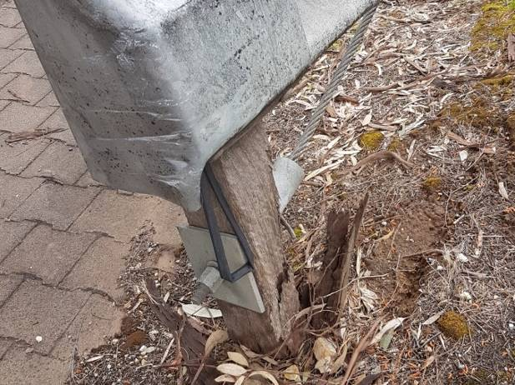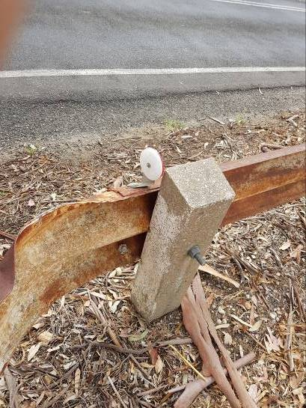

  - Motorcycle Protection
As motorcycle protection have only been installed for the last 15 years, it is not expected to have any poor or unserviceable motorcycle protection. Steel condition components refer to barriers for examples.

New
TBC

Good
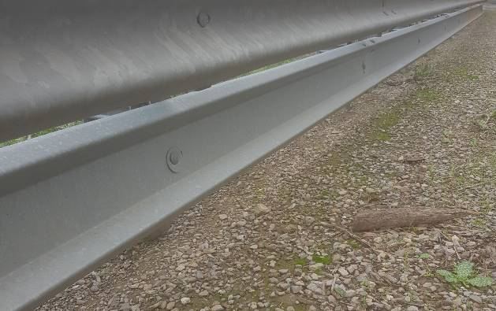

Average
TBC

Poor
TBC

Unserviceable
TBC

  - Drainage
New
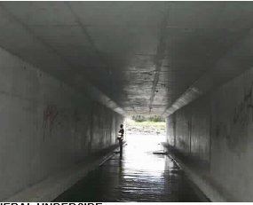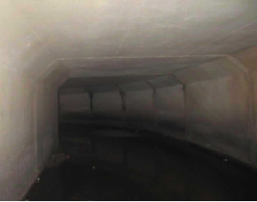

Good
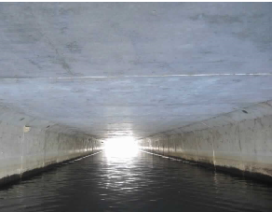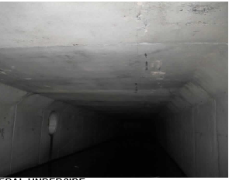

Average
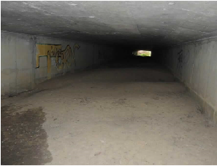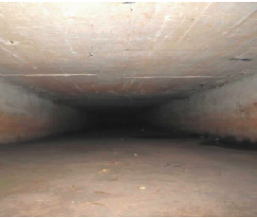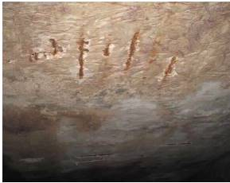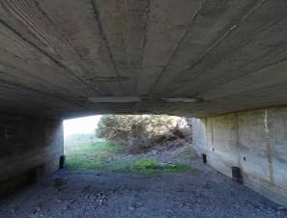

Poor
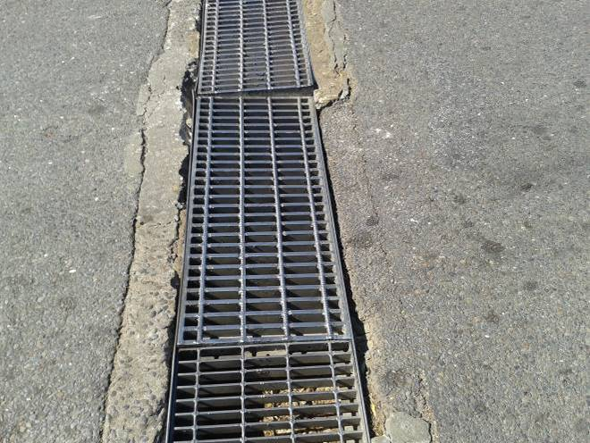

Unserviceable
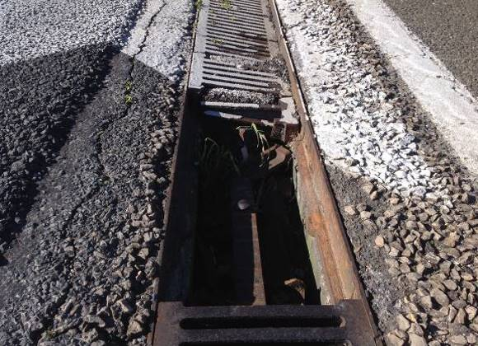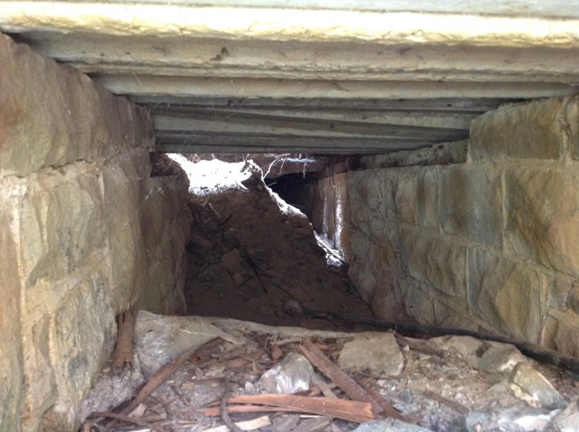

  - Inlet / Outlet / Junction
Condition examples to be provided at later date
New
TBC

Good
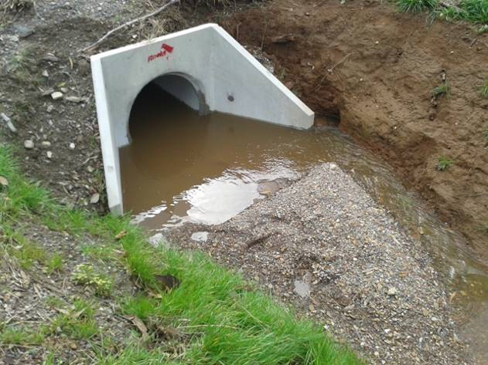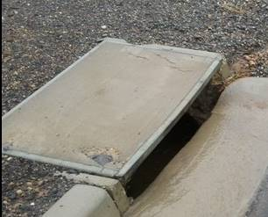

Average
TBC

Poor
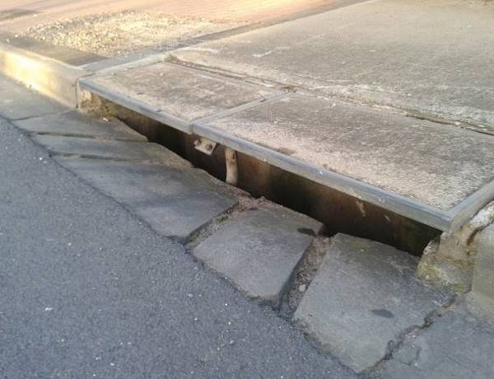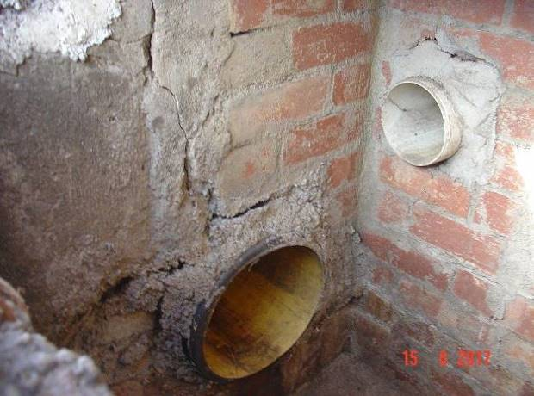

Unserviceable
TBC

  - Fence / Gates
New
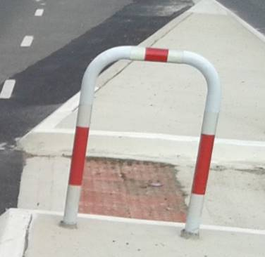

Good
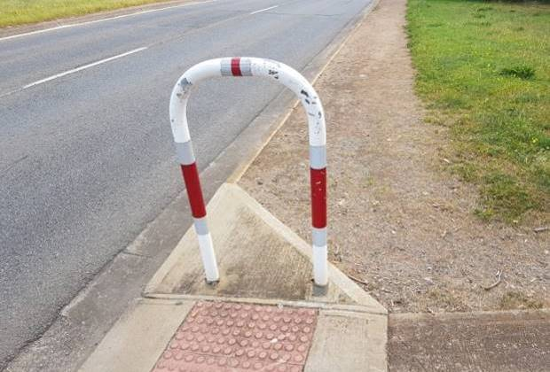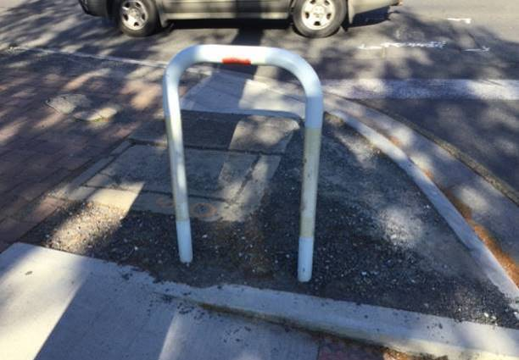

Average
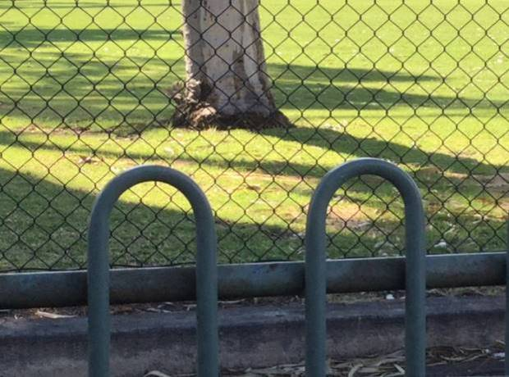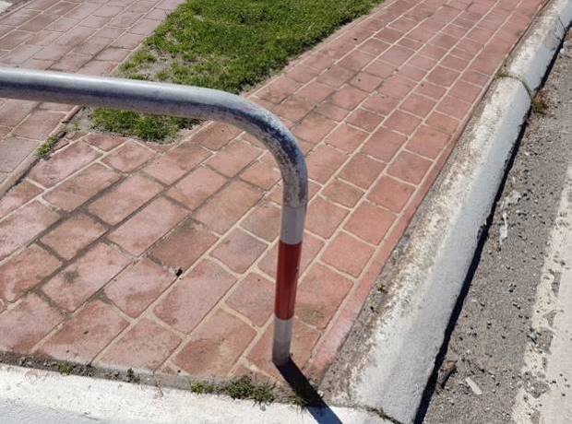

Poor
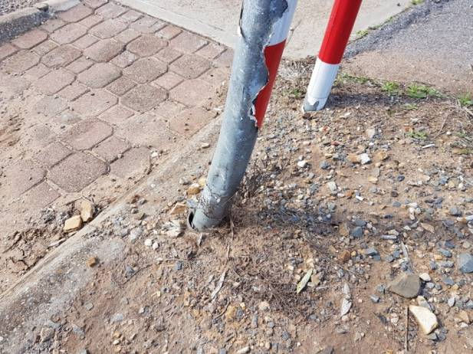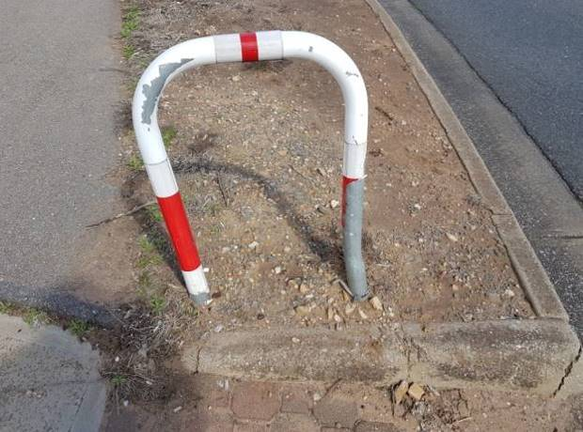

Unserviceable
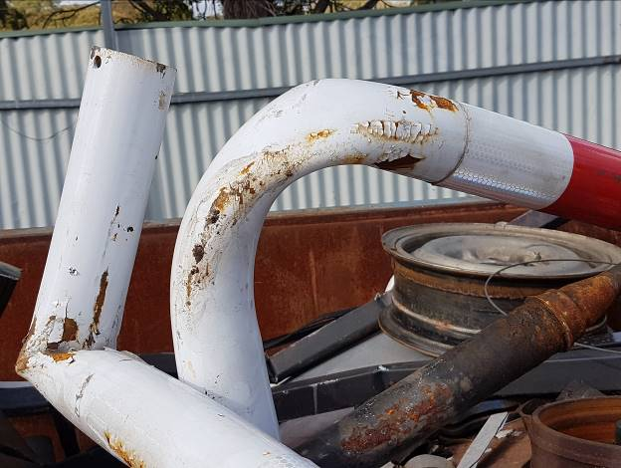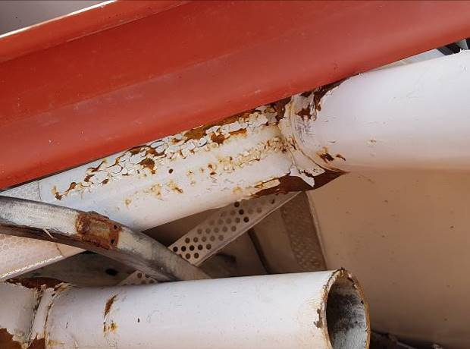

  - Stack Sites
New
TBC

Good
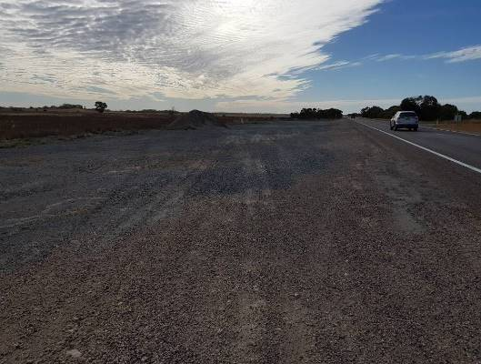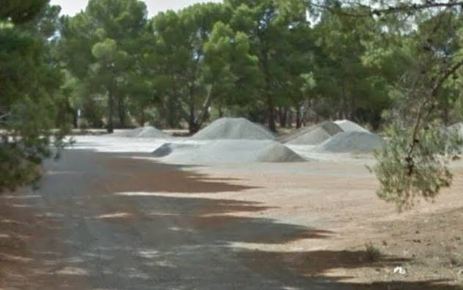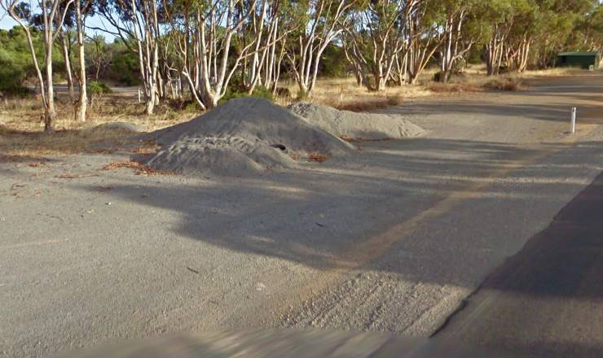

Average
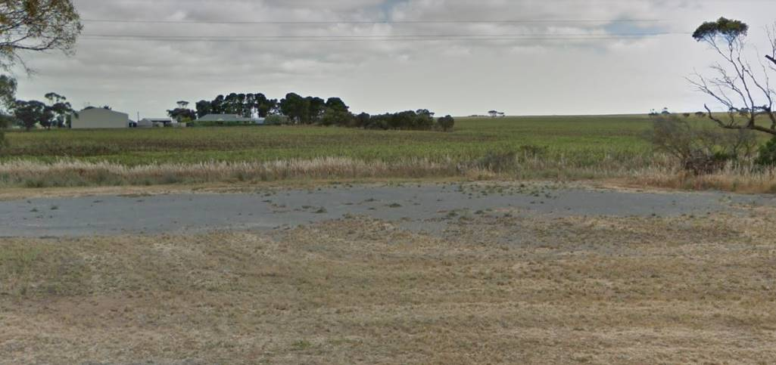

Poor
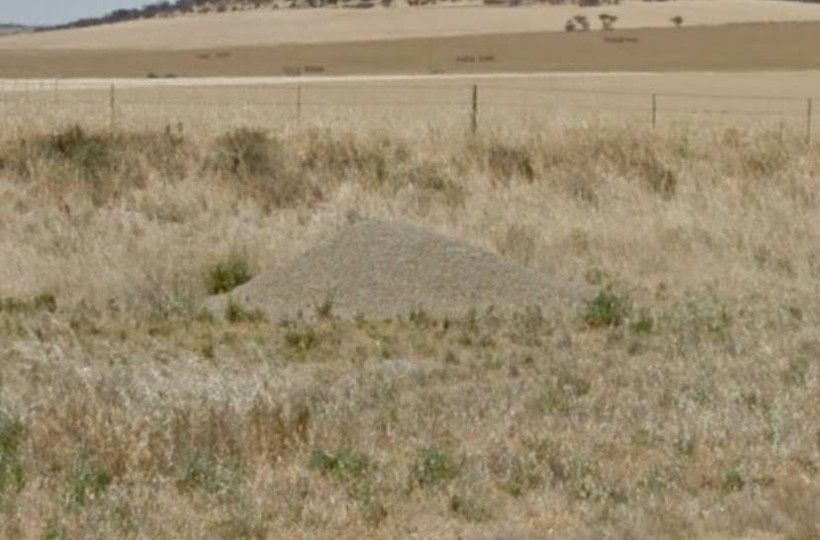

Unserviceable
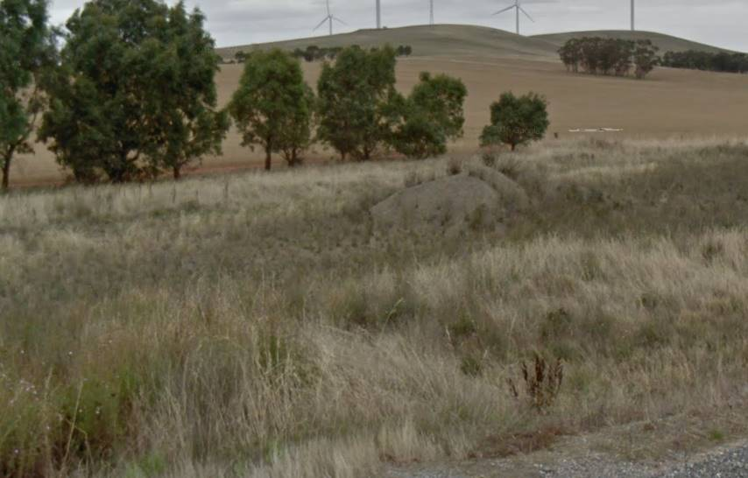

  - Retaining Wall
New
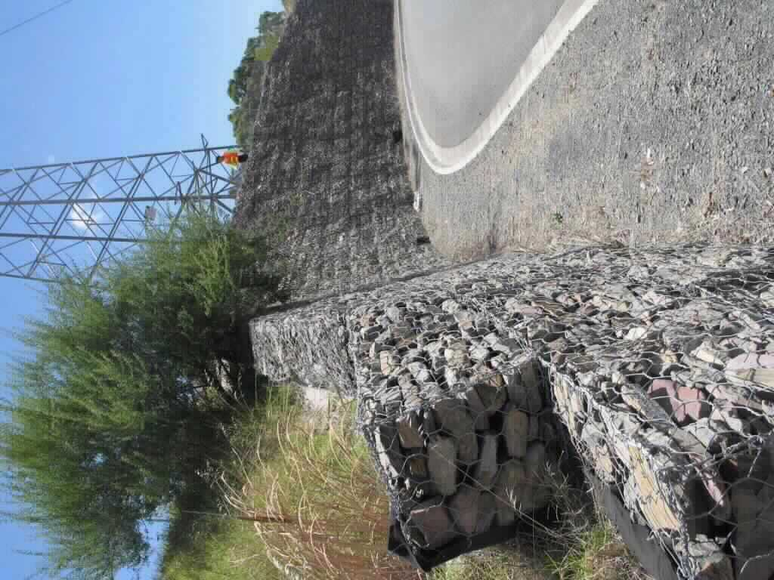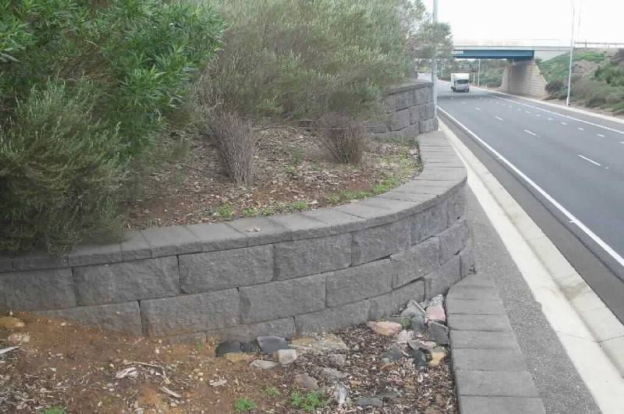

Good
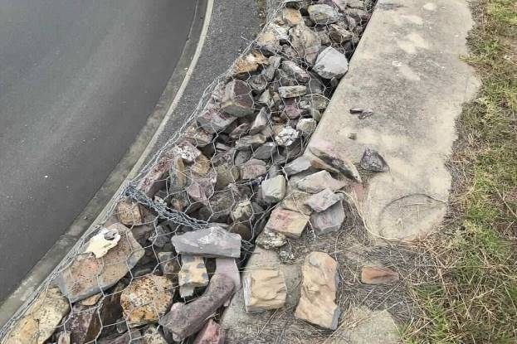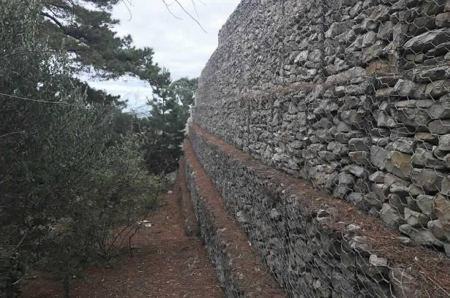

Average
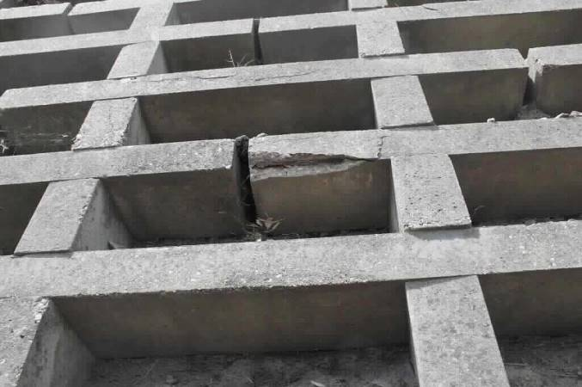

Poor
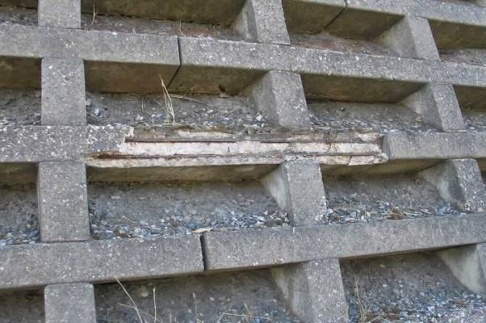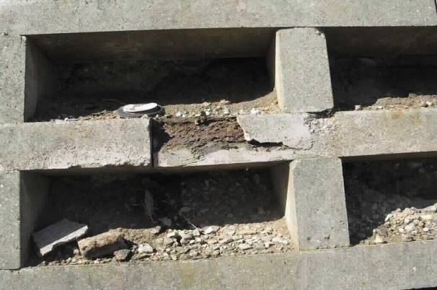

Unserviceable
TBC

  - Rest Area
Condition based on surface condition. Increasing amount of cracking, bleeding or pot holing within the rest are will determine the condition.
New
TBC

Good
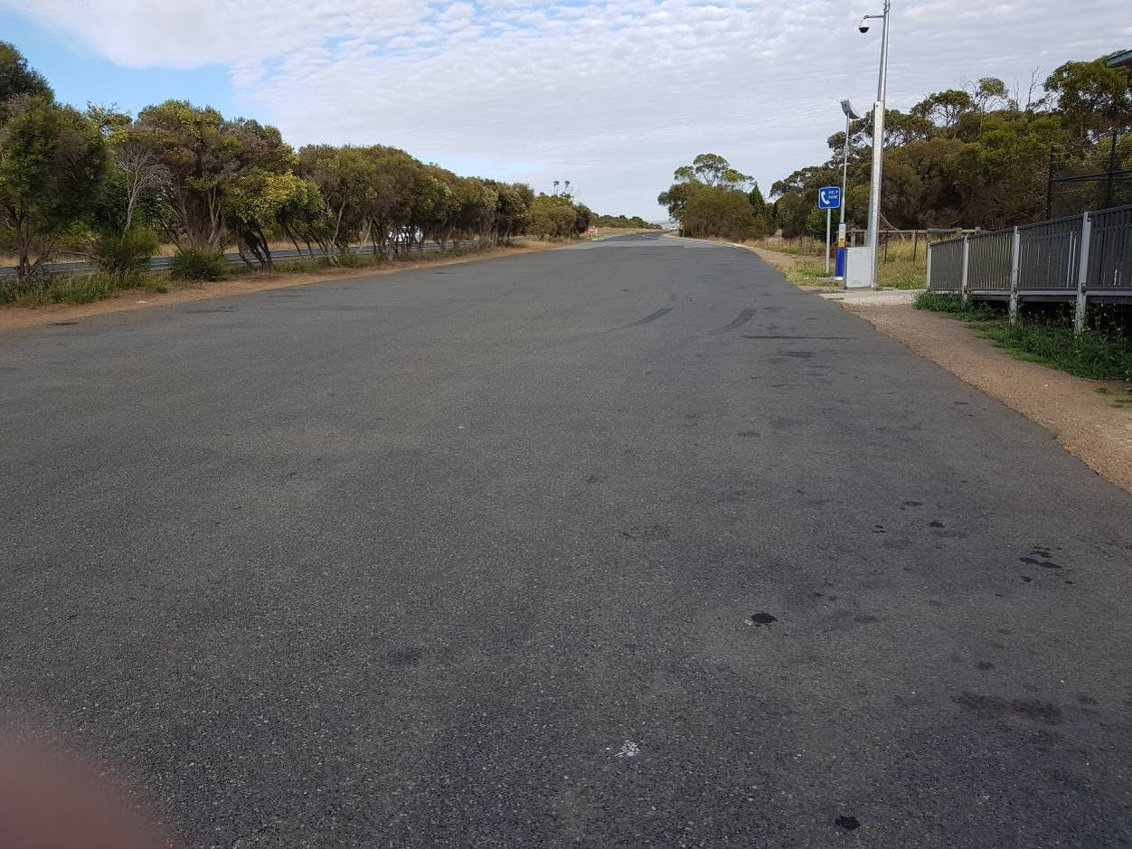

Average
TBC

Poor
TBC

Unserviceable
TBC

  - Bins
New
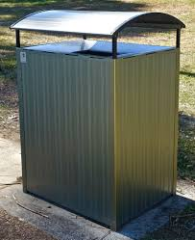

Good
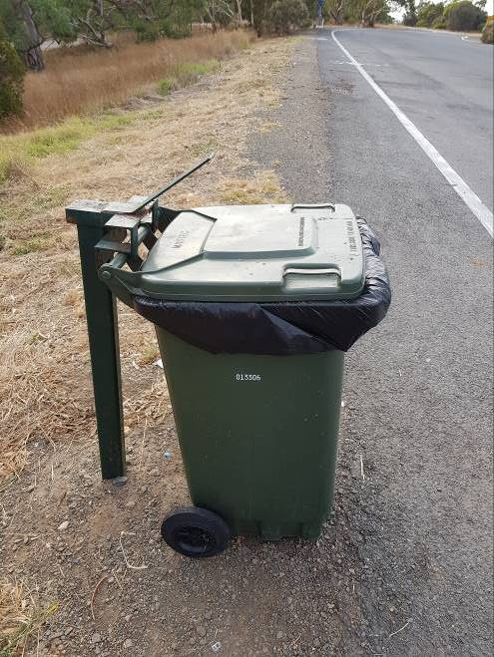

Average
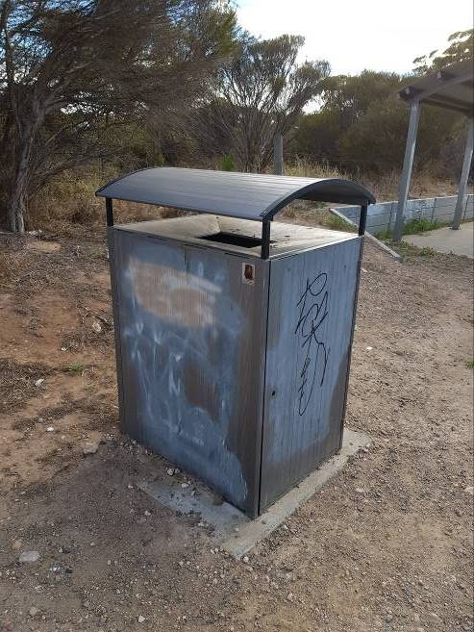

Poor
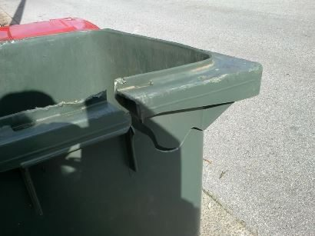

Unserviceable
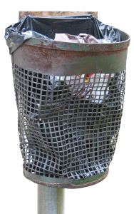

  - Table
Additional images on condition will be provided on next version. Refer to retaining walls for concrete table examples of cracking. Bins for plastic and metal condition ratings.
New
TBC

Good
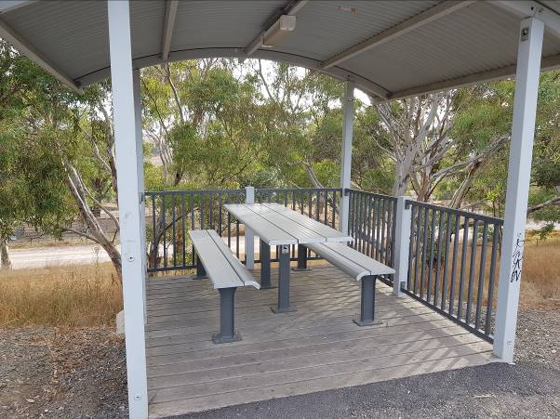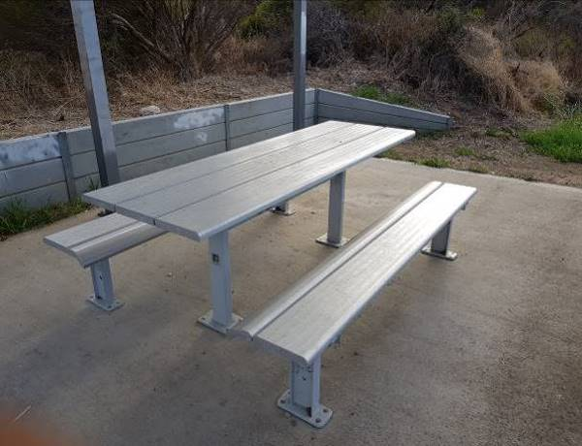

Average
TBC

Poor
TBC

Unserviceable
TBC

  - Shelter
New
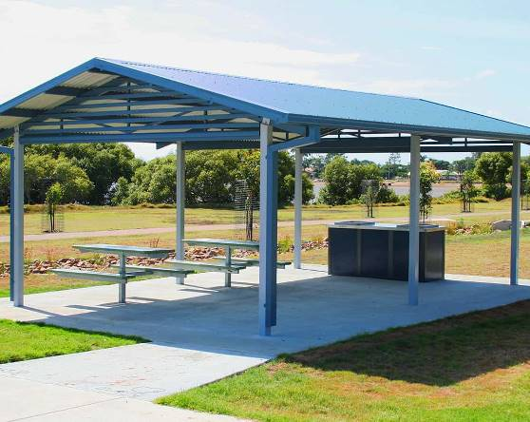

Good
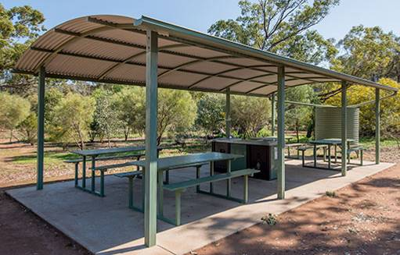

Average
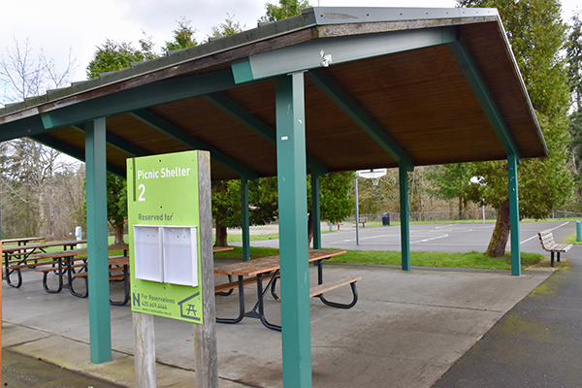

Poor
TBC

Unserviceable
TBC

  - Toilet Block
New
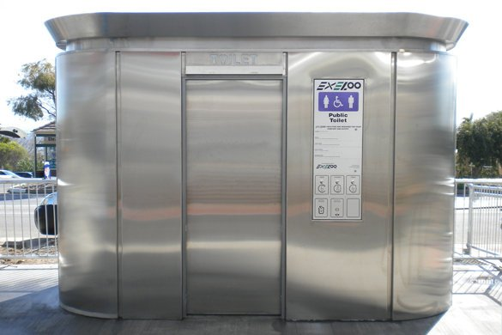

Good
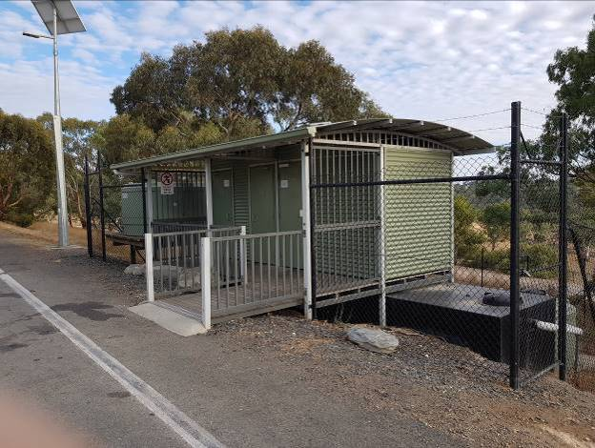

Average
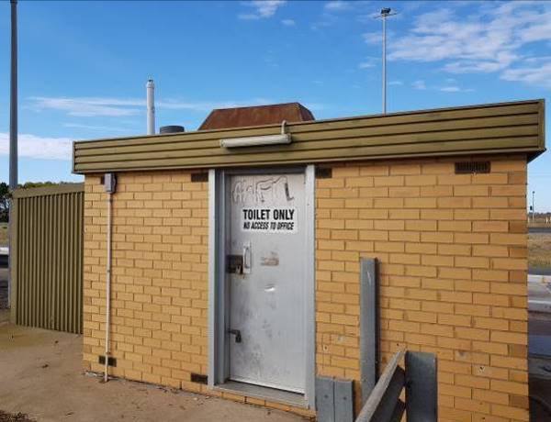

Poor
TBC

Unserviceable
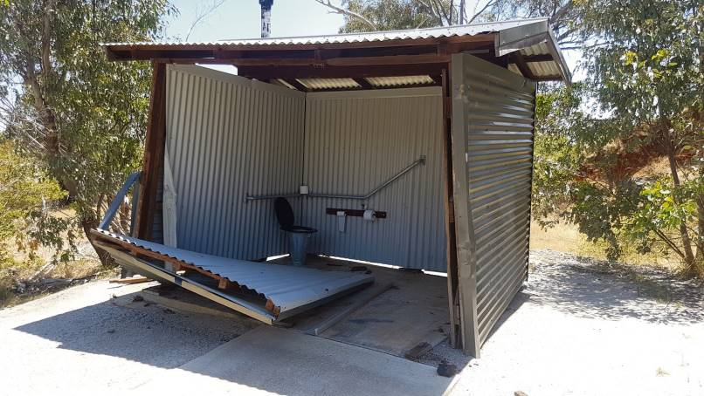

  - Water Tank
New
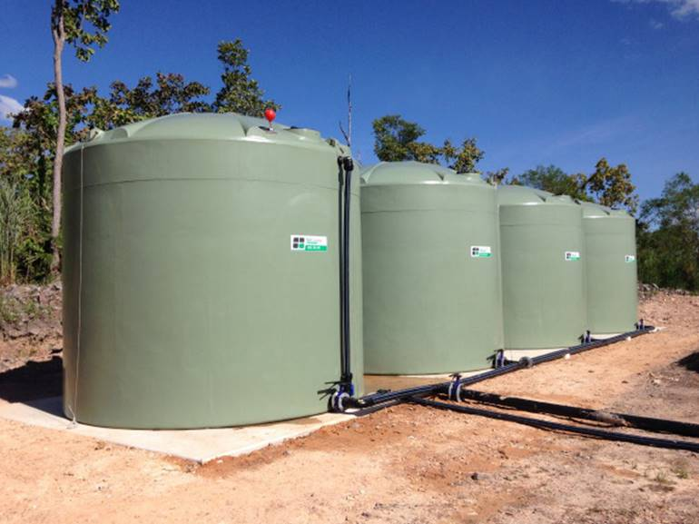

Good
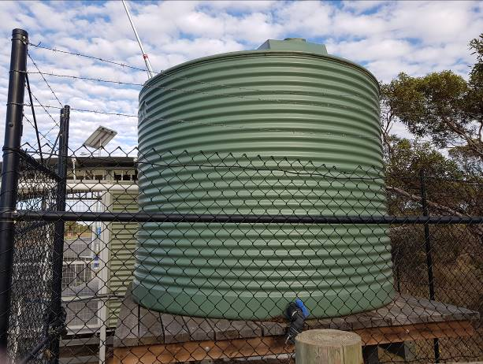 | 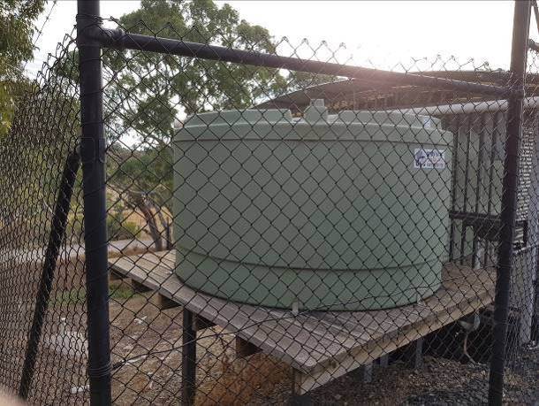

Average
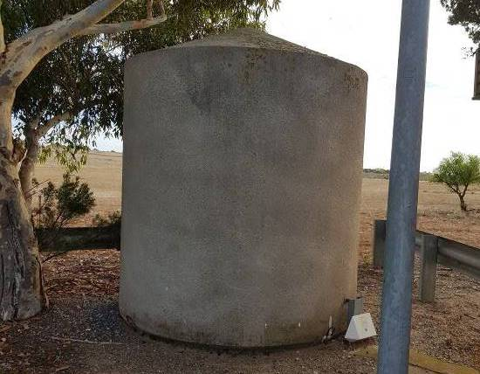

Poor
TBC

Unserviceable
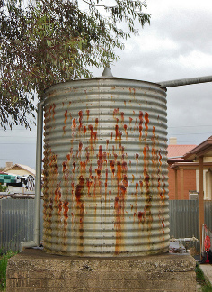

  - Median
Condition is based on the concrete kerbing and not the infill.
New
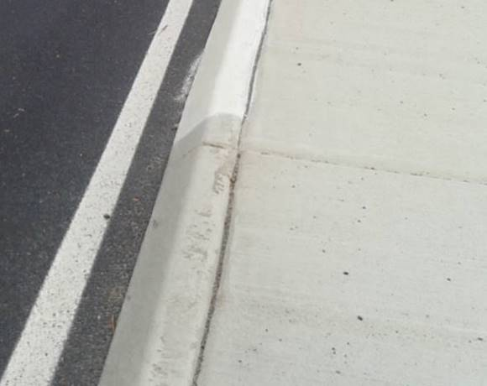

Good
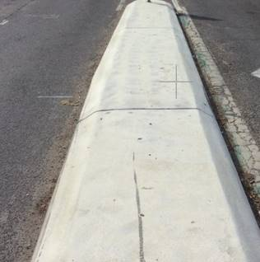

Average
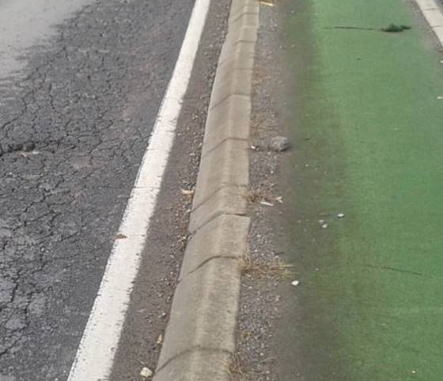

Poor
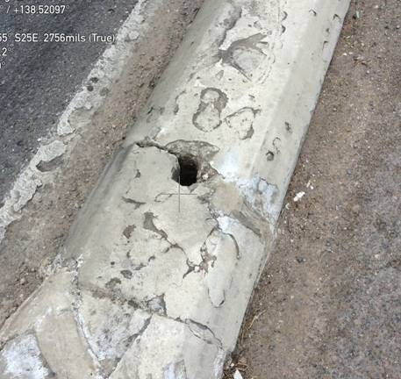

Unserviceable
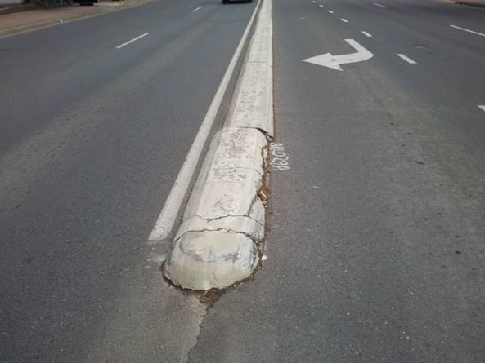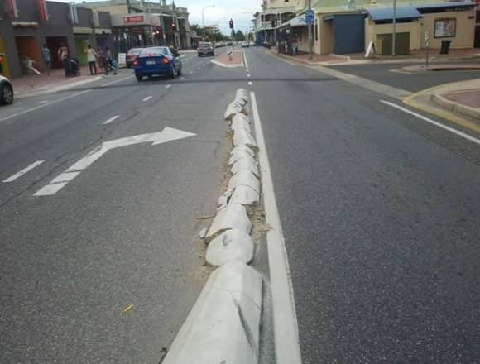

  - Pathways
Refer to median for general condition ratings of concrete pathways.
New
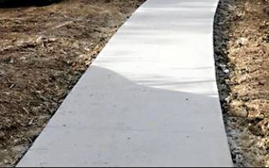

Good


Average
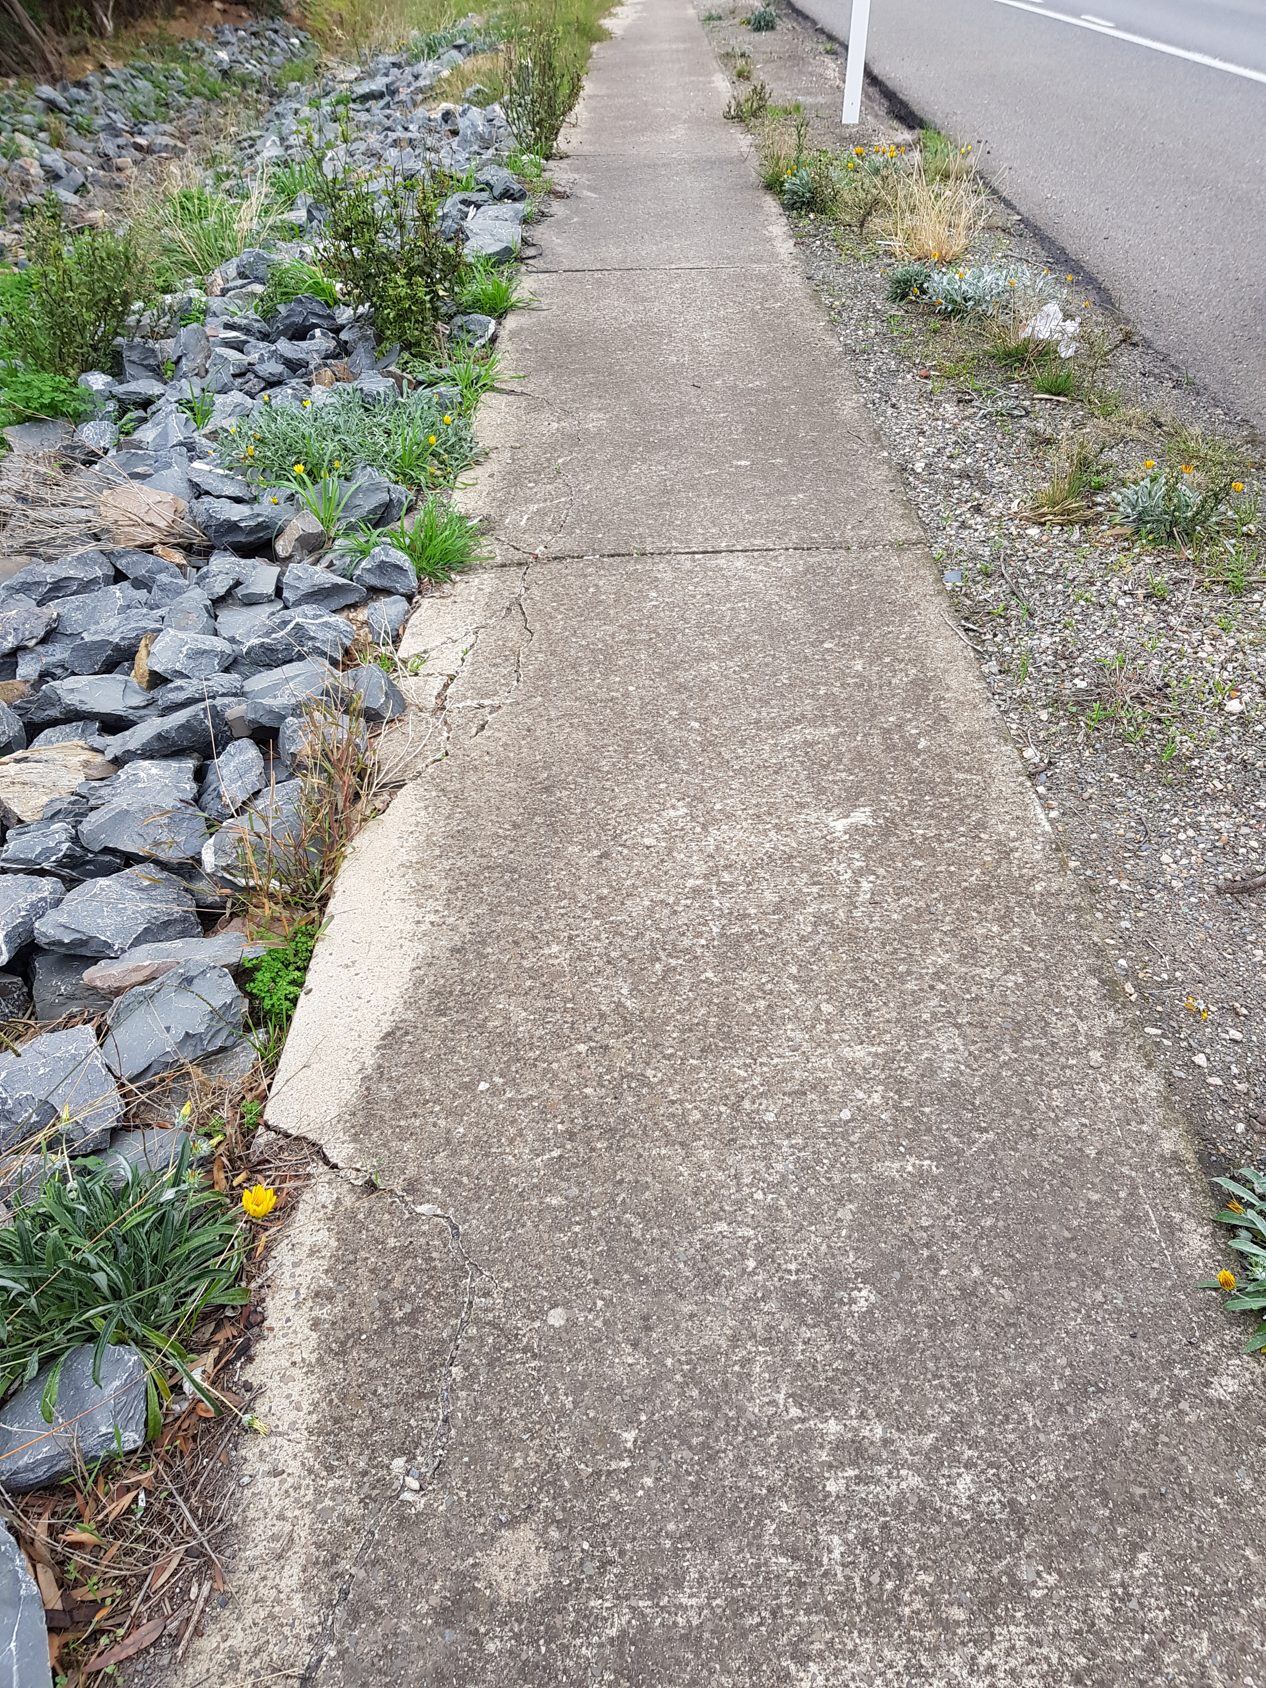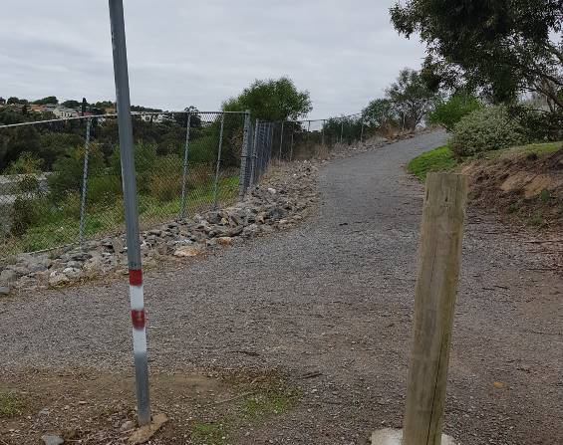

Poor
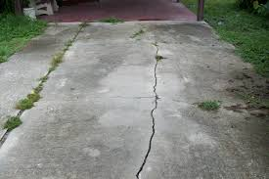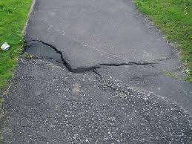

Unserviceable
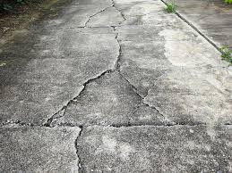

  - Bollards
New
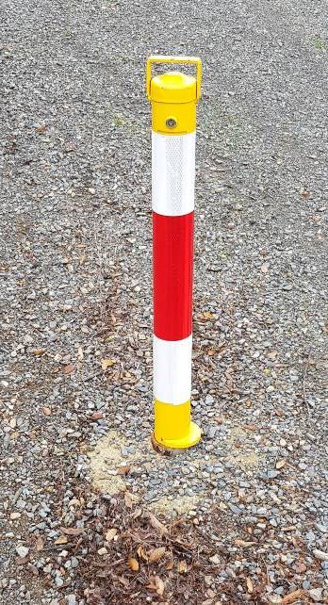

Good
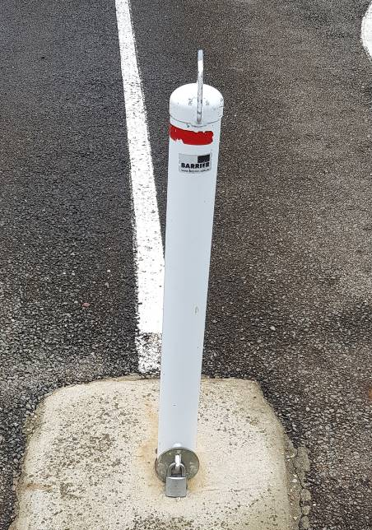

Average
TBC

Poor
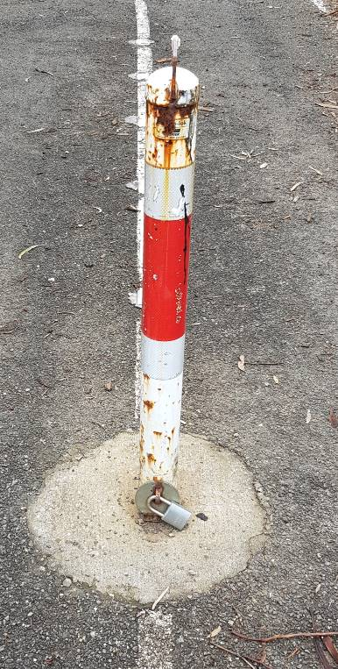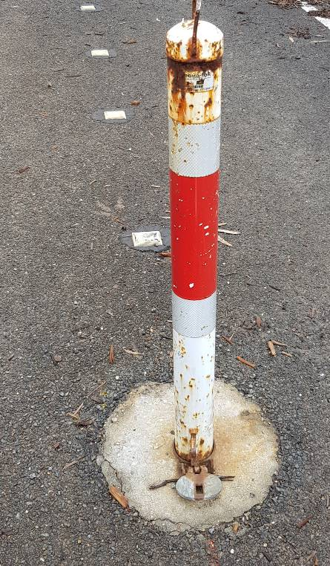

Unserviceable
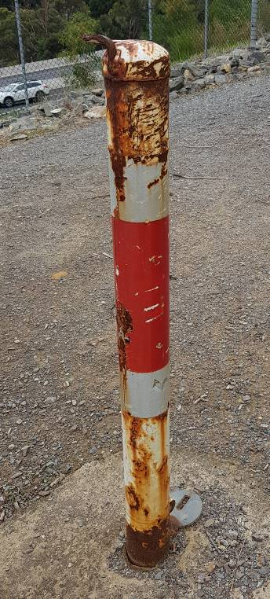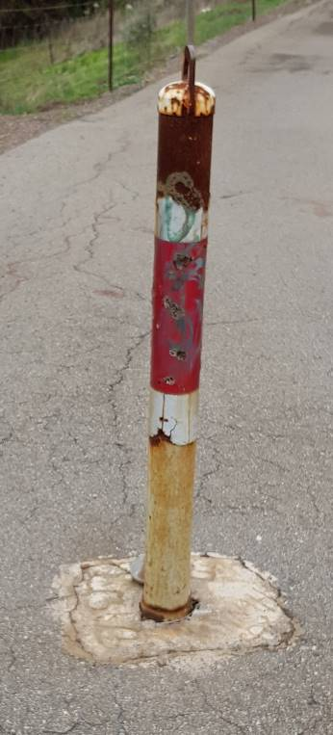

  - Windsocks
New


Good
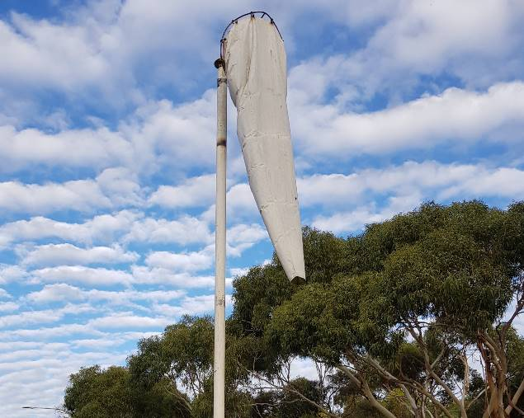

Average
TBC

Poor
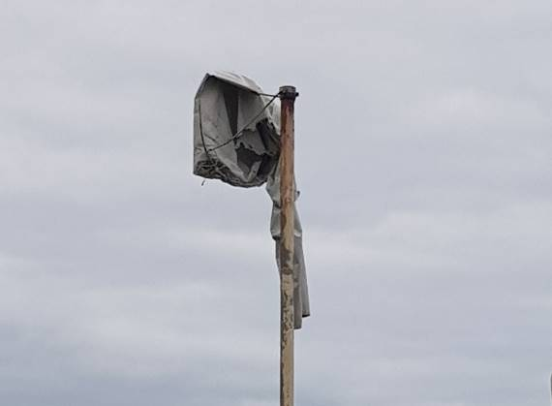

Unserviceable


  - Weigh Stations
New
TBC

Good
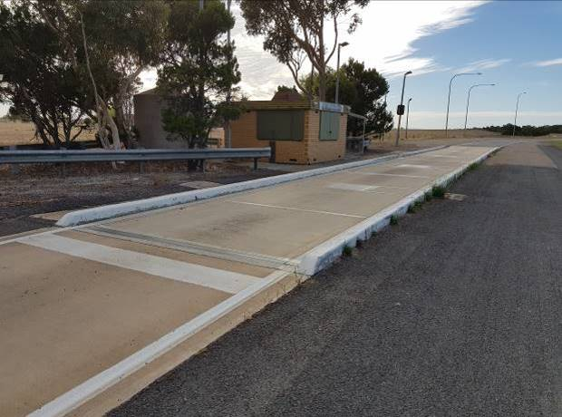

Average
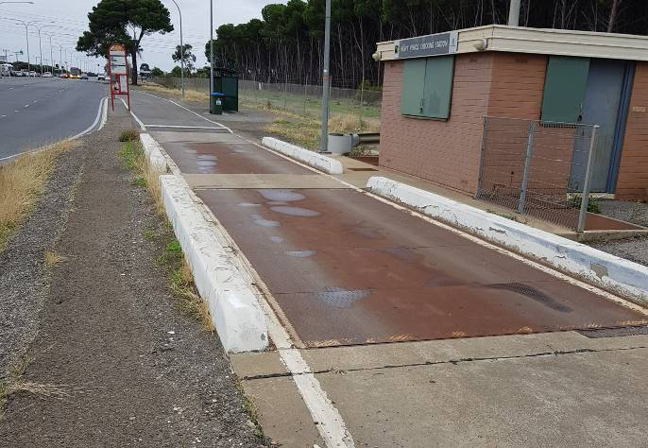

Poor
TBC

Unserviceable
TBC

  - Grids
New
Steels in good condition No material build up, no spalling
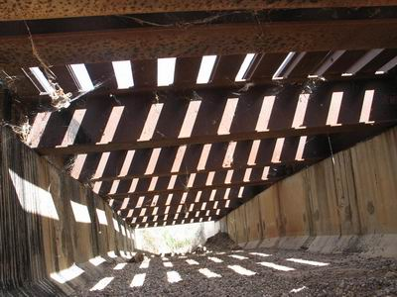
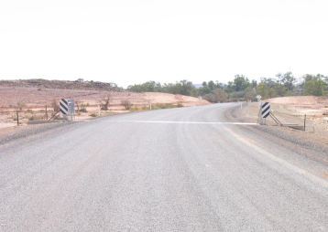

Good
Steels in good condition Minimal Soil
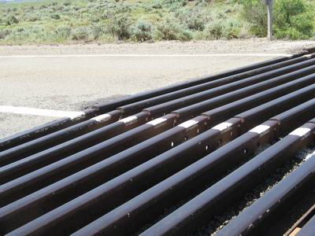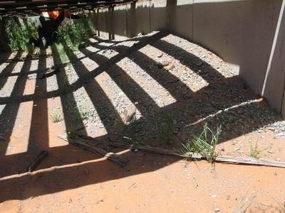

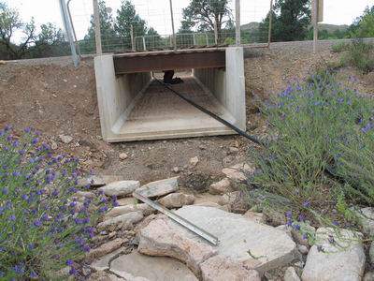

Average
Spalling on abutments Grid half full of soil
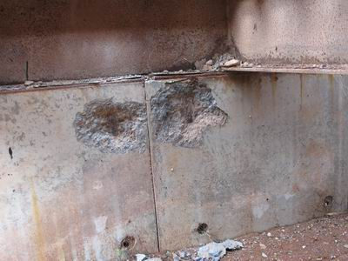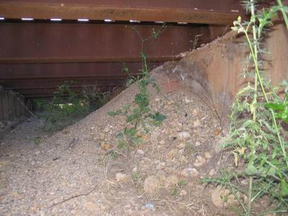
Rusting Broken weld
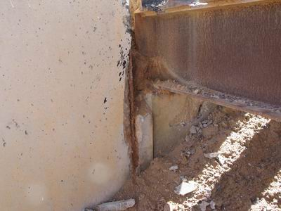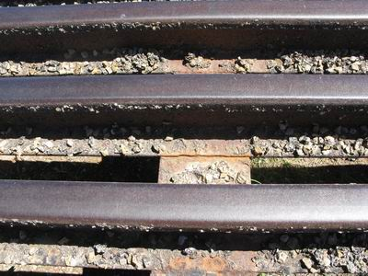

Poor
Spalling on abutments Grid full of soil
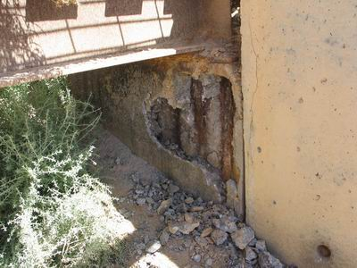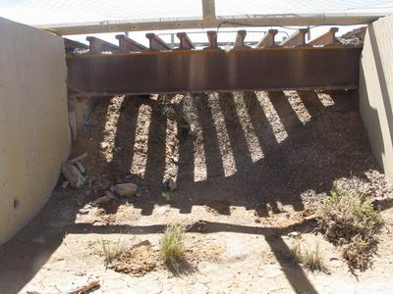

Rusting Rusting
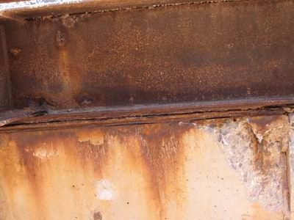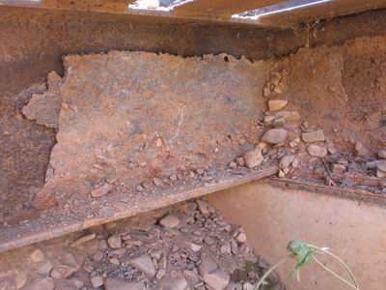

Unserviceable
Spalling on abutments Grid full of soil and in unrepairable condition
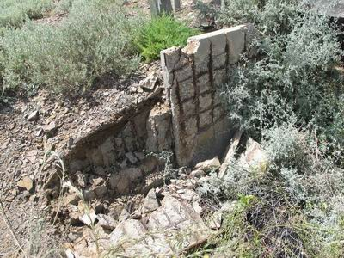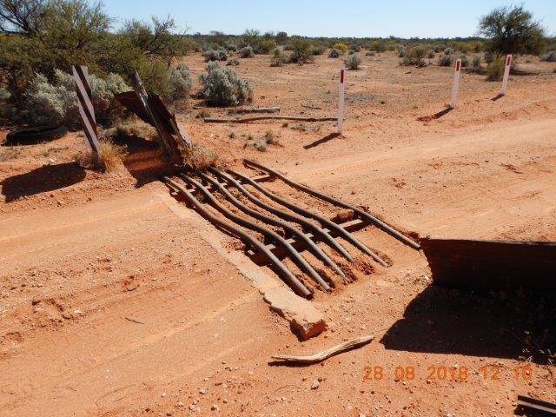
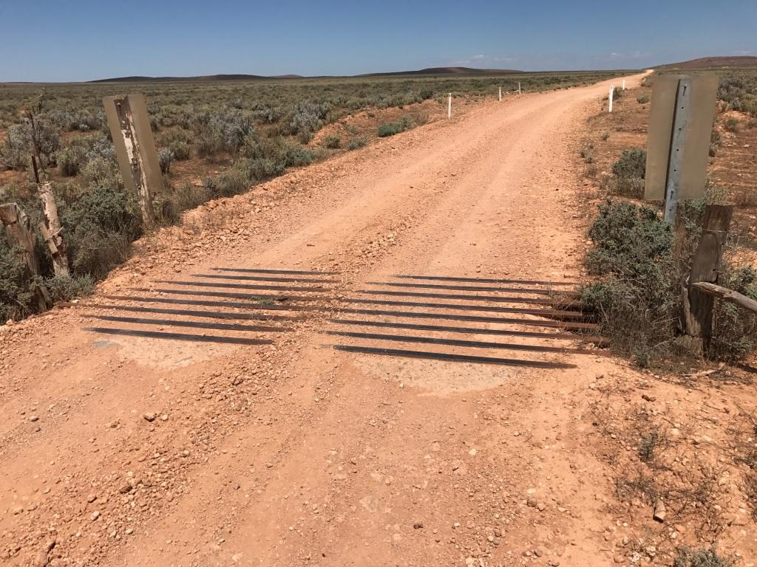

  - Floodways
New
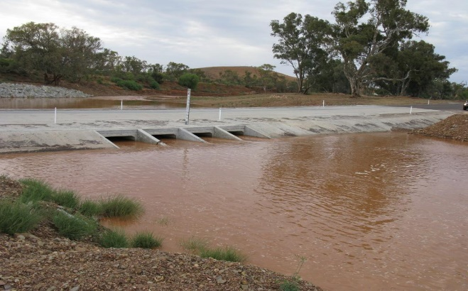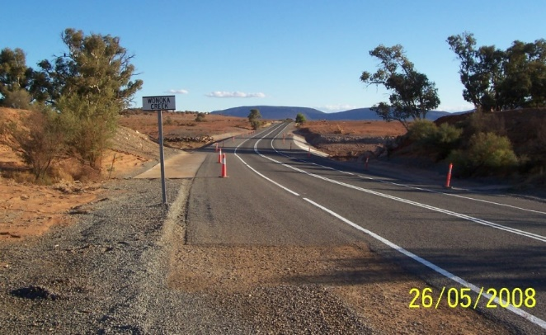

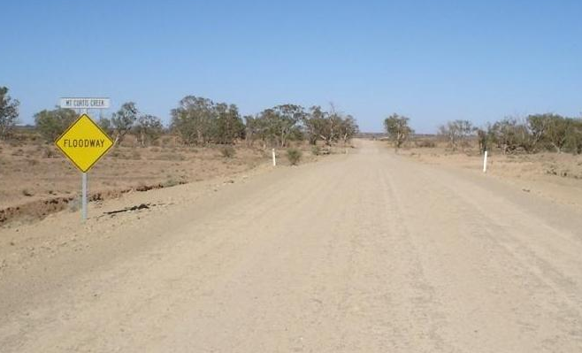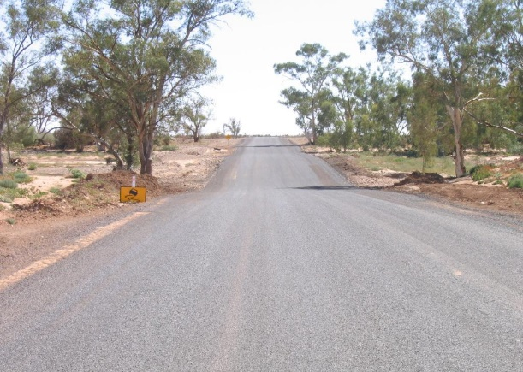

Good
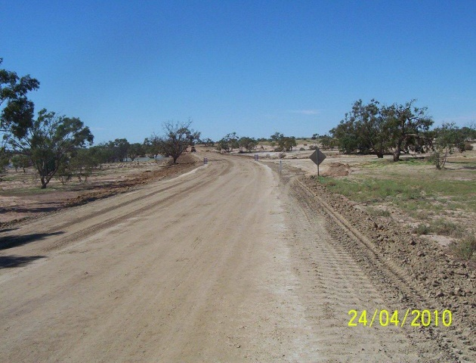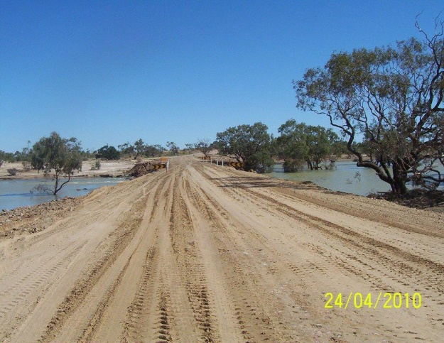

Average
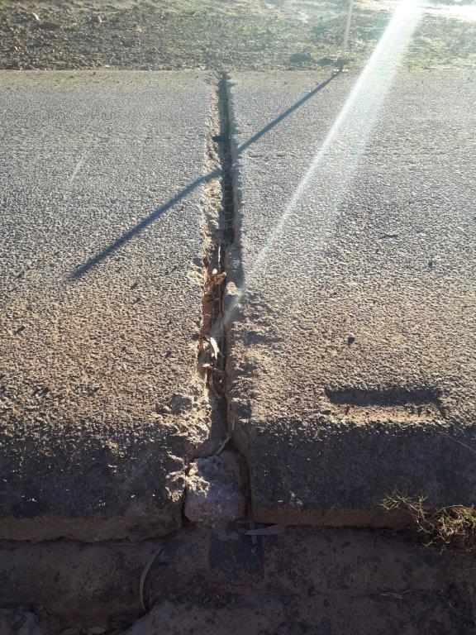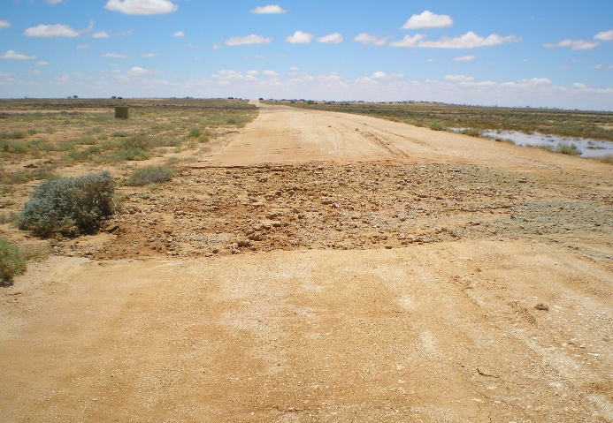

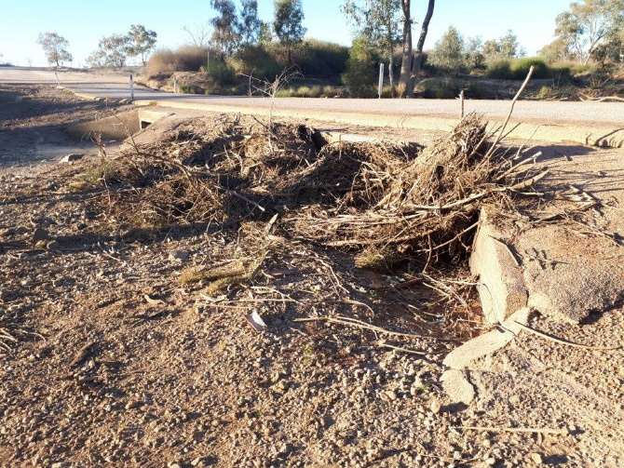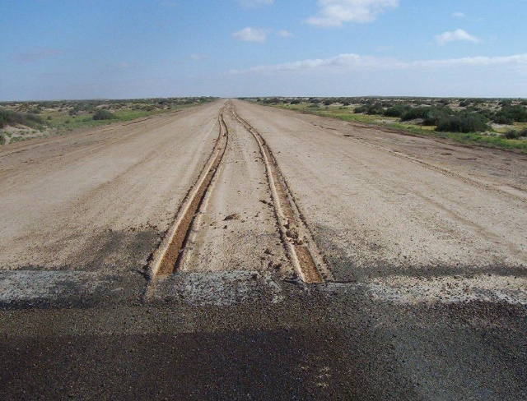

Poor
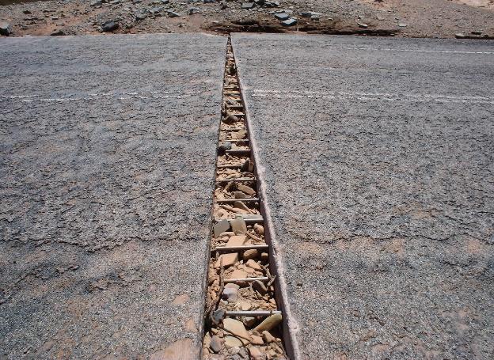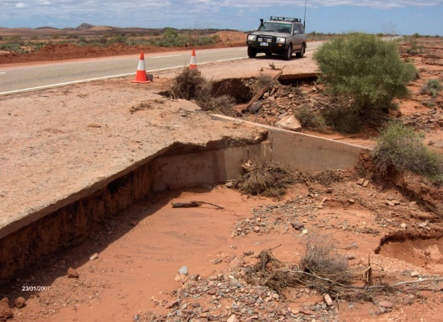
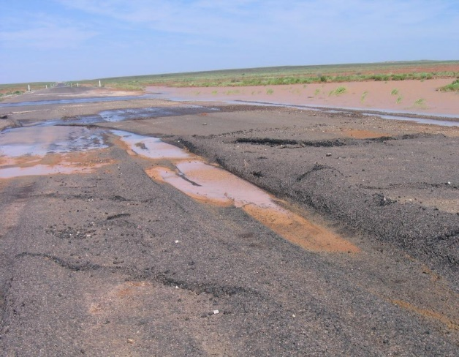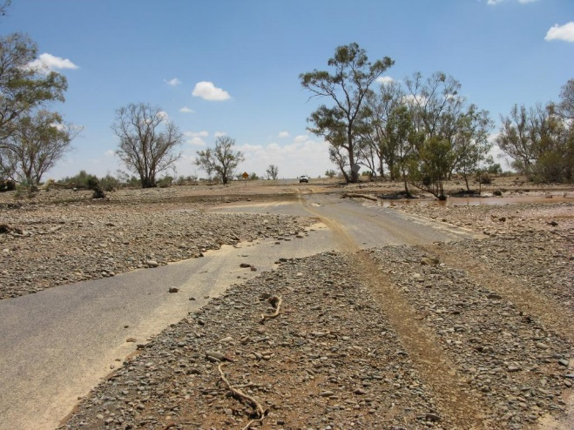

Unserviceable


