Design Departure / Extended Design Domain (EDD) Procedure

Standards & Guidelines

Road Design

K Net Number: 12971461
Document Revision: 2
Document Date: 22/01/19

Document Amendment Record
Rev | Change Description | Date | Author | Checked | Authorised
1 | Initial Issue | 18/08/18 | J Davies | E Winkler | A Glavinic
2 | Section 11.1 updated | 01/07/19 | J Davies | E Winkler | A Glavinic

Document Management
This document is the Property of the Department of Planning Transport and Infrastructure (DPTI) and contains information that is confidential to DPTI. It must not be copied or reproduced in any way without the written consent of DPTI. This is a controlled document and it will be updated and reissued as approved changes are made.

To be read in conjunction with DPTI Brownfield / Greenfield Guideline:
Location | Document Ref
Internal | Knet# 12986288
External | https://www.dpti.sa.gov.au/standards/road_design_outputs

Extended Design Domain application form:
Location | Document Ref
Internal | Knet# 10322417
External | https://www.dpti.sa.gov.au/standards/road_design_outputs

Contents

Contents 3
Figures 3
Design Departure / EDD Procedure 4
1 General 4
2 Introduction 4
3 Purpose 4
4 Scope 4
5 Related Documents 5
6 Definitions 5
7 General approach 5
8 EDD Principles 5
9 Controlling Criteria 7
10 Roles and Responsibilities 8
11 Documentation 8
12 Approval Stages 10
13 Monitoring and Evaluation 10
14 References 11

Figures

Figure 1: Conceptual Diagram showing the design domain (QMR, 2005) 7
Figure 2: Design Departure / EDD process 9
Figure 3: Documentation / approval process (Main Roads Western Australia, 2018) 10

Design Departure / EDD Procedure

General
    - Austroads guides should be adopted to provide a level of consistency and harmonization across all jurisdictions. The Austroads guides will be the primary technical reference. This supplement is issued to clarify, add to, or modify the Austroads Guides.

Introduction
    - This procedure forms part of the project management framework, which provides the key structural elements for managing and governing projects undertaken by DPTI. The framework includes policies, standards and guidelines aimed at successfully delivering projects, and tools and templates that help facilitate delivery of projects.
    - While it would be preferable that all road design fall within existing standards and guidelines. Occasionally departures in design may be deemed to be warranted. These departures require examination to ensure that the justification is warranted, and also to ensure the departure is subject to a risk assessment. Consultation with all necessary/relevant stakeholders within the Department is also required as part of this process.
    - A brownfield site is a location where development or constraints influence the design to the extent that use values outside the normal design domain (NDD) may be necessary for one or more elements of the design.
    - The Austroads guides to Road design provides NND suitable for greenfield sites. The use of design parameters outside NDD requires approval.
    - Design Departures can only be granted using a documented management process.

Purpose
    - The purpose of this document is to describe how Safety & Services Division develops and approves design departures, or extended design domain, where proposed design falls outside of the scope of projects, as outlined in the respective CSTR, or outside of the normal design domain.

Scope
    - This document applies to design departures, or extended design domain, to be used in the design of roads under the care and control of the State Government.
    - Typical uses of this document include, but are not limited to:
- The generation of design departures not complying with project CSTR
- The generation of Extended Design Domain (EDD) proposals
- Facilitation of consultation with appropriate stakeholders
- Seeking and issuing approvals
- Updating the necessary registers
- Inform the Design Report

Related Documents
    - The following documents support or are related to this document:
Document Name | DOCUMENT NUMBER
DPTI Master Specification
Design Departure / Extended Design Domain Application Form | https://www.dpti.sa.gov.au/standards/roads-all#roaddesignoutputs  kNet #10322417
DPTI Brownfield / Greenfield Guideline | https://www.dpti.sa.gov.au/standards/roads-all#roaddesignoutputs  kNet #12986288

Definitions
Term | Definition
NDD - Normal Design Domain | The normal limits for the values of parameters that have traditionally been selected for new roads.
EDD - Extended Design Domain | A range of design values below the minimum values traditionally specified for new roads in road design guidelines
kNet | DPTI Electronic Record and Document Management System
CSTR - Contract Scope and Technical Requirements | A document based on the DPTI Master Specification, containing the specific scope and design requirements for the project.

General approach
    - The necessity to depart from the approved design should be identified during the early stage of any project, i.e. in the design or pre-construction stage. This approach will provide sufficient time to do the risk assessment and allow reviewers to examine the proposal and any supporting documents in a timely manner.
    - Extended Design Domain (EDD) must not be applied at the reference design stage or similar.
    - When using this form for EDD, evidence shall be included that indicates all reasonable steps have been undertaken to achieve Normal Design Domain (NDD) prior to the consideration of EDD.
    - NDD criteria should be applied where possible. If site constraints restrict the upgrade of the existing geometric alignment with normal design domain standards, and acceptable operational and safety levels can be maintained, the use of EDD can be considered as part of the upgrade works. The use of EDD is limited to only one design element and must be accompanied with an off-set element designed above minimum NDD. This procedure provides technical approval of the design only. Final approval of installation/construction of design remains with the Project Manager/Sponsor. This procedure can be applied to NDD and other non-standard applications where applicable.
    - To be formally approved, a decision to use EDD criteria must be supported by a well-documented risk assessment that gives careful consideration to appropriate mitigation strategies. The risk assessment must be unbiased, clearly demonstrate the proposed benefits and show how risks will be managed. Further, any proposed mitigation measures must comply with relevant standards and be appropriate to the risk identified.

EDD Principles
    - EDD is only applicable if any/all of the following apply:
- There are significant controls/constraints on the site.
- Significant investment would be required to ameliorate the constraint and it is unjustifiable in the scope of works.
- The existing facility is likely to have been designed to a lesser standard.
- There is no accident/crash history or operational problems associated with the site, relating to the EDD parameter under consideration.
- The use of EDD within DPTI is considered an acceptable standard, provided its application is justified accordingly within an approval form
- Designers should consult with the delegated representative from DPTI for advice and direction with respect to an appropriate standard when values within the design domain are not achievable
- If using EDD values, the reduction in standard associated with their use should be appropriate for the prevailing local conditions.
- Generally, EDD should be used for only one parameter in any application and not be used in combination with any other minimum or EDD value for any related or associated parameters.
- Design values used outside of Normal Design Domain (NDD) are only to be used if approved in writing by the delegated representative within DPTI
- EDD report approvals are to be submitted in conjunction with the relevant design reports
- The implementation of registering EDD provides DPTI with records and ongoing monitoring of projects and locations where EDD has been used.
    - Information provided in support of EDD should, where possible, limit the use of jargon and be in plain English.
    - Departures shall be documented and justified using approval form as stated in section 4. Consultation with the project manager should be undertaken to determine the necessity and whether Section C of the form is applicable.
    - Figure 1 illustrates a conceptual diagram showing design domain. EDD shows an increase in risk and increase in liability (QMR, 2005)
Figure 1: Conceptual Diagram showing the design domain (QMR, 2005)
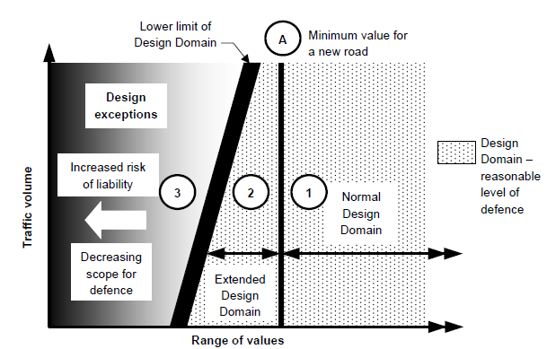

Controlling Criteria
    - The following criteria have been identified as having ‘substantial importance to the operational and safety performance of any roadway’. Any proposed variations from NDD must approved in writing through the EDD process:
- Design speed
- Lane width
- Shoulder width
- Bridge width
- Horizontal alignment
- Superelevation
- Vertical alignment
- Grade
- Stopping sight distance (including Approach Sight Distance at intersections)
- Cross slope
- Vertical clearance
- Lateral offset to obstruction
- Structural capacity / design vehicles
- Acceleration lane length
- Deceleration lane length
- Waterways capacity / serviceability requirements
- Pavement design

Roles and Responsibilities
    - Proposer
The proposer is responsible for recommending the departure by completion of the Design Departure/EDD Application Form. By completion of the form the proposer undertakes the consultation and completing the risk analysis and issues register defining the safety risk and impacts of the design departure.
    - Project Representative
The Project Representative is to be nominated by name within the DD/EDD Form and is responsible and accountable for ensuring that the requirements of the form are completed and all necessary information required to enable the Principle Road Advisor or subsequent approver to make a decision.
The Project Representative may be the Proposer.
    - Project Manager
The Project Manager is responsible for reviewing the form and ensuring that;
- The Proposer and Project Representative have completed the DD/EDD Form appropriately;
- Advising of any further considerations that should be considered when the Design departure or EDD is submitted for approval.
    - Principal Road Design Engineer
The Principal Road Design Engineer is responsible for approving Design Departures.
    - Manager Technical Services
The Manager, Technical Services is responsible for approving/rejecting Extended Design Domain requests and the mitigating treatments therein proposed. The Manager Technical Services may deem the proposal sensitive enough to warrant approval by more senior management.

Documentation
    - Design Departures and EDD decisions are to be documented within the standard project management process and included in the Design report (#kNet 2238920) (Design Report - DPTI)/ Drawing Acceptance Form (DAF).
    - This process is shown in Figure 2.
Figure 2: Design Departure / EDD process
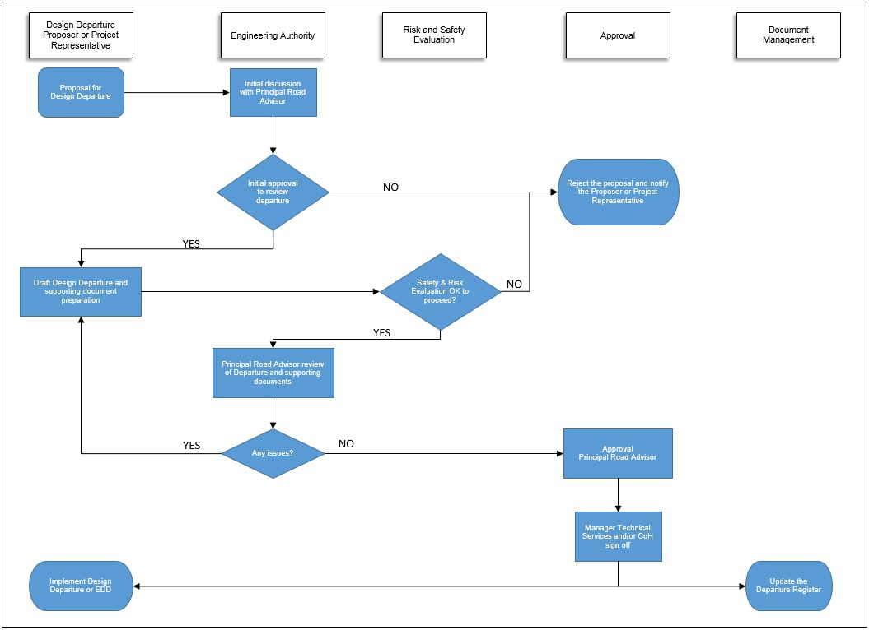
The amount of documentation will vary according to the complexity of the element. Figure 3 illustrates the content required for EDD approval.

Figure 3: Documentation / approval process (Main Roads Western Australia, 2018)
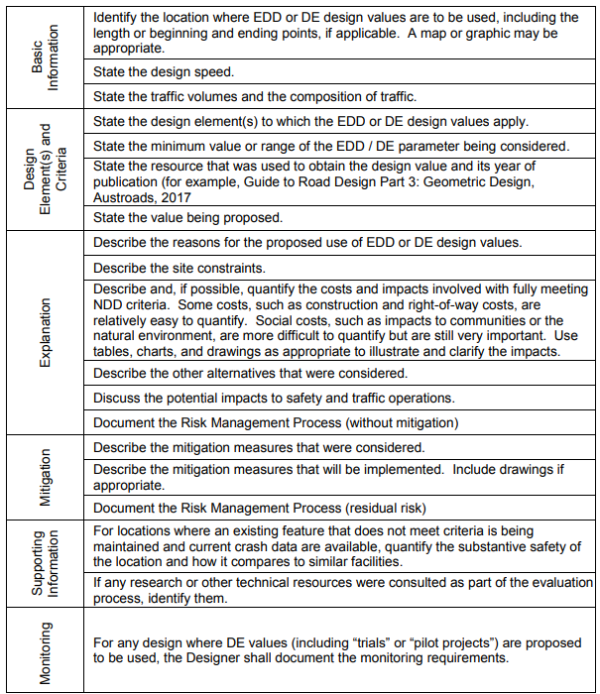

Approval Stages
    - The EDD process is anticipated to take place at either the preliminary design or detailed design stage. It is not required for concept stage because it is deemed to be too early to apply standards that do not conform to NDD. It is also not anticipated the process should not be commenced at final design as it is deemed too late in the design to apply standards that to not conform to NDD design values.

Monitoring and Evaluation
    - If deemed necessary, the asset will be monitored once construction is complete for a considerable period of time. This is to demonstrate to the agency the decision to balance safety against other factors such as cost is worth the trade off and prove the methodology. The monitoring process will conform to the DPTI master specification

References
- Austroads Guides to Road Design, available from https://www.onlinepublications.austroads.com.au/
- DPTI Standards and Guidelines, available from http://www.dpti.sa.gov.au/standards
- QMR, Design Philosophy, 2005
- Main Roads Western Australia, Guidelines for EDD & Design Exception Process, 2018

