Deflectograph:
To Determine Pavement Strength

Tech Note 27

INTRODUCTION
The Deflectograph is a non-destructive testing device used to evaluate the structural condition of pavements for rehabilitation projects, research, and pavement structure failure determinations.
To determine the pavement condition it is necessary to measure the deflection of the pavement under prescribed loads using standardised procedures. This can be done using two automated devices available in South Australia. They are the Deflectograph and the Falling Weight Deflectometer (FWD).
The Deflectograph (4000), in use with the DPTI, was manufactured by WDM, Bristol, UK.
Selecting the type of rehabilitation to be used for given situation is of considerable economic significance and to arrive at that decision without any knowledge of the structural condition of the pavement may be expensive.

DISCUSSION
The Deflectograph is a fully self-contained, vehicle mounted system of standard configuration, consisting of a deflection measuring assembly and data recording electronics.
Deflections of pavements in South Australia can range for example from 0.3 mm to 1.0 mm. Pavement deflections will occur every time a vehicle passes over the road but they vary in intensity, depending upon the size of the load being applied by the vehicle through the tyres.
Deflectograph is used to measure the deflection of the road surface under a rolling wheel at standard loading conditions, operating at a survey speed of 2.5 km/h.
The Deflectograph is an automated deflection measuring system based on the Deflection Beam principle and deflection measurements are taken in both wheel paths. The deflection beams, and reference frame are at rest during the deflection measurement cycle and remain stationary until the maximum deflection has been recorded. At this point in the cycle the reference frame is then pulled forward at twice the vehicle speed to the initial position for the next measurement cycle.
Operation of the machine requires ongoing maintenance, regular calibration and daily checks. The latter occurs particularly during testing.

REFERENCES
Deflectograph 4000; Operation and maintenance manual, DWM, Bristol, UK, 2006, p125.
Pavement rehabilitation – A guide to the design of rehabilitation treatment of road pavements, (2004), AP-G78/04, Austroads, Sydney.

Contact:
D Holloway
Supervising Testing Officer, Field Testing,
Pavements Engineering Unit
Technical Services Group
(08) 8260 0588

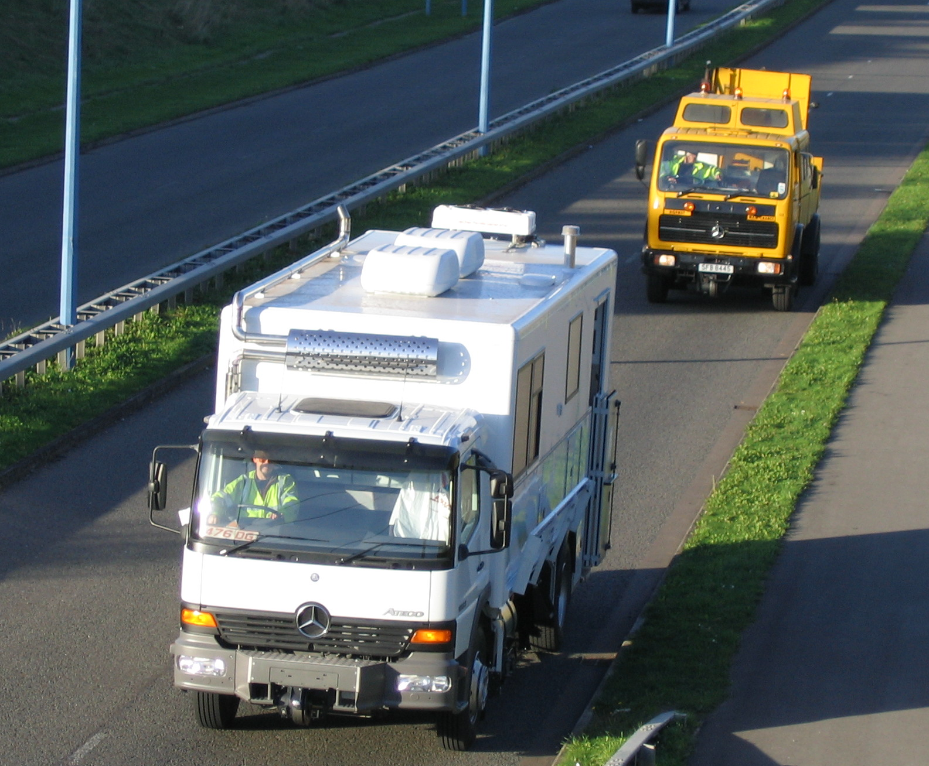

DPTI, Deflectograph vehicle.

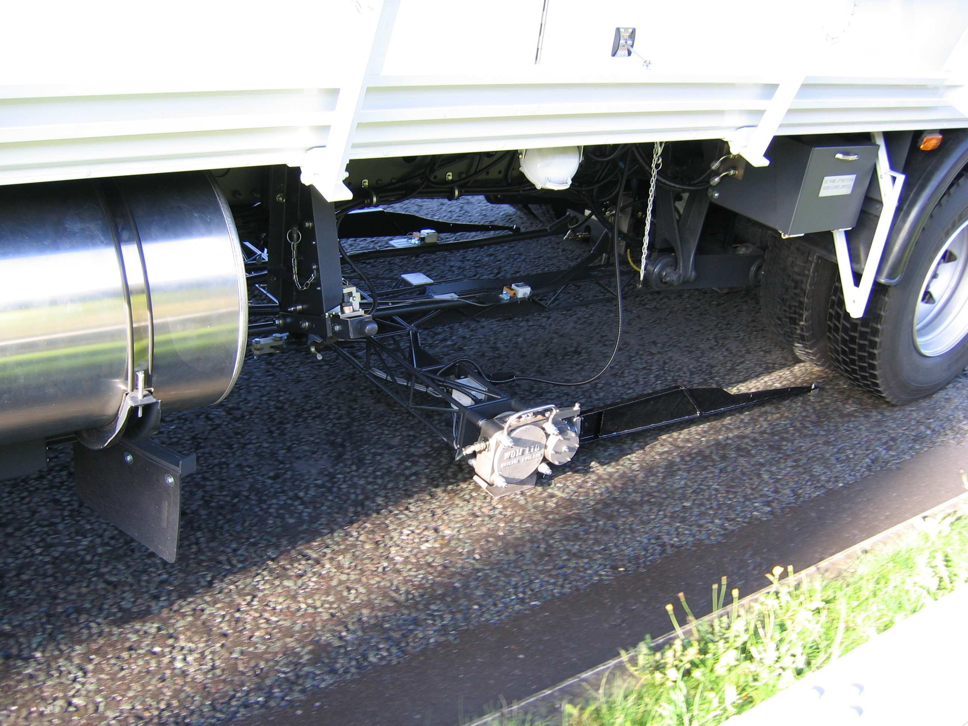

Deflectograph beam used to
measure pavement deflections

