South Australian Government Department for Infrastructure and Transport
Disability Access and Inclusion Plan 2020–2024
Easy Read version

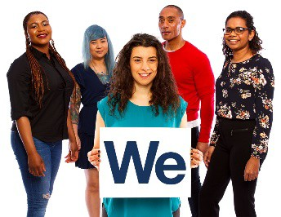
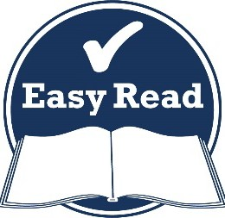
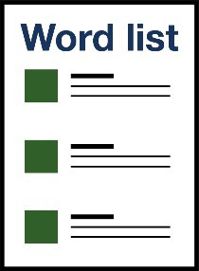
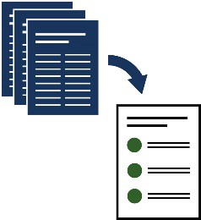
How to use this plan

The South Australian Government Department for Infrastructure and Transport (DIT) wrote this plan. When you see the word ‘we’, it means DIT.
We wrote this information in an easy to read way. We use pictures to explain some ideas.
We have written some words in bold.

This means the letters are thicker and darker.
We explain what these words mean. There is a list of these words on page 28.
This Easy Read plan is a summary of another plan. This means it only includes
the most important ideas.
You can find the other plan on our website at
dit.sa.gov.au

You can ask for help to read this plan.
A friend, family member or support person may be able to help you.
We recognise First Nations peoples as the traditional owners of our land – South Australia.
First Nations people are also known as Aboriginal and Torres Strait Islander people.
They were the first people to live on and use the:

- land

- rivers

- seas.

What’s in this plan?
About us 5
What we want for South Australia 6
The laws that apply 8
What people told us 10
Our Disability Access and Inclusion Plan 13
- Communities that include everyone 15
- Leading and working together 17
- Accessible communities 20
- Learning and working 23
Making sure our plan works 26
Word list 28
Contact us 31

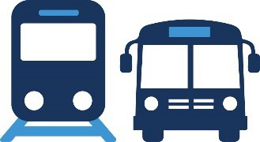
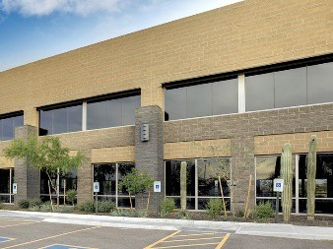
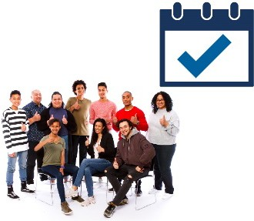
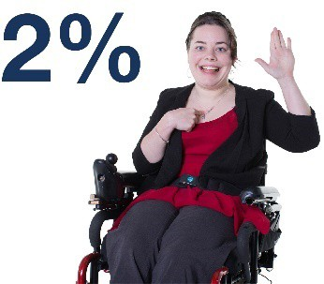
About us

DIT is part of the South Australian Government.
We look after South Australia’s:
- public transport
- roads
- public and government buildings.
We also keep the community up to date about:

- public transport
- roads.
2% of our team are people with disability.

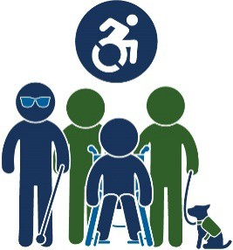
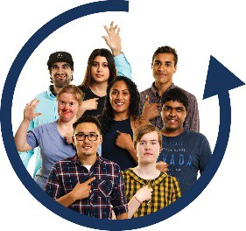
What we want for South Australia

We want to make South Australia:
- accessible
- inclusive.
When something is accessible, everyone can use it. This might be:
- a place or a building

- transport

- a service

- information

- a website.
When something is inclusive, everyone can take part.

We want South Australia to be a place where everyone is treated:
- with respect
- fairly.
We also want South Australia to be a place where everyone:
- can work safely
- feels supported

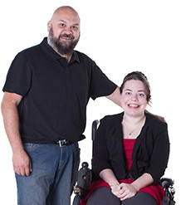
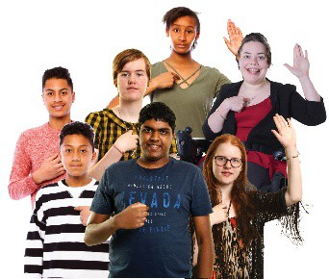
- is given the same chances to do things.

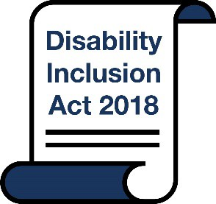
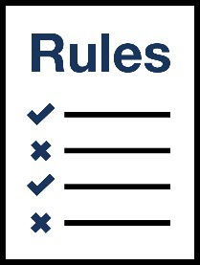
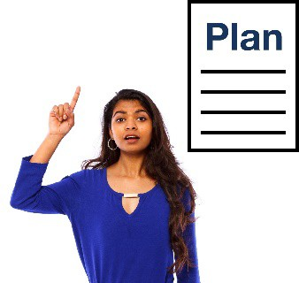
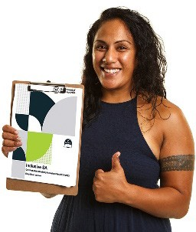
The laws that apply

In South Australia we have a law called the
Disability Inclusion Act 2018 (the Act).
The Act explains the rules that everyone needs to follow.
The Act makes sure people with disability in South Australia are treated fairly.
The Act says that we must have a Disability Access and Inclusion Plan.
We call it a plan.
We must also follow the State Disability Inclusion Plan (Inclusive SA).

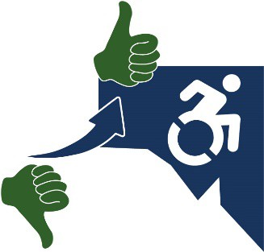
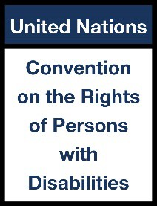
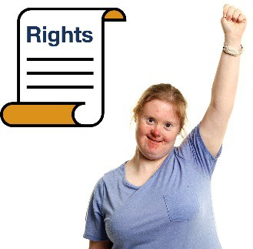

Inclusive SA is a plan to make life better for people with disability in South Australia.
We also follow the United Nations Convention on the Rights of Persons with Disabilities (the UN Convention) in our plan.
The UN Convention is a document that sets out the
rights of people with disability around the world.
Rights are rules about how everyone should be treated fairly.

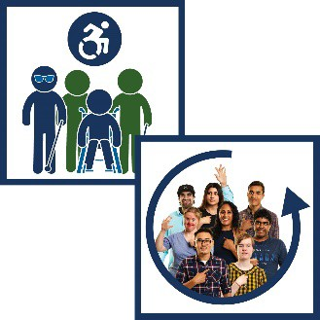
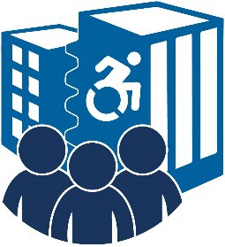
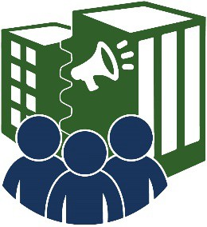
What people told us

We asked people to share their ideas about how to make South Australia more:
- accessible

- inclusive.
These people were from:
- our team
- the South Australian community
- disability organisations
- advocacy organisations.

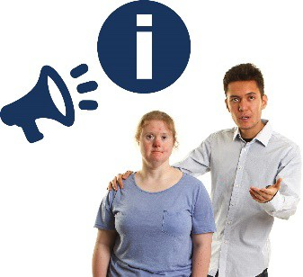
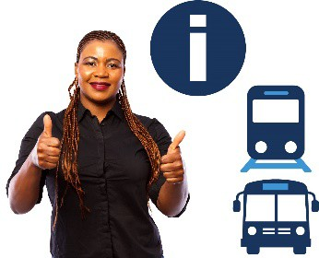
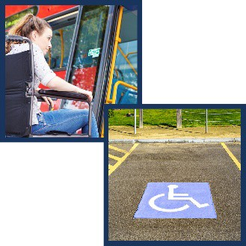
Advocacy organisations are groups that speak up for people with disability. They can:
- help you have your say
- give you information and advice.
People told us we should make information about public transport more accessible.
People also said there should be more accessible:

- public transport

- car parks.
People told us we should help First Nations people with disability feel safe when they use public transport.
People told us we need to put accessible pathways next to:
- main roads
- places where roads meet.

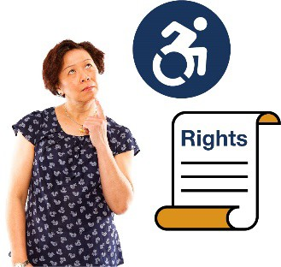

People told us we need to help our team understand the rights of people with disability.
We have included these ideas in our plan.

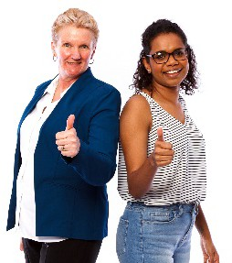
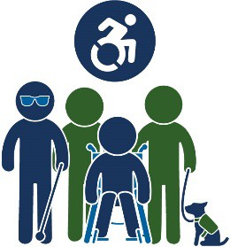
Our Disability Access and Inclusion Plan

Our Disability Access and Inclusion Plan talks about what we will do over the next 2 years to make South Australia more:
- accessible

- inclusive.
We call it our plan.
Our plan has 4 main themes:
1. Communities that include everyone
2. Leading and working together
3. Accessible communities
4. Learning and working

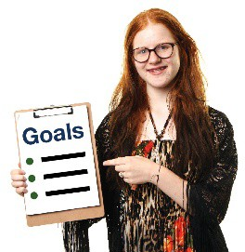

Each of these themes has a list of actions.

Our actions are the things we will do to reach our goals.
We talk about each theme in more detail on the following pages.

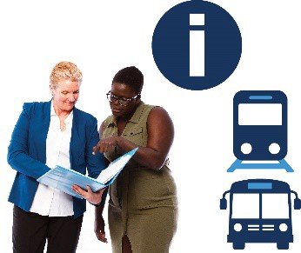
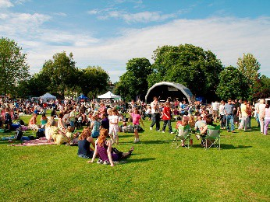
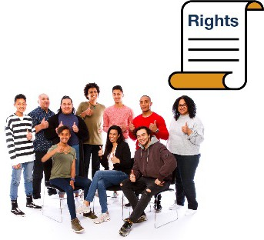
- Communities that include everyone

We want people with disability to be included in our community.
We want the rights of people with disability to be:

- valued
- respected
- protected.
We will share more information about accessible public transport.
We will use Inclusive SA to make our public events more:
- accessible
- inclusive.
We will help the community understand the rights of people with disability when they use
public transport.

We will look at how:
- well we teach our staff about working with people with disability
- we can make this training better.
We will make sure all our staff learn how to work with people with disability.
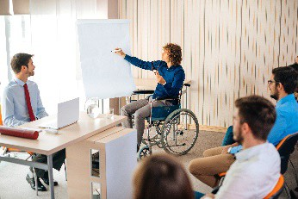
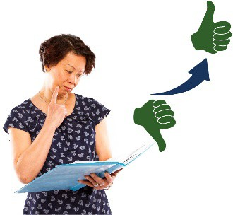
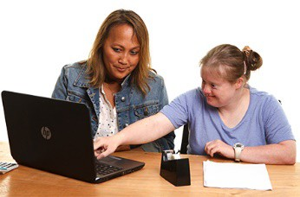

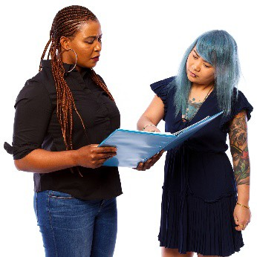
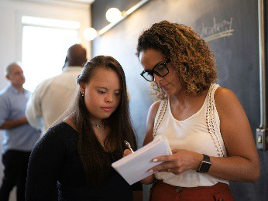
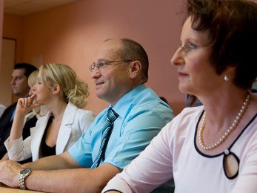
- Leading and working together

People with disability want to take part in decisions that affect them.
We want to hear what people with disability have to say when we make decisions that affect them.
We will make sure people with disability can take part in making decisions that affect them.
We will support staff with disability to join:

- boards
- committees.
A board is a group of people who make decisions for:
- an organisation
- a company.

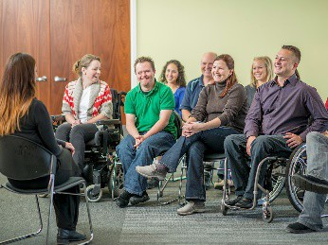
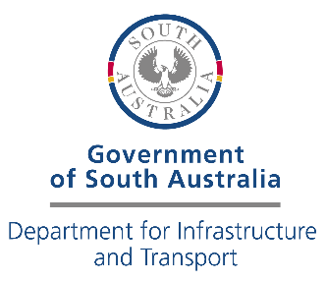

A committee is a group of people who meet to talk about ideas.
We will help DIT committees be more inclusive.
The Disability Action and Inclusion Committee (DAIC) is part of the DIT.
The DAIC helps us understand how we can make our work more:
- accessible

- inclusive.
We will talk to the DAIC about how we can make our projects more:
- accessible
- inclusive.

We will look at how we communicate with the community to see what:
- works well

- needs to be better.
We will use what we learn to communicate better with the community.
We will make sure people can make a complaint
in an accessible way.
When you make a complaint, you tell someone that something:
- has gone wrong
- isn’t working well.
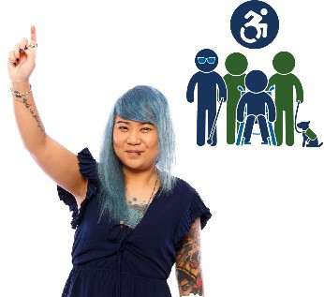

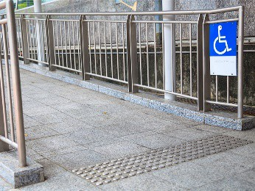
- Accessible communities

We can make sure we include people with disability if our:
- places and spaces are accessible
- community is inclusive.
This includes:

- public spaces

- transport

- services

- information.
We will make buildings and public spaces in South Australia more:
- accessible
- inclusive.

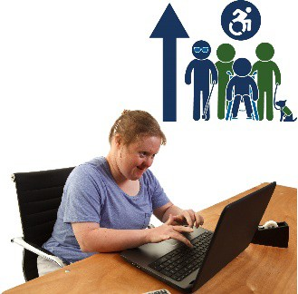
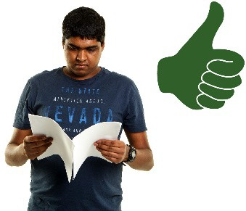
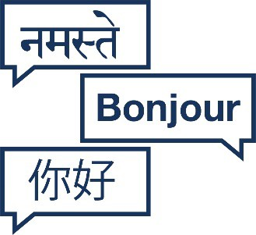
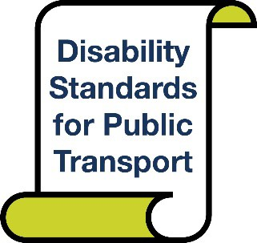

We will make our website more accessible.
We will share accessible versions of important documents.
This can include:
- Easy Read versions
- Braille versions
- versions in languages other than English.
We will work with the Australian Government on the new Disability Standards for Public Transport
2002 (the Standards).

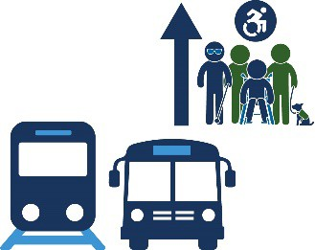
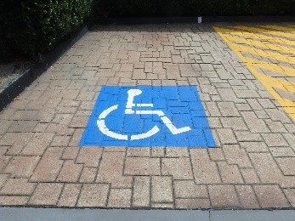
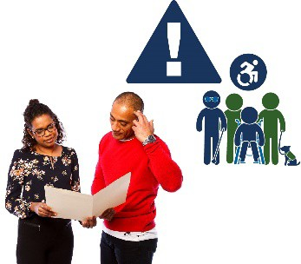

The Standards explain how to make public transport more accessible.
We will keep making public transport more accessible.
We will improve accessible car parks near:

- bus stops
- train stations.
We will make our projects more:

- accessible

- inclusive.
We will help solve accessibility problems that happen when we make our roads better.

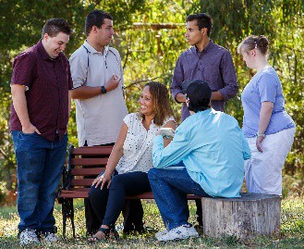
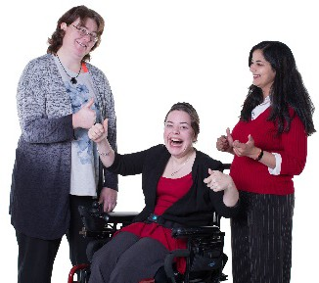
- Learning and working

When people with disability work, they can:
- earn their own money
- connect with other people
- take part in the community
- feel like they belong
- do more for themselves and do it on their own.

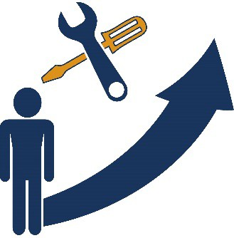
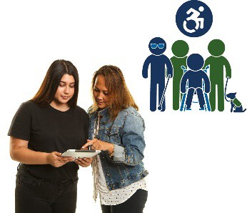
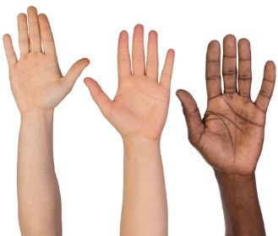
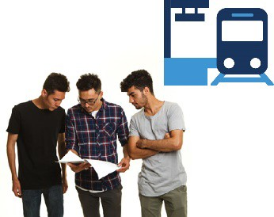

We will help our staff with disability have good careers.
Your career is the path you take in your chosen area of work during your life.
We will make accessible versions of our training information.
We will work with people with disability to have more chances to volunteer.
These volunteers can join different groups to help look after our train stations.
Volunteering means you work but don’t get paid. Volunteers usually do work that helps other people.

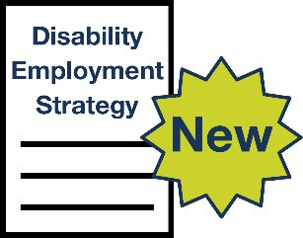

We will help make a new Disability Employment Strategy.
A Disability Employment Strategy explains how our government will make employment better for people with disability.
We will make the guides we use in our
workplaces more inclusive.
A workplace is any place you might work, such as:

- an office

- a factory

- a shop.
We will look at how we collect information about people with disability who:
- have a job

- keep their job.

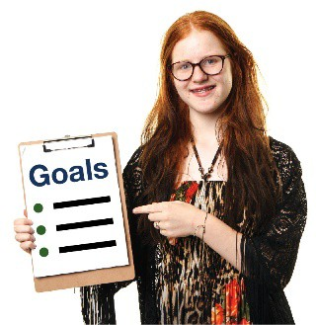
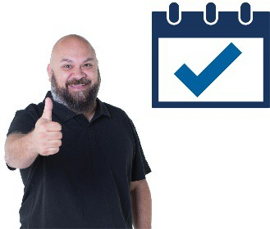
Making sure our plan works

We will keep track of how well our plan is going.
We will make sure it:
- talks about how we will reach our goals
- stays up to date
- meets the needs of people with disability.

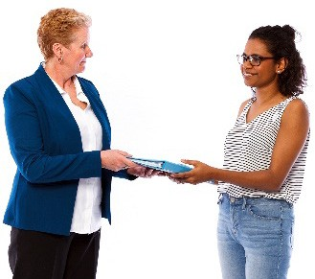
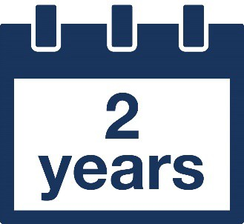

We will write a report about our plan each year.
We will share this report with the South Australian Government Department of Human Services.
Our plan will last for 2 years.

Word list

This list explains what the bold words in this plan mean.
Accessible

When something is accessible, everyone can use it. This might be:
- a place or a building

- transport

- a service

- information

- a website.
Advocacy organisations

Advocacy organisations are groups that speak up for people with disability. They can:
- help you have your say
- give you information and advice.
Boards

A board is a group of people who make decisions for:
- an organisation
- a company.

Careers

Your career is the path you take in your chosen area of work during your life.
Committees

A committee is a group of people who meet to talk about ideas.
Complaint

When you make a complaint, you tell someone that something:
- has gone wrong
- isn’t working well.
Disability Employment Strategy

A Disability Employment Strategy explains how our government will make employment better for people with disability.
First Nations
First Nations people are also known as Aboriginal and Torres Strait Islander people.

Inclusive

When something is inclusive, everyone can take part.
Rights

Rights are rules about how everyone should be treated fairly.
State Disability Inclusion Plan (Inclusive SA)

Inclusive SA is a plan to make life better for people with disability in South Australia.
Volunteer

Volunteering means you work but don’t get paid. Volunteers usually do work that helps other people.
Workplaces

A workplace is any place you might work, such as:

- an office

- a factory

- a shop.

Contact us

1300 872 677
DIT.AccessandInclusion@sa.gov.au
Department for Infrastructure and Transport GPO Box 1533
Adelaide SA 5001
dit.sa.gov.au/contact_us

The Information Access Group created this Easy Read document using stock photography and custom images. The images may not be reused without permission. For any enquiries about the images, please visit www.informationaccessgroup.com. Quote job number 3929.

