DPTI File No. 2017/XXXXX/01

DESKTOP VEGETATION ASSESSMENT REPORT
FOR LEVEL 1 NATIVE VEGETATION CLEARANCE UNDER THE
NATIVE VEGETATION REGULATIONS 2017
VS 2017/???

PROJECT:
RN (road number) and name e.g. RN22003 Gawler Ranges Road
MM XX – YY (location) e.g. MM 200.55 LHS, between Kingoonya and Yantanabie
Project name e.g. Bore IR24 and associated tank pad

GENERAL
The following report assesses impacts to native vegetation associated with Level 1 clearance under the Native Vegetation Regulations 2017. This assessment has been undertaken in accordance with:
- the Native Vegetation Council Guide for applications to clear native vegetation and
- the DPTI Vegetation Removal Policy, which is a Standard Operating Procedure under the Native Vegetation Act 1991 and is available online at www.dpti.sa.gov.au/documents/environment.

Criteria and escalating factors for Level 1 impacts to native vegetation (modified excerpt from Table 3.2 of DPTI Vegetation Removal Policy)
Impact Level |  | Escalating Factors
Agricultural Zone  (AMLR, EP, N&Y, SAMDB and SE NRM Regions) | Pastoral Zone  (AW and SAAL NRM Regions) | Escalating Factors
Level 1:
- Patches – 500 m² (0.05 ha) or less  AND/OR  - Scattered Trees – 5 trees or less  - Both the Patches and Scattered Trees can not include any trees with a trunk circumference of 500 mm or more measured at 1 m above the ground. | - Patches – 3 ha or less  AND/OR  - Scattered Trees – 5 trees or less  - Both the Area and Scattered Trees can not include any trees with a trunk circumference of 300 mm or more measured at 1 m above the ground. | The application is raised to a Level 2 if there is:  - a high likelihood that the site contains or is habitat for species listed under the NPW Act or a threatened community under the EPBC Act,  AND/OR  - an associated application within the last 5 years.

SITE AND PROJECT INFORMATION
Zone | e.g. Pastoral / Agricultural
NRM Region | e.g. SA Arid Lands
What is the purpose of clearance? | e.g. The department is planning re-sheeting works along Gawler Ranges Road (section between Kingoonya to Yantanabie from MM 202.00-214.65). To supply water for construction, it is proposed to use an existing water well. Vegetation clearance is sought to make a pad for the placement of three tanks for water storage as the bore pumps slowly.
Why is there no alternative involving no clearance or less clearance? | e.g. Other alternatives to source water and stand tanks would result in more vegetation clearance. The site selected is heavily disturbed with regrowth present.
Has there been any associated clearance application¹ in the last 5 years? | No
Yes Assessment does not meet Level 1 criteria.
Engage an Accredited Consultant for detailed assessment.
Shape file | A shape file must be provided to DPTI to be recorded in the DPTI Vegetation Removal Approval Status Sheet knet #10590236.

NATIVE VEGETATION AND FAUNA
The likelihood of the presence of threatened flora and fauna species, and that of threatened ecological communities, has been assessed via searches of the following databases undertaken on X Month 2017:
- Biological Database of South Australia (BDBSA) via DEWNR’s NatureMaps www.naturemaps.sa.gov.au (publically available)
- EPBC Protected Matters Search Tool www.environment.gov.au/epbc/protected-matters-search-tool, and
- Atlas of Living Australia www.ala.org.au.
Searches were undertaken for threatened flora and fauna species under the SA National Parks and Wildlife Act 1972 (NPW Act) and the Commonwealth Environment Protection and Biodiversity Conservation Act 1991 (EPBC Act), and for threatened ecological communities under the EPBC Act.

Proposed native vegetation clearance | e.g. Removal of 0.006 ha of highly degraded Chenopod open shrubland.
Do any trees potentially impacted have a trunk circumference (measured at 1m above ground level): | 50cm or more in the Agricultural Zone? | N/A Not in Agricultural Zone
 | 50cm or more in the Agricultural Zone? | No
 | 50cm or more in the Agricultural Zone? | Yes Assessment does not meet Level 1 criteria.  Engage an Accredited Consultant for detailed assessment.
 | 30cm or more in the Pastoral Zone? | N/A Not in Pastoral Zone
 | 30cm or more in the Pastoral Zone? | No
 | 30cm or more in the Pastoral Zone? | Yes Assessment does not meet Level 1 criteria.  Engage an Accredited Consultant for detailed assessment.

Is there a high likelihood that the site contains threatened flora species? | No
Yes Assessment does not meet Level 1 criteria.
Engage an Accredited Consultant for detailed assessment.
Is there a high likelihood² that the site contains or is habitat for threatened fauna species? | No
Yes Assessment does not meet Level 1 criteria.
Engage an Accredited Consultant for detailed assessment.
Is there a high likelihood² that the site contains a threatened ecological community? | No
Yes Assessment does not meet Level 1 criteria.
Engage an Accredited Consultant for detailed assessment.

Discussion of threatened flora species, fauna species and ecological communities, and moderating factors on the likelihood of them being present
Flora or fauna species /  Ecological Community name  (scientific and common) | Conservation status* |  | Comments and likely occurrence, including habitat description for fauna
 | NPW Act | EPBC Act
e.g. Calidris ferruginea  Curlew Sandpiper |  | CE | Mainly occur on intertidal mudflats in sheltered coastal areas, such as estuaries, bays, inlets and lagoons, and also around non-tidal swamps, lakes and lagoons near the coast, and ponds in saltworks and sewage farms. They are also recorded inland, though less often, including around ephemeral and permanent lakes, dams, waterholes and bore drains, usually with bare edges of mud or sand. They occur in both fresh and brackish waters.  EPBC Protected Matters Tool states: Species or species habitat may occur within area.  However, highly unlikely to be present within the clearance area as no suitable habitat is available.
e.g. Leipoa ocellata  Malleefowl | V | V | Semi-arid and arid mallee and reliant on large patches of long unburnt mallee with deep litter.  EPBC Protected Matters Tool states: Species or species habitat likely to occur within area.  However, highly unlikely to be present within the clearance area as no suitable habitat is available.
e.g. Sminthopsis psammophila  Sandhill Dunnart | V | E | Sandy arid and semi-arid areas in the Great Victoria Desert and the Eyre Peninsula. Occurs in vegetation dominated by hummock (Triodia) grassland. Shelters in nests in the centre of large hummocks, especially in hummocks that have started to die off in the centre. May use hollow logs for shelter.  EPBC Protected Matters Tool states: Species or species habitat likely to occur within area.  However, highly unlikely to be present within the clearance area as no suitable habitat is available.
* R = Rare, V = Vulnerable, E = Endangered, CE = Critically endangered

FURTHER INFORMATION
e.g. A vegetation clearance application was submitted for a borrow pit extension and approved by General Manager, Infrastructure Delivery on 14 September 2016 under the previous survey methods. Although this was related to the same re-sheeting project, it is not considered an associated application as it is located more than 5 kilometres away.

APPROVAL, SEB AND RECOMMENDATIONS

Approval | In accordance with the DPTI Vegetation Removal Policy, the approving authority for Level 1 clearance is the Senior Environmental Advisor.
Significant Environmental Benefit (SEB) | For approved Level 1 applications, the SEB is a Fixed $500 payment into the Native Vegetation Fund.
Recommendations | e.g.  - Impacts to vegetation must be confined to those approved in accordance with the DPTI Vegetation Removal Policy.  - Declared plant and/or environmental weed species, including Buffel Grass, have been identified on site and care must be taken during works to ensure these weeds are not spread.  - Phytophthora control must be undertaken in accordance with DPTI Phytopthora (Dieback) Control Environmental Instruction 21.3.  - Staff from DPTI Technical Services are available for further assistance and advice if required.

Report prepared by:  Name:  Job title:  Company:  Date: / / 2017 | Report checked by:  Name:  Job title:  Company:  Date: / / 2017
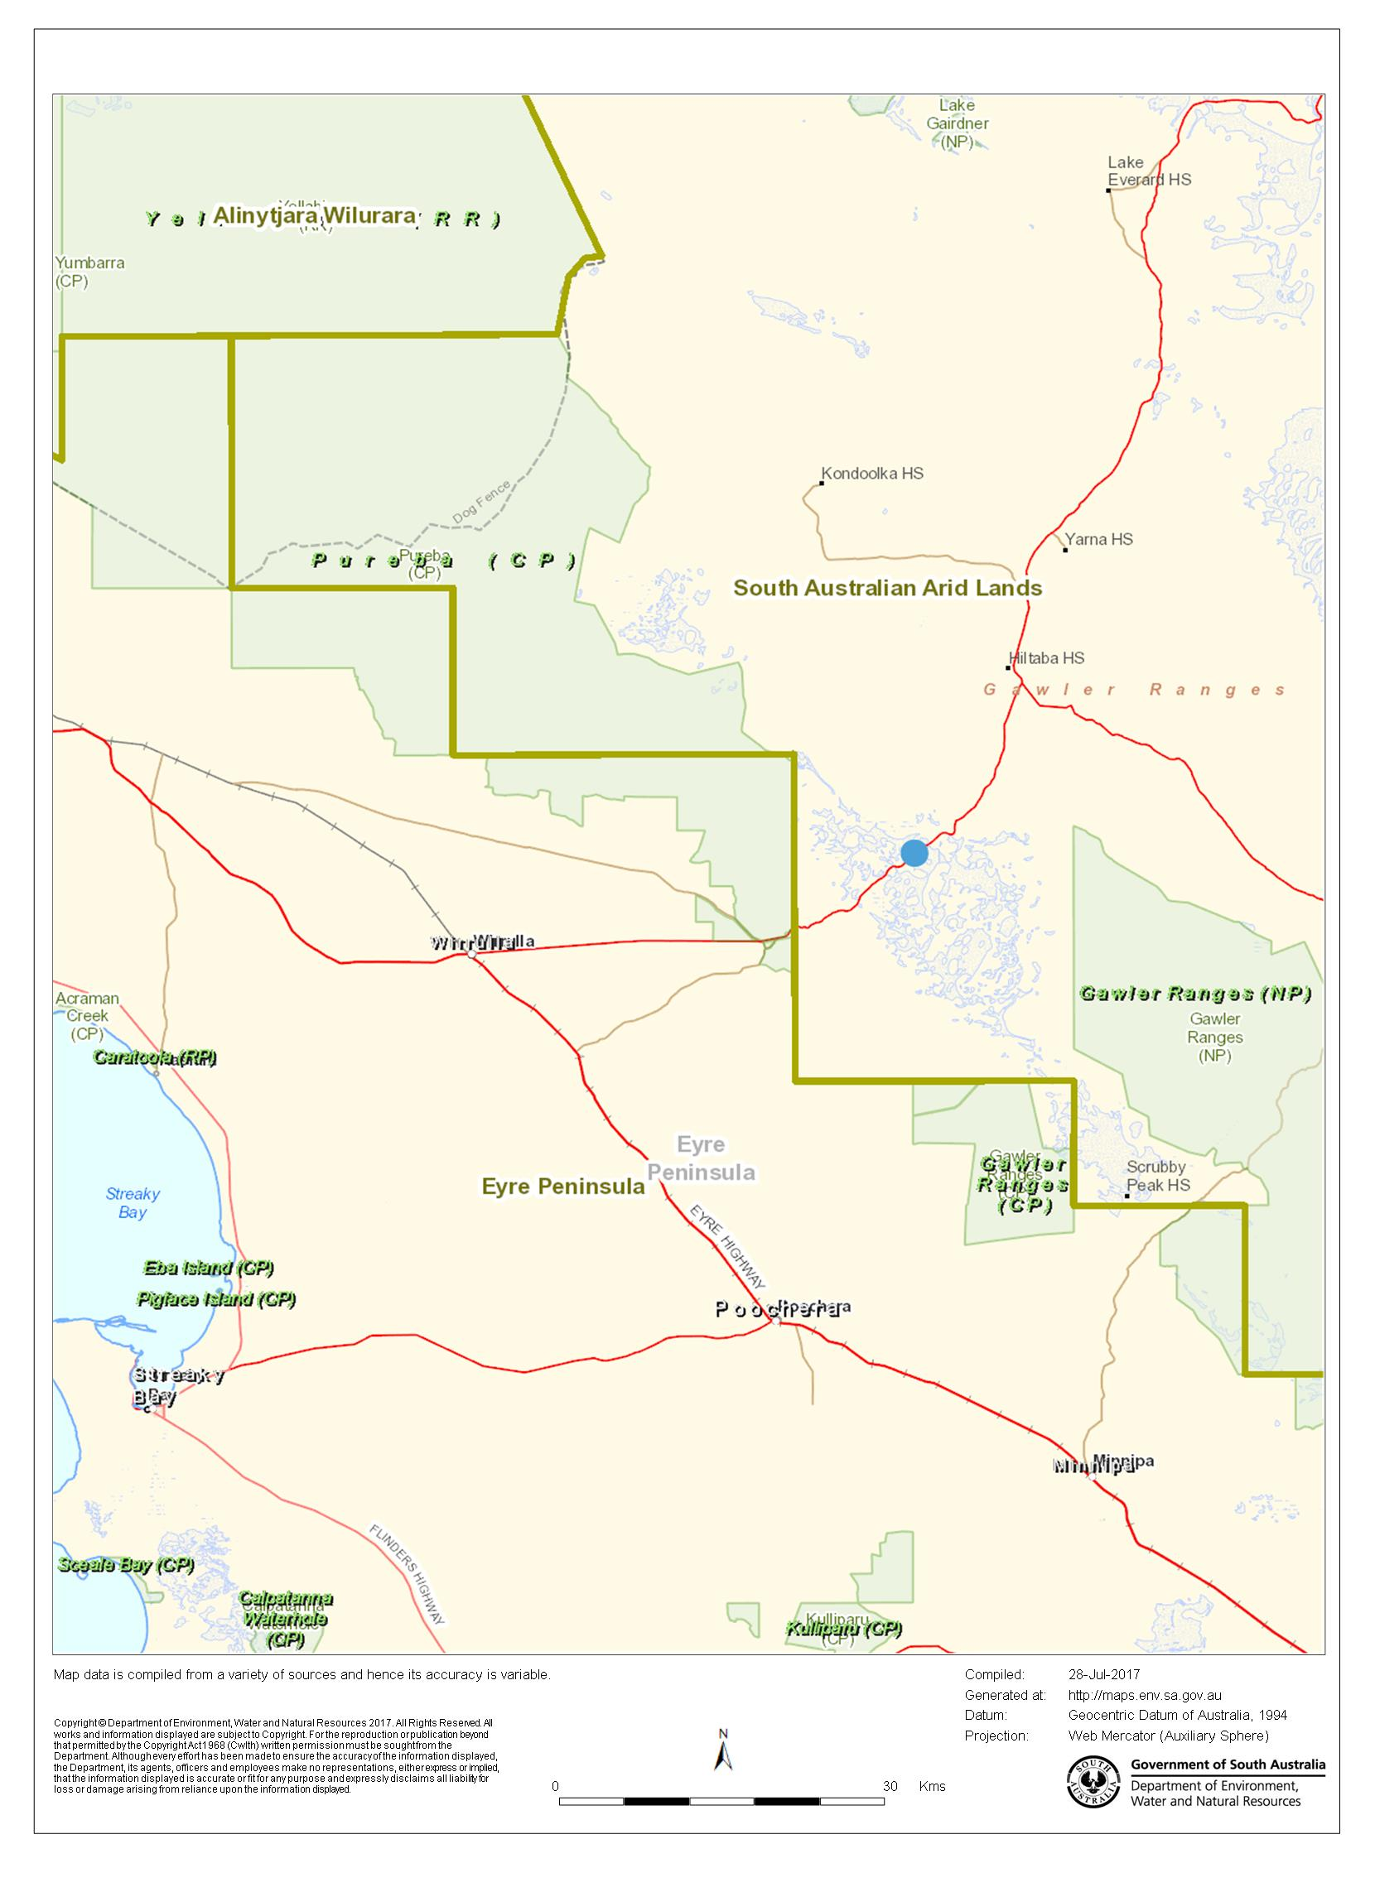
Figure 1: Map showing native vegetation clearance location (Source: NatureMaps, July 2017)

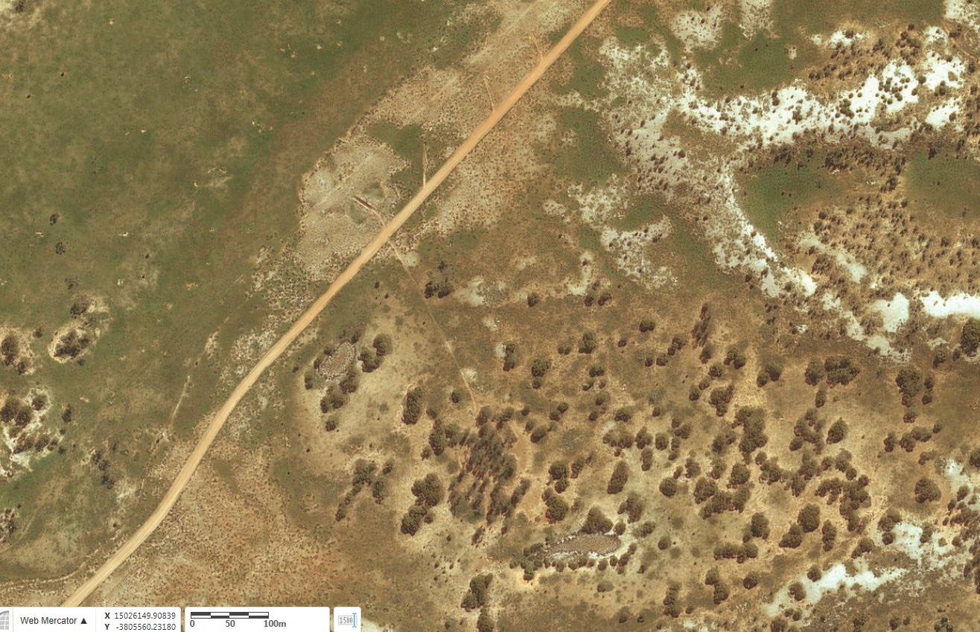
Figure 2: Map showing native vegetation clearance area (Source: NatureMaps, July 2017)

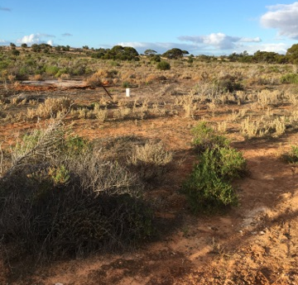
Figure 3: Site photograph, looking north east (Taken 1 July 2017)

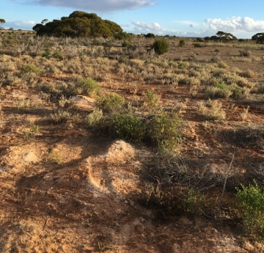
Figure 4: Site photograph, looking south west (Source: Google Street View, July 2017)

In accordance with the NVC Guide for applications to clear native vegetation and the Native Vegetation Regulations 2017, an application is associated when the following applies to DPTI: - An application to clear native vegetation was approved or has been applied for on the same property title within the last 5 years, regardless of whether the applicant was the owner of the land at the time of the previous application. - Where the applicant is not the owner of the land (e.g. local councils managing the land under their care and control, utility companies building infrastructure) or clearance will occur on land not subject to a property title (e.g. road reserve), an application to clear native vegetation was approved or has been applied for within 5 km of the proposed clearance area and directly related to the current application (i.e. for the same project, development or piece of infrastructure) within the last 5 years.
A site may be considered to have a high likelihood of the presence of threatened flora and fauna species, or that of threatened ecological communities, if those species/communities have been recorded within a 5 kilometre radius of the project site in the last 20 years with locational reliability of less than 1 kilometre, and/or as advised by expert opinion. For the EPBC Protected Matters Search Tool, only record species that state ‘Species or species habitat known to occur within area’. Moderating factors (e.g. level of disturbance, barriers to movement) should be considered when determining whether the likelihood is high. Expert knowledge (e.g. from DEWNR Native Vegetation Unit or Natural Resources regions) should be sought where there is uncertainty.

