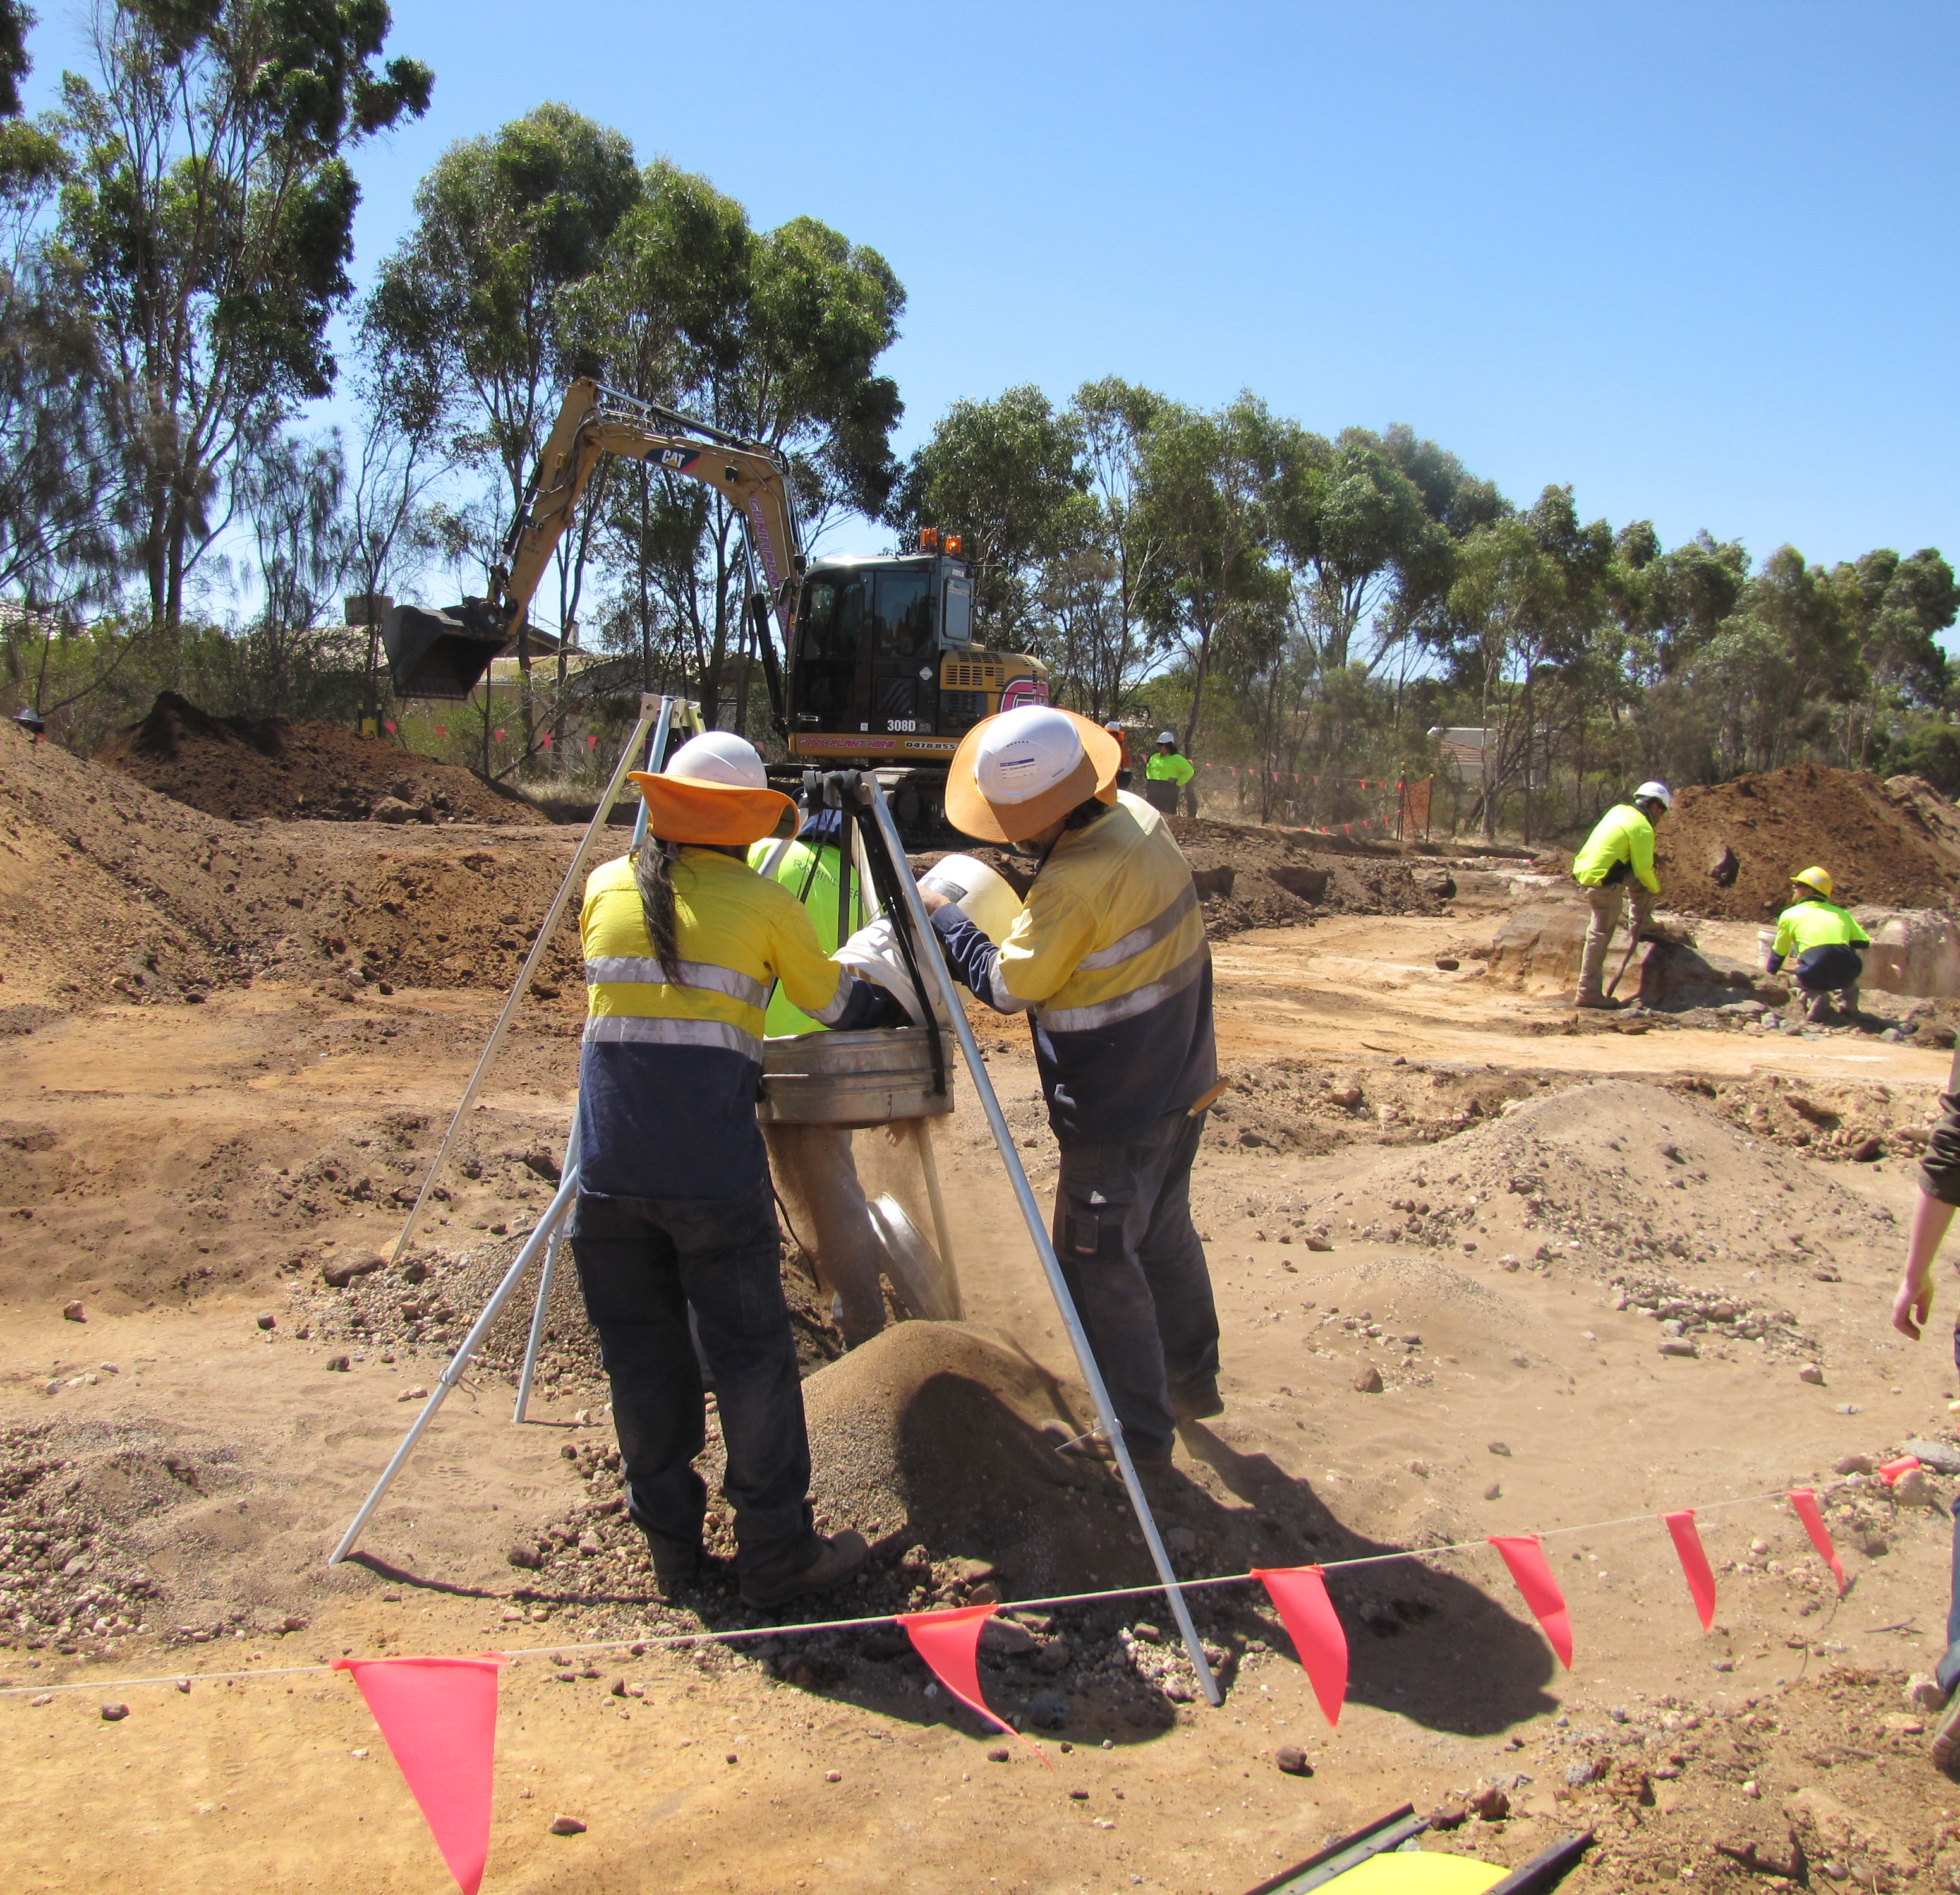

Superseded/repealed from 1 November 2021 – refer to https://www.dit.sa.gov.au/standards/environment

Aboriginal Objects, Sites and Remains Flow Chart

Department of Planning, Transport and Infrastructure
Aboriginal Objects, Sites and Remains Flow Chart
First published: May 2014
Updated: May 2016
Version 2

Copyright Department of Planning, Transport and Infrastructure
77 Grenfell Street
GPO Box 1533
Adelaide SA 5001

It has been approved and authorised for use by departmental staff and its authorised agents by:

19 May 2014

Extracts may be reproduced providing the subject is kept in context and the source is acknowledged. Every effort has been made to supply complete and accurate information. This document is subject to continual revision and may change.

To ensure you have the most up-to-date version of this document refer to
Technical Documents - DIT

For information regarding the interpretation of this document contact:
Stormwater, Environment and Heritage Unit, Asset Management Directorate
Telephone: (08) 8343 2398 Facsimile: (08) 8343 2905

Contents

1. PURPOSE 4
2. LEGISLATION 4
3. PRE-PLANNING 5
4. Managing the discovery and treatment of skeletal remains 8
4.1 Stop work and notification 8
4.2 Negotiations on the treatment of Aboriginal remains 8
Appendix 1 – Legislation References 10

PURPOSE
The flow charts presented in Figures 1 and 2 illustrate the procedure to be followed when archaeological objects, sites or skeletal remains are disturbed during construction of infrastructure projects or maintenance activities. The procedure applies to all work undertaken by departmental contractors. Table 1 provides a list of abbreviations used in Figures 1 and 2.

Table 1: Abbreviations
DSD-AAR | SA Department of State Development - Aboriginal Affairs and Reconciliation
DPTI | SA Department of Planning, Transport and Infrastructure
EMR | Contractor Environmental Management Officer
EO | DPTI Environment Officer
Forensic Science SA | SA Attorney-General’s Department, Forensic Science SA
S12 | SA Aboriginal Heritage Act 1988, Section 12-Determination of whether site or object is an Aboriginal site or object
S23 | SA Aboriginal Heritage Act 1988, Section 23-Damage etc to sites, objects or remains
S37 | SA Aboriginal Heritage Act 1988, Section 37-Preservation of right to act according to tradition
SAPOL | South Australian Police

LEGISLATION

The relevant legislation with regard to the management of Aboriginal objects, sites and remains is the Aboriginal Heritage Act 1988 (the Act). The Act is administered by the Department of State Development - Aboriginal Affairs and Reconciliation (DSD-AAR).

Section 21 of the Act prohibits the excavation of land for the purpose of uncovering any Aboriginal site, object or remains, without the permission of the Minster.

Approval is required under Section 23 of the Act to damage, disturb or interfere with Aboriginal objects, sites or remains, although this does not extend to Aboriginal people acting in accordance with tradition. Section 37 of the Act preserves the right of Aboriginal people to do anything in relation to Aboriginal sites, objects or remains in accordance with Aboriginal tradition, without the need to seek approval under Section 23.

Approval is required under Section 29 of the Act to remove an Aboriginal object from the State.

Section 35 of the Act prevents people from divulging information relating to Aboriginal sites, objects, remains or traditions in contravention of Aboriginal tradition without the authority of the Minister.

The Minister may delegate any of the Minister's powers or functions under this Act other than the power to authorise the commencement of proceedings for an offence against this Act (Section 6).

Approval for non-cremated human remains to be exhumed or removed from their place of interment is also required under the Local Government Act 1999 (Exhumation of Human Remains) Regulations 2005. This approval can be obtained by writing a minute to the Chief Executive, Attorney-General’s Department from the DPTI Chief Executive.

The Coroner's Act 2003 authorises SA Police to deal with discoveries of human remains.

PRE-PLANNING
The discovery procedure differs for sites which have already obtained Section 23 authorisation under the Aboriginal Heritage Act 1988. For some projects where there is a strong likelihood of encountering Aboriginal objects, sites or remains, DPTI may have obtained Section 23 Authorisation during the planning phase (this will be identified in the Contract). Often, for these projects, Aboriginal monitors will be present on-site during certain activities and an Archaeologist will be on-call for the duration of excavation works.

For some projects in high-risk areas, DPTI may have a pre-agreed management plan in place prior to commencing earthworks. This plan will document an agreed process for dealing with objects and remains, and may include who will attend site in the event of a discovery, how finds will be documented, temporary storage locations/facilities and possible reburial sites.

If a pre-agreed management plan exists, this will be identified in the Contract, and the details will be made available to the Contractor as appropriate.

Figure 1: Discovery procedure flow chart (without SECTION 23 authorisation)
Skeletal remains
Discovery of site, object or skeletal remains that may be Aboriginal Heritage.

STOP WORK in immediate area and redirect works to avoid further impact. Do not disturb, remove, touch or displace the skeletal remains.
Leaving objects in place – Site Supervisor to take photos and send to project Archaeologist (if a Project Archaeologist is on-call).
Objects

STOP WORK in immediate area and redirect works to avoid further impact. Do not disturb, remove, touch or displace the objects.
Leaving objects in place – Site Supervisor to take photos and send to project Archaeologist (if a Project Archaeologist is on-call).
Contractor’s EMR to contact DPTI EO.
Site Supervisor / Contractor’s EMR to notify Client Representative and DPTI EO.
If the Project Archaeologist advises that the remains are human, or if there is no Project Archaeologist to provide this advice, Site Supervisor to contact SAPOL (Tel 131 444).
The immediate area will become under the control of SAPOL for forensic investigation.
Client Representative to notify Communications staff

Forensic Science SA will determine if the remains are human. If human, whether they are ancestral or a crime scene.
EO to notify Project Manager and if not already on call, engage an Archaeologist to determine whether it’s a Site in accordance with the Act.

Non-human:
SAPOL provides site clearance. Area reverts to Contractor’s responsibility. Works fully resume.
Ancestral remains:
Area reverts to Contractor’s responsibility but works should not resume. Contractor to cordon off the area.
DPTI Site Manager will advise Contractor when work can resume.
Crime scene:
Area remains under control of SAPOL until further notice.
EO to apply for a S12 and/or S23 authorisation as appropriate (refer Appendix 1). If required, Project Archaeologist to submit site card to DSD-AAR.

DPTI Environment team to consult with relevant Aboriginal group(s) with interests in the project area to determine if they are in agreement regarding the treatment of the remains. Project Archaeologist to assist with this process. If not already engaged, DPTI will engage an Archaeologist.
For a S23, DSD-AAR will undertake consultation with Aboriginal people and organisations with an interest, including the State Aboriginal Heritage Committee, and report the outcomes to the Minister of Aboriginal Affairs and Reconciliation. If authorisation granted, works can resume.
Note: a S23 process can take 6-12 months.

If the Aboriginal group(s) are in agreement regarding the treatment of the remains subject to Aboriginal tradition, then under S37 of the Act works may proceed as agreed (refer Appendix 1).
If the Aboriginal group(s) are not in agreement regarding the treatment of the remains, DSD-AAR will advise on an appropriate course of action. This may include applying for a S12 and S23 authorisation (refer Appendix 1).
If required, Project Archaeologist to submit site card to DSD-AAR.

Figure 2: Discovery procedure flow chart (with SECTION 23 authorisation)
Skeletal Remains
Discovery of site, object or skeletal remains that may be Aboriginal Heritage.

Objects
*Note: it may be acceptable in some cases for the EO to email photos of the objects to the Project Archaeologist and receive advice via email on how to record the find prior to excavating, rather than the Archaeologist attending site.
STOP WORK in immediate area and redirect works to avoid further impact. Do not disturb, remove, touch or displace the objects.
Leaving objects in place – Site Supervisor to take photos and send to project Archaeologist. Contractor’s EMR to contact DPTI EO.

Non-human:
SAPOL provides site clearance. Area reverts to Contractor’s responsibility. Works fully resume.

Ancestral remains:
Area reverts to Contractor’s responsibility but works should not resume. Contractor to cordon off the area.
Contractor’s EMR to notify DPTI EO. DPTI Environment team to consult with relevant Aboriginal group(s) with interests in the project area. Project Archaeologist to assist with this process. Aboriginal representatives/ Archaeologist advise and manage any salvage or excavation and removal to temporary storage area (in accordance with previously agreed management plan, if prepared). DPTI EO to negotiate timing, funding and safe location for reburial.
DPTI Site Manager will advise Contractor when work can resume. Archaeologist submits site card and reports for burial and reburial to DSD-AAR.

Crime scene:
Area remains under control of SAPOL until further notice.

Aboriginal object(s):
Leave object(s) in situ until Archaeologist has recorded, bagged and labelled finds*.
Aboriginal site:
Archaeologist makes recommendations, i.e. salvage, excavation, research
Non-Aboriginal site/ object(s)
DPTI Project Manager decides on further action based on recommendations
Archaeologist stores object(s) securely (in accordance with an agreed management plan, if prepared).
Archaeologist reports discovery to DSD-AAR
Works can proceed.
Archaeologist to advise on significance and appropriate management.
STOP WORK in immediate area and redirect works to avoid further impact. Do not disturb, remove, touch or displace the skeletal remains.
Leaving objects in place – Site Supervisor to take photos and send to project Archaeologist.
Site Supervisor / Contractor’s EMR to notify Client Representative and DPTI EO.
Based on Project Archaeologist’s advice, if suspected human remains have been discovered, Site Supervisor to contact SAPOL (Tel 131 444).
The immediate area will become under the control of SAPOL for forensic investigation.
Client Representative to notify Communications staff.

Forensic Science SA will determine if the remains are human, and whether they are ancestral or a crime scene.

MANAGING THE DISCOVERY AND TREATMENT OF SKELETAL REMAINS

4.1 Stop work and notification
If skeletal remains are exposed during DPTI or Contractor works, all work must stop in the immediate area the Contractor shall:
- STOP WORK in immediate area and redirect works to avoid further impact. Do not disturb, remove, touch or displace the skeletal remains.
- Leaving objects in place – Site Supervisor to take photos and send to project Archaeologist.
- Site Supervisor / Contractor’s Environment Management Representative (EMR) to notify Client Representative and DPTI Environment Officer (EO).
- Based on the Project Archaeologist’s advice, if suspected human remains have been discovered, the Contractor’s Site Supervisor shall contact SA Police and advise of the discovery, it’s location and site access details. SA Police has the authority to enter the project site and the Contractor shall assist them where required. The Contractor shall arrange an escort if required.
- Bunt off the area. Consider adding a buffer of approximately 20-50m if there is sufficient space to do so.
- Stop carting of materials from the discovery site. If possible, have any loaded trucks containing material from the discovery site return to the discovery site. If the excavated material was being transported and deposited to additional sites consider bunting off the sites where the material was unloaded until the origins of the remains are determined.
- Limit unnecessary workers congregating at the discovery site.

Once police are on site, their directions/requirements must be followed, as they will control the area until the remains have been examined. Forensic Science SA will determine whether the remains are animal or human. If the remains are human, Forensic Science SA will determine whether the remains are non-indigenous (potentially a crime scene) or are Aboriginal (a burial). If remains are determined not to be a crime scene, control of the site will be handed back to DPTI and the Contractor.

The DPTI Environmental Officer (or representative) will advise the Project Manager and the Community Engagement representative, and will notify DSD-AAR of the project location, contact details, whether any Aboriginal monitors were present, and the time the discovery was made. The Contractor will also ensure their staff are notified of the discovery.

DPTI will advise the Contractor when work can resume.

4.2 Negotiations on the treatment of Aboriginal remains
The DPTI Environmental Officer will coordinate negotiations between the Aboriginal group(s), the Archaeologist, the Contractor and DSD-AAR to ensure the necessary agreements/ approvals are obtained regarding the treatment of the remains. This may involve meetings with the Contractor to:
- discuss how construction activities adjacent the site are to be managed,
- discuss the involvement of Aboriginal monitors (if applicable),
- determine appropriate locations/ facilities for temporary storage of objects/ remains,
- discuss exhumation and reburial (if applicable)
The time required for these negotiations can vary depending on the nature and scale of the site and the attitude and wishes of the Aboriginal group(s) involved.

Appendix 1 – Legislation References

Aboriginal Heritage Act 1988

Aboriginal object means an object—
(a) of significance according to Aboriginal tradition; or
(b) of significance to Aboriginal archaeology, anthropology or history,
and includes an object or an object of a class declared by regulation to be an Aboriginal object but does not include an object or an object of a class excluded by regulation from the ambit of this definition

Aboriginal remains means the whole or part of the skeletal remains of an Aboriginal person but does not include remains that have been buried in accordance with the law of the State

Aboriginal site means an area of land—
- that is of significance according to Aboriginal tradition; or
- that is of significance to Aboriginal archaeology, anthropology or history, and includes an area or an area of a class declared by regulation to be an Aboriginal site but does not include an area or an area of a class excluded by regulation from the ambit of this definition.

Aboriginal tradition means traditions, observances, customs or beliefs of the people who inhabited Australia before European colonisation and includes traditions, observances, customs and beliefs that have evolved or developed from that tradition since European colonisation.

Section 6—Delegation
- The Minister may delegate any of the Minister's powers or functions under this Act other than the power to authorise the commencement of proceedings for an offence against this Act.
- A delegation under this section—
- must be in writing; and
- may be subject to such conditions as the Minister considers appropriate; and
- may authorise the sub-delegation of a specified power; and
- if made to the holder of a specified office or position, empowers any person holding or acting in the office or position to exercise the delegated powers; and
- is revocable at will; and
- does not prevent the Minister from acting personally in any matter.
(4) The Minister must not revoke a delegation under subsection (2) without the consent of the traditional owners.

Section 12—Determination of whether site or object is an Aboriginal site or object
- If a person proposes to take action in relation to a particular object and that action may constitute an offence against this Act if the object is an Aboriginal object, the person may apply to the Minister under this section.
- On an application under subsection (1), the Minister must—
  - if the object is entered in the Register of Aboriginal Sites and Objects, give the applicant written notice that it is so entered;
  - if the object is not entered in the Register, determine whether it should be so entered and give the applicant written notice of the determination.
- If a person proposes to take action in relation to a particular area and that action may constitute an offence against this Act if the area is, is part of or includes an Aboriginal site or if an Aboriginal object is located in the area, the person may apply to the Minister under this section.
- On an application under subsection (3), the Minister must—
  - determine whether any entries should be made in the Register of Aboriginal Sites and Objects in relation to sites or objects in the area that are not so entered and give the applicant written notice of the determination; or
  - subject to subsection (5), give the applicant written notice of the location of each Aboriginal site or object in the area that is entered, or that the Minister has determined should be entered, in the Register.
- The Minister must not disclose the exact location of a site or object if, in the Minister's opinion, the disclosure is likely to be detrimental to the protection or preservation of the site or object or to be in contravention of Aboriginal tradition.
- The Minister may, within 20 working days after receiving an application, require an applicant to provide information in connection with the application or to engage an expert acceptable to the Minister to do so.
- Where the Minister requires information to be provided under subsection (6), the Minister must determine the application within 30 working days of receiving that information.
- The Minister may refuse to entertain an application under this section on the grounds—
  - that the area or object is insufficiently identified; or
  - that the application is not genuine; or
  - that the Minister does not have the resources to determine the application.

Section 21—Excavating sites, objects or remains
A person must not, without the authority of the Minister, excavate land for the purpose of uncovering any Aboriginal site, object or remains.

Section 23—Damage etc to sites, objects or remains
A person must not, without the authority of the Minister—
- damage, disturb or interfere with any Aboriginal site; or
- damage any Aboriginal object; or
- where any Aboriginal object or remains are found—
- disturb or interfere with the object or remains; or
(ii) remove the object or remains.

Section 35—Divulging information contrary to Aboriginal tradition
- Except as authorised or required by this Act, a person must not, in contravention of Aboriginal tradition, divulge information relating to—
  - an Aboriginal site, object or remains; or
  - Aboriginal tradition.
- Such information may be divulged with the authority of the Minister

Section 37—Preservation of right to act according to tradition
- Nothing in this Act prevents Aboriginal people from doing anything in relation to Aboriginal sites, objects or remains in accordance with Aboriginal tradition.

