

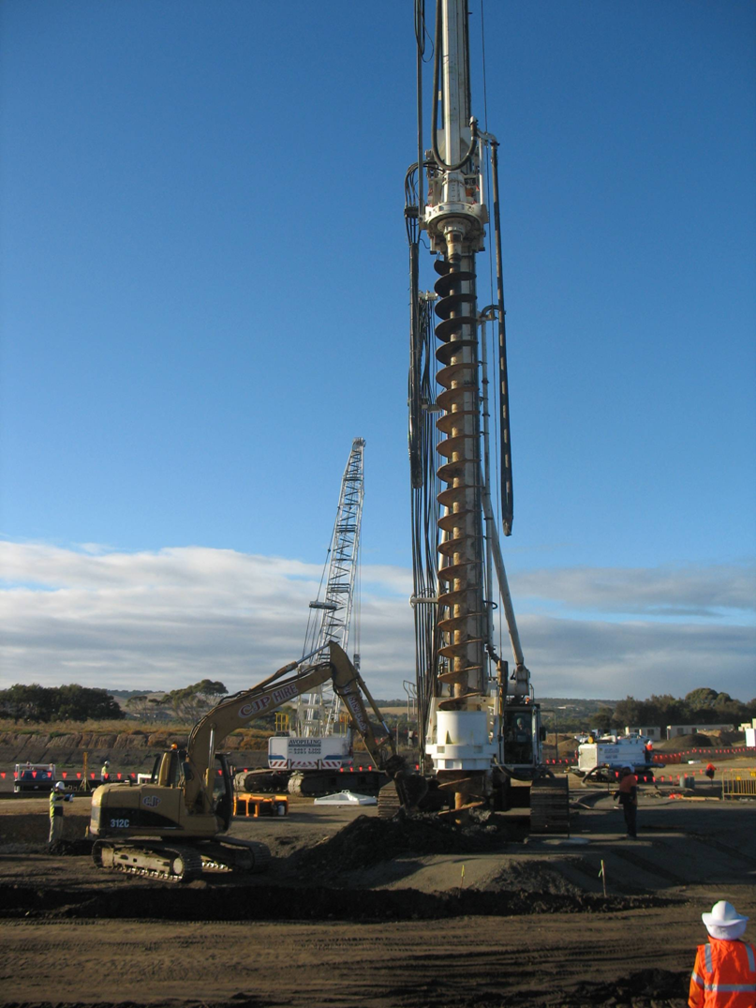
Contractor’s Environmental Management Plan Guidelines


Contractor’s Environmental
Management Plan Guidelines

First Published: November 1997
Last Updated: September 2017

This document has been prepared by Technical Services Section, Asset Management Directorate in the Department of Planning Transport and Infrastructure. It has been approved for use by the Department of Planning, Transport and Infrastructure and its authorised agents.

Extracts may be reproduced providing the subject is kept in context and the source is acknowledged. Every effort has been made to supply complete and accurate information. This document is subject to continual revision and may change. To ensure you have the most up-to-date version of this document refer to Technical Documents.

For more information regarding the interpretation of this document contact:
Principal Environmental Advisor
Telephone: (08) 8343 2398

Contents

1. INTRODUCTION 4
2. CONTRACTOR’S Environmental Management Plan 4
3. CEMP RESPONSIBILITIES 5
3.1 CONTRACTOR’S RESPONSIBILITIES 5
3.2 OTHER RESPONSIBILITIES 5
4. DEVELOPMENT of A CEMP 5
4.1 CONTENT OF A CEMP 6
4.2 ISSUE SPECIFIC MANAGEMENT PLANS 7
4.3 CONTINUOUS IMPROVEMENT 7
APPENDIX A: CEMP SCHEDULE TABLE 9

INTRODUCTION

These Guidelines provide direction for Contractors undertaking work on behalf of the Department of Planning, Transport and Infrastructure (DPTI) in relation to Contractor’s Environmental Management Plans (CEMP). The Guidelines detail the purpose and scope of a CEMP, and outline requirements for Contractors during the Management Plan’s preparation, implementation and maintenance.

These Guidelines apply to all Departmental contracts, including construction and maintenance, which require a CEMP.

The Department is committed to meeting legislative environmental requirements and environmental best practice, and implements an Environmental Management System to ensure this is achieved for all works and activities. The Department requires its Contractors to meet the same environmental objectives, and the use of CEMPs is an important part of achieving and demonstrating this.

An effective CEMP will assist the Contractor in demonstrating that it is meeting legislative environmental compliance, particularly its general environmental duty in accordance with the Environment Protection Act 1993, as well as environmental best practice.

CONTRACTOR’S Environmental Management Plan

A CEMP is a Controlled Document prepared by the Contractor prior to works commencing on site, as a response to the environmental requirements of the Contract. Depending on the type of works and type of Contract, the CEMP may be required to be prepared prior to submission of a development application in accordance with the Development Act 1993.

The Contract will specify the environmental management requirements for the work across a range of environmental aspects. The Department’s Master Specification documents are available at: Master Specification.

The CEMP must detail how the environmental management requirements, as identified in the Contract, will be implemented and managed during the works. It is designed to assist the Contractor to plan, document and implement effective strategies that will minimise the environmental impacts associated with delivery of the work. For example, it should include information about how the Contractor will minimise and mitigate environmental impacts and undertake a continuous improvement process through activities such as inspections, monitoring, verification and auditing.

The CEMP must comply with the requirements of the Contract and be specific to the activities being undertaken.

CEMP RESPONSIBILITIES

CONTRACTOR’S RESPONSIBILITIES

The Contractor is responsible for activities including:
- identifying the person(s) responsible for the preparation, implementation, maintenance and overall management of the CEMP (this is likely to include the Contractor’s Environmental Management Representative),
- preparing the CEMP,
- submitting an electronic controlled copy of the CEMP, including all supporting documentation, to the Principal prior to commencement of any work on Site,
- adhering to CEMP related Hold Points under the Contract,
- implementing the CEMP, including ensuring that the CEMP is covered in inductions for all Contractor and sub-Contractor staff,
- maintaining the CEMP, including management review and approval, and internal auditing of the effectiveness of the CEMP against the Contract, and
- reporting on the CEMP in accordance with Contract requirements.

OTHER RESPONSIBILITIES

The Department and/or an independent verifier (as specified in the Contract) is responsible for activities including:
- release of CEMP related Hold Points under the Contract, and
- external auditing of the effectiveness of the CEMP against the Contract.

DEVELOPMENT of A CEMP

A CEMP is a living document that once established, requires continual implementation and maintenance.

The Contractor must establish a CEMP prior to the commencement of works on-site. This includes preparing the CEMP, and obtaining the release of related Hold Point(s) in the Contract.

The Contractor must then implement and maintain the CEMP for the duration of the Contract. This includes ongoing review and continuous improvement based on the outcomes of inspections, monitoring and auditing, including any identified corrective actions and issues arising from non-conformances. The Contractor must also obtain the release of any Hold Point(s) related to any proposed amendments to the CEMP, and supporting documentation.

4.1 CONTENT OF A CEMP

The Contractor may develop its own format for the CEMP document(s), however the content must meet the requirements of the Contract and these Guidelines.

The CEMP must include:
- a brief project description,
- a description of the role of the CEMP and how it will be utilised during the Contract,
- reference to relevant environmental legislation, standards, codes of practice and environmental authorisations (including approvals, licenses, permits or exemptions),
- a summary of the Contractor’s Environmental Management System and how it will apply to the Contract including:
- the Contractor’s environmental policy,
- an organisational chart specific to the Contract, which shows reporting relationships and highlights personnel with specific environmental management responsibilities. This must include subcontractors,
- reference to the Contractor’s relevant environment related policies, manuals and work procedures (such as inspections, monitoring and auditing, and non-conformance and corrective action), and
- the document control system,
- an environmental risk assessment of all work activities,
- the method(s) to ensure the Contractor’s work, and the work of its subcontractors, complies with the environmental requirements of this Contract,
- details of the process for ensuring that the Contractor's personnel and subcontractors understand all environmental requirements of the Contract, including a procedure for conducting environmental inductions,
- the approach to inspection, monitoring and testing to verify compliance with the specified environmental requirements. This may include a Schedule Table (see example template in Appendix A),
- an environmental audit schedule – in accordance with the Environmental Audit Guidelines for Construction (knet #1765253) available from Technical Documents,
- details of which personnel are responsible for, and which personnel will undertake, particular tasks,
- details of the Contractor’s Activity Zone (CAZ) (including plans or drawings), as well as details of any approved alterations to the CAZ, and
- an environment reporting schedule.

4.2 ISSUE SPECIFIC MANAGEMENT PLANS

Management Plans for specific environmental issues may be incorporated into the CEMP or be stand-alone documents. The CEMP must reference any such stand-alone documents. Management Plans must be prepared by appropriately qualified and experienced specialists included on or eligible for inclusion on DPTI’s Panel. Management Plans for specific environmental issues may include:
- Weed Management Plan,
- Phytophthora Hygiene Plan / Management Plan – in accordance with Phytophthora (Dieback) Control: Environmental Instruction 21.3 (knet #1791907),
- Water Quality Monitoring Plan – in accordance with the Water Quality Monitoring Manual for Construction Sites (knet #1792013),
- Soil Erosion and Drainage Management Plan – in accordance with the Protecting Waterways Manual (knet #3476572),
- Construction Noise and Vibration Management Plan – in accordance with Management of Noise and Vibration: Construction and Maintenance Activities: Environmental Instruction 21.7 (knet #1004908),
- Air Quality Management Plan,
- Contamination / Remediation Management Plan – refer to the SA EPA Guidelines for Environmental management of on-site remediation available from www.epa.sa.gov.au/files/4771274_guide_remediation.pdf,
- Cultural Heritage Management Plan,
- Conservation Plan, and
- Environmental Emergency Response Plan / Procedure.
The DPTI environmental documents referred to above are available from Technical Documents.

4.3 CONTINUOUS IMPROVEMENT

The CEMP is subject to Quality requirements as specified in the Contract.

Regular inspection, monitoring and auditing against the Contract environmental requirements, together with verification and reporting, will assist in reviewing and improving the effectiveness of the CEMP. This may include internal or external monitoring, auditing and reporting conducted by the Contractor, Principal, a verifier, auditor and/or environmental specialist.

The Contractor must provide a status report on the implementation of the CEMP at intervals specified in the Contract, or at a minimum of every 6 months. The report must include a response and evidence that addresses the following questions:
- Has the Contractor implemented all measures identified in the CEMP?
- Is the CEMP operating effectively to manage the environmental risks?
- Has the CEMP been continually updated to reflect changes in work activities/locations, and does it address current work activities?

APPENDIX A: CEMP SCHEDULE TABLE

This is an example template of a CEMP Schedule.

Contract clause | CEMP measure | Action | Inspection frequency | Test requirement | Test frequency | Acceptance criteria | Evidence | Personnel responsible
e.g. CH50 Clause 6 | Construction Noise and Vibration Management Plan: No vibration induced damage. | Vibration monitor installed in proximity to State Heritage listed property | Daily (to ensure vibration monitor is in situ and operating correctly) | Vibration levels adjacent State Heritage listed property | Ongoing during works | Vibration levels below structural damage thresholds (refer DIN 4150-3 Structural Vibration Part 3) | Monitoring records  Vibration report | Environmental Management Representative  Vibration specialist

