Superseded/repealed from 1 November 2021 – refer to https://www.dit.sa.gov.au/standards/environment

Environmental Work Plan
and Risk Assessment
Guidelines

for Road Maintenance Contracts

1 INTRODUCTION 4
1.1 DPTI’s Environmental Management Framework for Maintenance Contracts 4
1.2 What is an Environmental Work Plan? 4
1.3 Environmental Work Plan Responsibilities 5
2 Content of an ENVIRONMENTAL Work Plan 6
2.1 Introduction 6
2.2 Environmental Management System 6
2.3 Environmental Management Schedules 6
3 Implementation of A Work Plan 7
3.1 Process of Implementation 7
3.2 Reporting 7
3.3 Training of Personnel 7
3.4 Auditing 7
4 Environmental RISK ASSESSMENT 8
4.1 Background 8
4.2 Guidelines 8

Appendix A: Example Environmental Work Plan Schedule
Appendix B: Proforma Environmental Work Plan Schedule

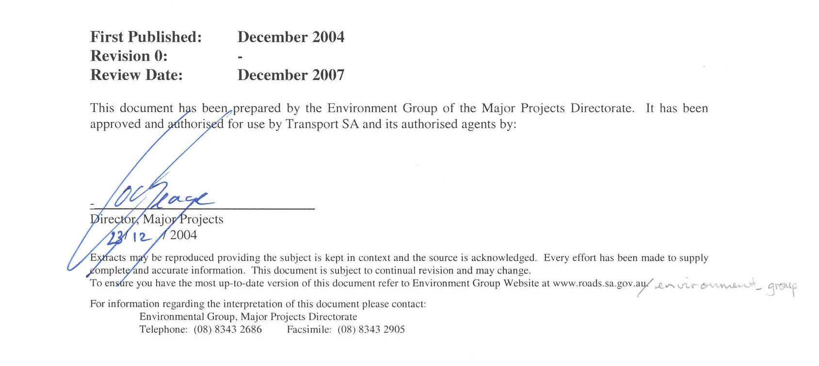

SECTION 1

INTRODUCTION
Department of Planning Transport and Infrastructure (DPTI) is committed to an environmental goal of developing and managing “a transport system in harmony with the environment”. Whether working on land or in water environments, care needs to be taken to protect flora and fauna, heritage items, water and air quality and impacts on the community. It is the responsibility of all people involved in maintenance activities to adopt environmentally responsible work practices.

To achieve these environmental goals, DPTI has in place an Environmental Management System (EMS). Part of this EMS process requires that DPTI maintenance Contractors also have in place their own EMS in order to adequately manage the environmental risks associated with their activities.

For certain maintenance works DPTI requires Contractors to prepare an Environmental Work Plan (EWP). The primary purpose of these guidelines is to outline the requirements of EWPs for contract managers and contractors.

This document has been divided into the following sections:
- Section 1 – provides background information on the DPTI EMS and when a EWP is required
- Section 2 – provides information on the required content of a EWP
- Section 3 – provides information on the implementation requirements for EWPs

DPTI’s Environmental Management Framework for Maintenance Contracts

The DPTI EMS is comprised of a number of elements and levels of documentation that relate to the management of environmental impacts associated with its activities, including the maintenance of transport infrastructure. Part of the DPTI EMS structure requires the demonstration of effective environmental management practices and systems by DPTI Contractors.

The main document governing the environmental management of maintenance activities is the Road Maintenance Contract, specifically:
- Part M50 - specifies the general EMS requirements for all types of maintenance activities
- Part M55 – specifies the on-ground environmental practice requirements for all regions
- Contract Specific Requirements to Part M55 – specifies environmental management requirements explicit to the relevant Contract region

DPTI will detail specific requirements to be addressed in the EWP within a Work Order to be provided to the Contractor as part of the process of the works commissioning.

What is an Environmental Work Plan?

An Environmental Work Plan is a project specific document prepared by the Contractor. The Plan shall list any environmental management requirements outlined in a Work Order, Protect Action Details of an RSSD site or other environmental requirements outlined in Part M55 and detail how those requirements will be implemented and managed at the site.
The Plan shall detail how the Contractor will mitigate specific maintenance impacts and document the Contractor’s response in accordance with their EMS

The objectives of the EWP are to:
- address the environmental concerns arising from the Work Order;
- detail how the Contractor will mitigate specific environmental impacts associated with the maintenance activities; and
- document the Contractor’s relevant environmental management controls for the works (eg. the relevant components of the Contractor EMS).

It should be noted that the EWP may need to be reviewed during the period of works to accommodate changes in management practices or to address environmental non-conformances identified.

Environmental Work Plan Responsibilities

It is DPTI’s responsibility to:
- Provide a copy of the relevant Contract Specific Requirements to Part M55
- Check the Roadside Significant Sites Database and provide details of relevant sites and required management practices
- Provide information on the location of areas where specific environmental issues exist and the required management controls within the Work Order.

It is the Contractor’s responsibility to:
- Prepare a EWP that addresses the Contract and Work Order requirements
- Assume full responsibility for the EWP under the Contract
- Submit the EWP for the Contract Manager’s acceptance
- Update the EWP as required (such as in response to corrective actions arising from audit non-conformances)
- Ensure that the EWP is fully implemented and maintained.

Specifically the Contractor will also identify the person(s) responsible for the implementation, maintenance and review of the EWP.

SECTION 2

Content of an ENVIRONMENTAL Work Plan
The EWP should be structured into the following components:

Introduction

The introduction of the Work Plan should include:
- A brief description of the work being undertaken (including a reference to the Work Order)
- A brief description of the work environment and the site environmental issues (including the location and number of the RSSD site(s) as well as the work activity zone)
- An explanation of the role of the EWP and how it will be used during the maintenance works to achieve the Contractor’s environmental requirements.

Environmental Management System

This section should contain a brief reference to the relevant components of the Contractor’s EMS that apply to the EWP (such as relevant procedures or work instructions for specific activities) and procedures that meet the requirements of the DPTI Contract Specification Part M50.

The EWP should also include a schedule for auditing works against the Plan and the Contractor’s EMS. The outcomes of audits will need to be detailed in reports on the implementation of the Work Plan and will form a basis for reviewing the EWP, where necessary.

Environmental Management Schedules

This section should provide details of the site specific environmental issues outlined in the Work Order, required management measures and how measures will be implemented and managed.

Site-specific issues detailed in the Work Plan might include:
- Roadside Significant Site conditions
- Flora and Fauna Management
- Weed, Pest and Disease Control
- Water Quality Protection, Erosion and Sediment Control
- Construction Noise and Vibration Control
- Air Quality Controls
- Waste Management
- Recycled Materials
- Storage and Handling of Dangerous and Hazardous Substances
- Protection of Sites of Cultural and Natural Heritage Significance
- Contaminated Land
- Specific requirements for a site Emergency Response Plan

For each identified issue this section should specify the following:
- the nature of the actual or potential environmental impact identified;
- a site specific risk assessment for each environmental issue; and
- the management measures to control the environmental issue.

An example of how the environment schedule might be presented in provided in Appendix A.

SECTION 3

Implementation of A Work Plan

Process of Implementation

The implementation of the EWP should be subject to the same level of quality assurance and audit procedures that apply to the other components of the Contractor’s EMS.

Components of the contractors EMS also apply to the Work Plan including:
- detection and reporting of a non-conformance
- implementation of corrective actions.

Reporting

The Contractor will be required to provide DPTI with progress reports on the implementation of the Work Plan at the request of the Contract Superintendent.

The progress report should include a brief summary of the following:
- Location and nature of maintenance work
- Site specific environmental issues
- Evidence of implementation of environmental management measure (photographs of site taken before and after works may be sufficient in most cases)
- Effectiveness of control measures
- Details of any non-conformance incidents/reports
- Outcomes of audits against the EWP
- List of attendees for site environmental induction
- Other relevant progress information.

Training of Personnel

The Contractor is responsible for informing employees and subcontractors of their environmental obligations and for ensuring that employees are adequately experienced and properly trained to conduct the works in a manner to minimise environmental impact.

Prior to the commencement of site works, employees and subcontractors should attend an environmental briefing detailing the site-specific environmental requirements and management measures required in the EWP.

Records of all briefing and training sessions including a list of attendees should be retained by the Contractor.

In the event that site-specific environmental issues are raised over the course of the contract period, additional site-specific briefings may be required for personnel.

Auditing

The contractor shall conduct internal audits to ensure that the EWP is being implemented effectively and that the environmental objectives of the maintenance Contract are being met.

SECTION 4

Environmental RISK ASSESSMENT

Background

An Environmental Risk Assessment of all maintenance activities is required to be undertaken by the Contractor as stated in Division M, Part M50, section 5. The Environmental Risk Assessment shall be carried out using the guidelines outlined in this Section. In addition to this an Environmental Risk Assessment shall be undertaken during the development of an Environmental Work Plan to assist with identify the various activities, impacts and control measures.

Guidelines

Environmental risk assessment is an integral part of an EMS and involves identifying actual or potential environmental impacts associated with Contract activities. A key purpose of undertaking an environmental risk assessment is to identify potential risks to the environment and eliminate these risks through appropriate management measures such as environmental work instructions. The risk assessment must be undertaken prior to the commencement of works and revised if a non-conformance is raised.

Figure 1 – Environmental Risk Assessment Guidelines

Step 1 – Evaluate the risks of all contract activities (consider the consequence if the impact occurred and the likelihood of it happening) |  | For example:  Activity: Re-sheeting unsealed roads  Impacts: Damage to native vegetation  Likelihood: medium  Risk: Med-High
Step 2 – Determine controls to manage the impact |  | Control Measures:  Work instructions detailing methods to control vegetation impacts (eg. excess material shall not be windrowed onto vegetation, debris and spoil shall not be left on the road site, equipment and machinery shall not be parked under native vegetation). Bunting of significant vegetation.

This information can then be recorded in the Environmental Work Schedule as shown in Appendix A. This information can be used to develop control measures for both Environmental Work Plans and Work Procedures.

Where environmental work procedures or instructions are developed they shall clearly spell out the work sequence, highlighting the procedures required to adequately control each risk identified through the risk assessment. All employees involved in each type of work activity shall receive appropriate training in the corresponding environmental work procedure.

DPTI will audit the Contractor’s procedures for ‘Environmental Risk Assessment’ and ensure that up-to-date risk assessments (as part of the Contractor’s EMS) are undertaken (i.e. at least annually or as a result of a non-conformance).

Appendix A - Example Environmental Work Plan Schedule
Contractor: Road Maintenance Solutions | Contract No. 123456A | DPTI Contract Manager: Richard Dodson
Contractors EWP Representative: Andrew Smith | Signature: | Date: 08/07/2004
Work Site Activity: Clear Open Drains | Worksite Location: RN 3500 Port Augusta – Port Wakefield Road MM 200 - 210

Activity | Task | Environmental Impact | Likelihood | Risk | Control Measures | Responsibility
Clearing Open Drains | Removal of vegetation (1,2, 3,9) | Soil erosion (1) | High | Low-Med | Restricting earthworks activity and vehicle movement to designated zones.
 | Removal and disposal of soil, organic material and litter (3,4,5,6,7,8,9) | Damage or removal of native vegetation and habitat (2) | Medium | High | Incorporation of requirements for the protection of native vegetation into work procedures.  Flagging off non-target vegetation areas.  Site-specific environmental training session.
 | Re-establishing a turn-out drain (1,4) | Spread of weeds and/or plant diseases (3) | Medium | High | Communication of weed and disease control procedures.  Appropriate vehicle cleaning protocols in place.  Designated areas for storage/disposal of excess fill.
 | Access of machinery and equipment (2,3,5,6,9) | Sedimentation of water bodies (4) | Medium | Low | Sediment and erosion control training sessions.  Use of temporary sediment and erosion control devices/measures.
 | Grading of drains and creation of a windrow (2,4,6,8,9) | Soil compaction (5) | Medium | Low | Minimal tracking of vehicles.
 |  | Generation of dust (6) | Medium | Med | Minimal tracking of vehicles.  Use of appropriate dust control measures when required.
 |  | Alteration of soil profile thru the addition/removal of soil (7) | Medium | Med | Restricting grading to designated zones
 |  | Disturbance of environmental or cultural significant site (8) | Low | Low | Incorporation of requirements for the protection of heritage sites into work procedures.  Flagging off of heritage sites.  Site-specific environmental training session.
 |  | Contamination of soil/water by hydrocarbons (9) | Low | Low | Regular maintenance of vehicles and equipment.  Appropriate emergency spill equipment carried by vehicles.  Restriction of vehicle refuelling to designated sites.

Appendix B - Environmental Work Plan Schedule
Contractor: | Contract No. | DPTI Contract Manager:
Contractors EWP Representative: | Signature: | Date:
Work Site Activity: | Worksite Location:

Activity | Task | Environmental Impact | Likelihood | Risk | Control Measures | Responsibility

